**Supporting Information (SI).**

This Supporting Information is organised in numbered sections corresponding to those in the main manuscript:

p. 2 SI-1. Introduction: How Low Can We Go?

p. 3 SI-2. The Low Energy Demand (LED) Scenario Narrative

p. 13 SI-3a. Final Energy Demand by End-Use Service: Thermal comfort

p. 18 SI-3b. Final Energy Demand by End-Use Service: Consumer goods

p. 34 SI-3c. Final Energy Demand by End-Use Service: Mobility

p. 46 SI-3d. Final Energy Demand by End-Use Service: Food

p. 48 SI-4a. Energy Used in Intermediate and Upstream Sectors:  
Commercial and Public Buildings

p. 50 SI-4b. Energy Used in Intermediate and Upstream Sectors: Industry

p. 56 SI-4c. Energy Used in Intermediate and Upstream Sectors: Freight Transportation

p. 58 SI-5. Summary of Energy Demand in the LED Scenario

p. 65 SI-6. Supply-Side Transformation

p. 81 SI-7. Implications of the LED Scenario for Sustainable Development Goals

p. 90 References SI

**Supporting Information 1 (SI-1). Introduction: How Low Can We Go?**

The structure of our paper is as follows. First, we develop a scenario narrative or storyline of secular trends shaping energy end-use globally to 2050. Second, we map the storyline down onto four main energy services comprising daily life in the Global North and South: thermal comfort, consumer goods, mobility, and food. Third, we build quantitative estimates of how our scenario narrative affects final energy demand. We also estimate the implications of resulting changes in energy-service quality and quantity on intermediate and upstream sectors including public and commercial buildings, manufacturing, construction, freight transport, agriculture and the energy supply. Fourth, we use a global integrated assessment framework, MESSAGE-GLOBIOM, to evaluate the consequences of our low energy demand scenario on energy supply and land-use. We also show that our scenario limits warming to 1.5°C with no overshoot, and has numerous other health and sustainable development benefits. We document our scenario in greater detail in the following Sections of this Supporting Information and also provide an online data base with all numerical model results available under the following link:  
www.xxxxxxxxxxxxxxxxxxxxxxxxxxxxxxxxxxxxxxxxxxxxxxxxx_FROM_PETER

The motivation for the end-use and efficiency focus of our scenario is twofold:  
First energy end-use has been identified to be the least efficient part of the global energy system with also the largest improvement potentials (Nakicenovic et al., 1990) that translate into significant upstream (energy supply) leverage effects (Figure SI-1-1). For instance based on current global energy systems efficiencies (primary to useful energy of some 40%), a unit useful energy conserved via efficiency improvements translates into a reduction of 2.5 units of primary energy. Likewise, Cullen and Allwood (2010) have estimated the emission reduction potential from improvements in energy end-use efficiency to be four times larger than efficiency improvement potentials in upstream energy supply. Nakicenovic et al., 1990 have complemented traditional energy efficiency calculations by corresponding exergy analysis, extended also to the level of energy service provision which we have also adopted for Figure SI-1-1[1]. The corresponding aggregate primary input to services delivered systems efficiency is conservatively estimated at 14% at the global level in 2020, i.e. improving energy efficiency at the service level by one unit yields a reduction in primary inputs by a factor of seven.

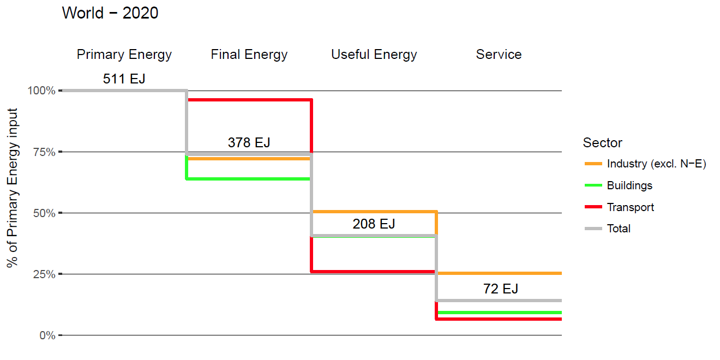

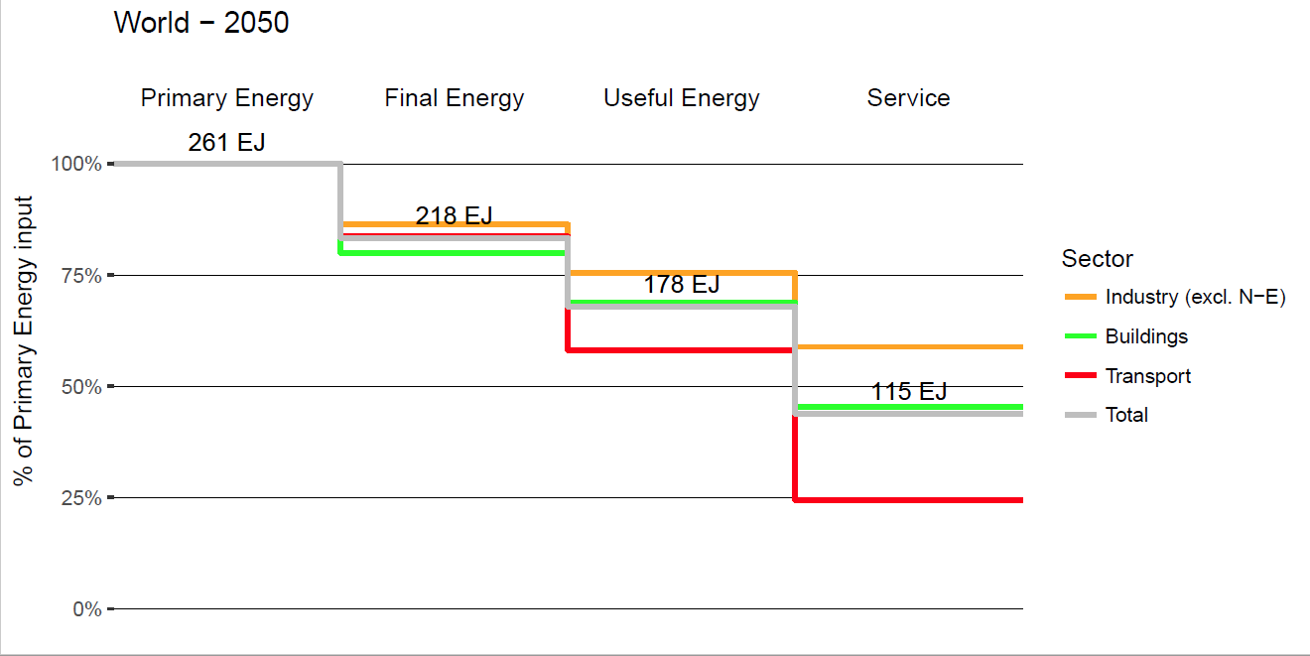

***Figure SI-1-1. Global Energy Efficiency Cascade (percent or primary energy delivered as final, useful and service respectively) by main energy end-use sector (transport, industry, residential/commercial and total) for LED base year 2020 (top panel) and LED Scenario in 2050 (bottom panel). Energy flows exclude non-energy feedstock uses of energy and are also quantified (EJ) for totals flows at each stage of the conversion cascade.****Data sources: Current primary, final, and useful energy levels and corresponding efficiencies from the MESSAGE model calibrated to 2020 base year data (see SI-5 and SI-6); service efficiencies are first-order (conservative) estimates based on Nakicenovic et al., 1990, and Nakicenovic and Grubler, 1993. LED 2050 energy flows and efficiencies as modelled by MESSAGE; service efficiencies derived from tables SI-3a-1, SI-3c-5, SI-4a-1, and SI-4b-1.*

Second, we wanted to explore a scenario of rapid transitions and emissions reductions. End-use technologies and user behaviour tend to change more rapidly than capital intensive supply side technologies and infrastructures (Grubler et al., 2016) and offer therefore of logical entry point. The use of an Integrated Assessment Modeling framework allows us to track the systemic interdependencies between end-use and supply and between energy demand quantities and qualities required for the provision of energy services and the corresponding upstream energy conversion chains and efficiencies.

**Supporting Information 2 (SI-2). The Low Energy Demand (LED) Scenario Narrative**

The main text summarises the LED scenario narrative in brief. Here we provide further information on:

* LED scenario drivers
* Additional features of the LED scenario narrative
* Key characteristics of the LED scenario
* Decent living standards in the LED scenario

**LED scenario drivers**

The Low Energy Demand (LED) Scenario has five drivers and five additional features which are derived from or generated by the drivers (Figure SI-2-1).

Each driver is a clearly observable 'mega-trend' that has, is still, and will continue to drive change in energy end-use (Table 1). These mega-trends are secular in being persistent and not reliant on normative assumptions nor strong climate policy. Rather our scenario narrative is driven by assumptions about behavioural, technological and institutional change in market contexts which are already changing and will continue to reshape energy end-use.

The five scenario drivers are: Quality of Life; Urbanisation; Novel Energy Services; End-User Roles; Information Innovation.

*Quality of Life [QOL]*. Continued push for higher living standards, clean local environments, and widely accessible services, particularly in developing countries as incomes and aspirational living standards rise, supported by policy efforts to ensure a decent living for all. Note that decent living standards are addressed in detail in a dedicated section at the end of this SI-2.

*Urbanisation [URB]*. Continued rapid urbanisation from a combination of population growth, internal migration and demographic shifts, particularly in mid-size cities in developing countries.

*Novel Energy Services [SER]*. Continued end-user demands for qualitative performance improvements in energy services including new functionality, new features, and new forms of service provision, consistent with quality of life improvements.

*End-User Roles [USR]*. Continued shift in end-user roles from passive consumer of centrally-provided services to multiple novel way of interaction, shifting engagement with energy production, trade, design, community and networks.

*Information Innovation [INF]*. Continued rapid improvements in information and communication technologies (ICTs) and applications of micro-processors, sensors, and wireless transmitters, enabling data-harvesting and analytics to improve system performance and energy service provision.

We use the following working definitions of these key terms:

* behavioural change (or ∆ behaviour): change in the quantity or quality of energy services consumed by end-users; micro-level (end-users)
* technological change (or ∆ technology): change in the technological, material or infrastructural form of energy services consumed by end-users; micro-to-macro level (devices to systems)
* institutional change (or ∆ institutions): change in organisational forms, markets, business models, ownership, policy environments, and supply chains through which energy services are provided for consumption by end-users; meso-to-macro level (organisations to markets)

Here we describe each additional scenario feature in turn, how it is generated by interrelationships between observable mega-trends, and how it can be characterised by interdependent processes of behavioural, technological and institutional change (Figure SI-2-2).

*Granularity [GRA]. A strong emphasis on granular technologies is generated by end users pursuing improved quality of life [QOL] through performance improvements in energy end-use technologies [INF] and a more active role in the production as well as consumption of energy services [USR].*

Granular technologies are small in unit size, have low unit investment costs, and are typically modular or scalable through standardised replication (e.g., solar PV, e-bikes); lumpy technologies are the converse (e.g., nuclear power, jet aircraft). Granular technologies have lower upfront costs and so lower barriers to entry. As a result, they are more equitably distributed among adopter populations so support more widespread improvements in quality of life. Low investment costs and short lifetimes mean granular technologies are also more open to experimentation and learning by users seeking to improve ease of use and convenience. Increasing integration of ICTs into granular end-use technologies further allows for rapid innovation cycles in digital design environments and applications through platforms or devices with rapid turnover.

***Table Drivers. LED Scenario Drivers.***

|  |  |  |  |
| --- | --- | --- | --- |
| ***observable driver*** | ***label*** | ***description*** | ***evidence*** |
| **Quality of Life** | **QOL** | - rising incomes & purchasing power  - globalising aspirations  - development efforts & policies (SDGs)  - ageing populations & health needs  - value placed on clean and healthy local environments (including indoors) | - GDP per capita trends  - global trade & cultural exchange  - technology spill-overs |
| **Urbanisation** | **URB** | - rising urban populations  - rising number of cities, esp. mid-size  - spatial constraints on mobility, property size & goods ownership  - more opportunities for experimentation & diversity | - urbanisation trends  - peak car  - peak material consumption |
| **Novel Energy Services** | **SER** | - consumer preferences for performance improvements, ease of use & convenience  - attractiveness of new value propositions & service functionality  - risk-taking early adopters seeding market growth | - long-run historical energy transitions  - market transformation by disruptive innovations  - ICT integration into energy service provision (‘smart’) |
| **End-User Roles** | **USR** | - energy market liberalisation & new entrants  - availability of residential-scale energy production  - accessibility & affordability of energy as politically-active issue  - co-design of end-use technologies and services (esp. through ICTs)  - energy citizenry as democratic response to utilities’ market power | - falling cost & rising numbers of residential PV (and battery storage)  - proliferation of local energy groups  - town & city-scale leadership on energy & climate  - integration of user-active ICTs with energy technologies (cf. social media production) |
| **Information Innovation** | **ICT** | - rapid & sustained cost declines in general purpose ICTs with economies of scope (inc. microprocessors, sensors, wireless transmitters)  - rapid & sustained performance improvements in wide range of ICT devices and applications  - standardised, mass produced units manufactured at large scales benefitting from economies of scale and learning effects  - rapid innovation cycles  - network effects from dominant digital platforms spurring further innovation | - Moore’s Law  - experience curves for mass-produced ICTs  - ICT penetration into conventional energy-using hardware & infrastructure |

*Decentralised Service Provision [DEC]. A marked shift to more distributed forms of energy generation, distribution and end-use is generated by more active energy end-users [USR] in spatially constrained urban environments [URB] with information-rich networks and systems enabling real-time management of energy service provision [INF].*

Decentralised or distributed energy resources range from energy end-use (e.g., smart phones) to storage (e.g., batteries) and supply (e.g., solar PV). Decentralisation at a systems level is a corollary of granularity at a technological level. Lock-in to lumpy infrastructures (e.g., grids, networks, pipelines) can be overcome through piecewise extensions or upgrades particularly in urban environments which are expanding incrementally with a highly fragmented and distributed availability of space. Alternatively, some new infrastructure may be modular in design (e.g., mobile telephony). Distributed, additive manufacturing has the same decentralising and localising effect on material supply chains. Decentralisation is enabled by, and also reinforces increasingly varied and diverse end-user roles in energy service provision, accelerating 'edge-of-the-grid' innovation such as community energy networks or peer-to-peer trading between residential solar-battery or fuel cell systems. The widespread availability and distribution of cheap sensors and wireless transmitters supports large-scale data harvesting and cloud-based analytics for system management including balancing of intermittent supply with heterogeneous and variable demand.

*Use Value from Services [USE]. A movement away from owning goods to deriving use value from services is generated by the increasing convenience and accessibility of new flexible, user-responsive services [SER] enabled by digital technologies and platforms [INF] among communities and networks of users [USR].*

Use-based business models create value from consuming a service rather than owning the good which provides that service. Data-driven digital platforms open up opportunities for distributed service providers to respond in real-time to users' needs. Sharing economies play an increasingly important role in linking providers with users, or users with users in peer-to-peer based institutions. Trust devolves from centralised regulatory institutions. Localised service provision develops, particularly in dense urban areas where proximity lowers transaction costs. Municipalities reconfigure modes of service provision to tap users' increasing involvement. Asset utilisation rates increase in buildings, cars, and consumer goods, enabling a steady dematerialisation of daily life and a freeing up of road infrastructure for repurposing. Service provision becomes novel, flexible, available on-demand, and reflexively improving based on user experiences. In contrast, owning an end-use technology locks users in to a singular form of energy service. Flexibility in consuming a service tailored to specific needs on an ever-changing basis reflects increasing flexibility in working and living practices. Service offerings which fail to engage end-users rapidly fail; alternatives are rapidly introduced as barriers to entry are low and innovation cycles rapid.

*Digitalisation of Daily Life [USE]. Pervasive integration of information technologies into energy service provision is generated by exponential cost declines and performance improvements in sensors, processors and wireless communication [INF] providing new service features including interactivity and control [SER] to make the demands of daily life easier for end users [QOL].*

Rapid improvements in the cost, performance and interoperability of ICTs accelerates their widespread embedding in devices, appliances, homes, workplaces, utility networks, infrastructures. Energy services become easier, cheaper, and more practically controlled to suit and respond to users' needs. New control functionality enables both user specifications (inputs, preferences, routines) but also user passivity (learning algorithms, intelligent automation). Smart phones and other mobile devices provide gateways to service providers of mobility, thermal comfort, and food. Daily life becomes data-rich: sensing, analysing, responding, optimising, learning. Shared infrastructure responds to real-time information on end-users' preferences, experiences, and interactions. In particular, constraints on space and resources in dense urban areas stimulate efforts to optimise the design and use of roads, green spaces, and public institutions.

*Rapid Transformation [RAP]. Accelerating improvements in energy service provision is generated by strong end-user demands for improved quality of life [QOL] particularly in cities where spatial density and economies of scope foster experimentation [URB] and the rapid diffusion of successful innovations [INF].*

As they have throughout history, end users continue to seek energy services which are higher quality, more accessible, cleaner, healthier, and more convenient. Rising incomes, rising aspirations, cultural spill-over, and globalised trade stimulate economic and social development which creates strong market demand for innovative service providers. Innovations brought to market quickly and effectively at scale win out. New functionality trumps cheapness. Granular technologies with lower adoption costs and risks are more equitably distributed, ensuring widespread accessibility to the benefits of rapid transformation. Granular technologies also diffuse faster *ceteris paribus* as they have lower upfront costs, lower complexity, and being widely distributed, are more observable and trialable: all key innovation attributes which explain diffusion speeds1. Rapid transformation implies losers as well as winners. Incumbents and marginalised groups of end-users receive transitional support mitigating their resistance to rapid change. Centralised planning agencies continue to be surprised by rapid rates of change (as currently with PV & EVs). Energy-supply, utility networks, transport infrastructure expands at the margins avoiding singular lumpy investments.



***Figure SI-2-1. The LED Scenario Narrative: Five Drivers & Five Additional Features.***





***Figure SI-2-2. Drivers of Change Combine to Generate Additional Features in LED Scenario Narrative.***

**Key characteristics of the LED scenario**

In previous sections we have described the mega-trends driving change in the LED scenario, and the additional set of emergent features generated by interrelationships between these mega-trends. Here we summarise the key characteristics of our scenario in general terms.

*1. End-use and end-user focus*. Our scenario is first and foremost about low energy demand. It is focused on energy end-use and end-use services. Resulting changes in energy-service qualities and quantities in turn induce transformation in intermediate sectors (manufacturing, freight, construction) and the upstream energy supply.

*2. Balancing descriptive realism with normative goals*. Mitigation scenarios and modelling tread a path between projecting likely outcomes based on current data, and illustrating optimal outcomes based on predefined policy goals. The motivating aim of our scenario is to trace the lowest bound for global energy demand to meet two normative objectives: ensuring decent living standards for all (see next section); and meeting the 1.5°C warming goal. However, we also make clear that our scenario narrative is built upon a realistic appraisal of current drivers of change in energy end-use.

*3. Very rapid rates of change*. The 1.5°C emissions budget requires rapid reductions in energy demand in the next few decades. Several of our scenario drivers underpin this fast transition, particularly the emphasis on granularity and decentralisation. Low cost, small-scale, modular end-use technologies with incremental expansions or adaptations of larger infrastructures offer the potential for rapid change. The end-user ‘pull’ for this rapid change is evidenced in consumer preferences for novel and better energy services consistent with the pursuit for a higher quality of life.

*4. Secular drivers not policy dependence*. Stringent mitigation scenarios rely overwhelmingly on stringent climate policy. However policy risk is hard to mitigate, and deters private investments (by both firms and consumers). Climate policy to-date has been weak, fragmented, insufficient. We build our narrative of future energy end-use from behavioural, technological and institutional changes already visible in market settings (Figure SI-2-2). Although these are not wholly independent of policy and regulatory frameworks, they are primarily driven by end users pursuing more attractive energy services which firms, cities and other organisational forms can provide. Climate policy is still necessary to drive rapid decarbonisation of the energy supply, but our scenario relies considerably less on climate policy stringency as the decarbonisation challenge is reduced by downscaling energy demand.

**Decent living standards**

Raising living standards in developing countries is central to the LED scenario. It is reasonable to expect that by 2050 living standards of all people will rise, even if future gains in economic growth are not equitably distributed. Based on some aggregate measures of human development, such as life expectancy or access to basic needs, at even past rates of progress most regions of the world barring some parts of Sub-Saharan Africa would reach thresholds that resemble the standards of industrialized countries by 2050. Development targets that break from the past and raise ambition would be consistent with a world that has embraced a low-carbon transformation, particularly in developing countries, where climate goals are typically embedded within a broader development agenda2,3.

What would such a better world look like, from the perspective of households and their living standards? In a world without poverty, people would have surmounted a broad range of deprivations, regardless of their income4,5. While the living standards to which people aspire depend on their culture, location, history and personal choice, there is enough common among us that one can expect that these standards include a minimum set of requirements, no matter what else they include6,7. We call these decent living standards (DLS). These requirements ensure that people have the means to pursue a decent life, and avoid harm to their basic interests7. Following Rao & Min6, these requirements include amenities that ensure good health, and those that enable people to engage with society.[2] They include safe and uncramped shelter, nutrition and water, clothing, health care, and basic comforts in the home, such as lighting and thermal comfort (including water heating), refrigerators and clean cooking devices. These basic comforts serve to avoid harm from extreme weather, disease and pollution. In engaging with society, people seek knowledge about the world, and the means to communicate with others, which give rise to the need for education, devices in the home to communicate (e.g., mobile phones) and access broadcast media (e.g. television), and access to mobility.

These material requirements of a decent life area associated with energy and other resource consumption to build the infrastructure in society to provide these goods and services and to operate them day to day. A world that achieves ambitious climate stabilization and attains these development goals has to ensure that the world has adequate energy in all regions to main these basic living standards. Furthermore, one has to allow for the possibility that a more equitable society is not an egalitarian one. Rather, the DLS serve as a floor, and average living standards may exceed this level, increasingly so in richer societies.

The components of a decent life in concept are reasonably well established in literature, but the quantities that people require are subjective, and therefore not easily generalized. Rao & Min6 provide rough guidelines, where possible, for DLS. First and foremost, people need adequate nutrition, from foods that do not increase the risk of chronic disease. This suggests people should have 2,500 calories a day on average, with a limit on the share of calories from meat (see SI-3d). Other indirect energy needs arise from building and equipping homes. Rao & Min6 find support in many high-income developing countries’ regulations for a minimum floor space of 10 m2 per capita, with a minimum size of 30 m2 for a household, to accommodate a bathroom and kitchen. Such a home should be made of durable materials, and be equipped with the basic comforts discussed above. In particular, based on the climate, homes should have sufficient heating and cooling equipment to ensure that indoor temperature and humidity remain within an acceptable range all year long, and to heat water for bathing. In addition, every home should have a refrigerator, a television and a mobile phone per adult.

All households should have access to motorized transport, either from private or public modes. Otherwise, people are severely limited in their livelihood options, because people typically do not want to spend more than an hour a day commuting, regardless of what modes of transport they use8. The mobility needs (in terms of distance) of a society are hard to define at a global scale, because they depend on spatial organization of society at a local scale, related to the location of peoples’ livelihoods, schools and hospitals, and other activities. However, one can estimate a minimum for a national average from the travel demand of affluent but compact societies that use public transport, such as Japan, which has the lowest travel demand (in passenger-km) among industrialized countries. The average person traveled about 7,000 km in 1987, 9,000 km per year in 19928, and more recently around 10,000 km per year. Given that Japan was an affluent society with advanced transportation systems for its time by the late 1980s, one can assume that travel demand can be as low as 7,000 km per capita. We use this as our minimum acceptable threshold for DLS. The modes of transport should be such that air pollution should be below levels that pose hazards to health. This is particularly relevant for densely populated urban areas.

These goods and services consumed in homes, and the DLS activities outside the home (e.g. health care and education), give rise to other supporting economic activities, which are usually classified in commercial and industrial sectors. These are country-specific, since they depend on economic structure and other socioeconomic characteristics, and therefore cannot be a priori prescribed or estimated at a global scale.

**Supplementary Information 3a (SI-3a). Final Energy Demand by End-Use Service: Thermal Comfort**

Here we discuss the underlying scenario drivers and energy demand implications for the provision of shelter, i.e. residential housing.[3] We focus here on the thermal energy demand of residential dwellings (heating, cooling, cooking, and hot water provision). The energy use of residents in buildings (i.e. electricity use in appliances and communication and entertainment equipment) is discussed separately in SI-3b on Consumer Goods.

Table SI-3a-1 below documents the assumptions underlying our LED scenario for residential thermal energy demand using a decompositional analysis linking the various scenario drivers related to activity as well as to energy variables respectively.

The starting point of our analysis is the GEA Efficiency scenario. Although the central metric of our LED scenario is formulated at the level of final energy (fuel input to home heating systems), we also need to discuss useful energy (heat/cooling delivered from residential heating/cooling systems) in the SI here due to our underlying LED scenario storyline and also for reasons of comparability to the GEA Efficiency Scenario.

An important characteristic of the LED scenario is its focus on changing practices and technologies at the level of energy end-use, which change drastically compared to current patterns and which can only be documented when also considering useful energy. For buildings the level of energy demand, determined through the thermal integrity characteristics (insulation) of the building shell, is best defined at the level of useful energy (energy released by residential heating systems, e.g. radiators, AC units). The ratio of final to useful energy then describes the efficiency by which this useful energy is generated, including the efficiency of the boilers and the heat losses in pipes etc. For instance, traditional, single purpose high temperature (60 °C hot water) heating systems (e.g. gas fired boilers) typically only convert between 60% to 85% of final energy (gas) into useful energy (heat from the radiator) with the difference lost in boiler efficiency and heat pipe losses. Hence, for each unit of useful energy delivered between 1.2 to 1.7 units of final energy (fuel) are required. (Using traditional, inefficient biomass stoves this ratio can approach/exceed a factor of 5.) Conversely, novel residential energy systems such as heat pumps not only can provide for economies of scope (delivery of heating, cooling, as well as hot water services all via one end-use device as opposed to the traditional separate single-purpose devices), but can additionally harness ambient energy (air, ground, or water heat pumps) with coefficients of performance (heat out/fuel in, COP) reaching typically 3 or above, provided low temperature (typically below 30 °C) heating/cooling (e.g. wall-integrated) systems are installed. In such cases final energy heating demand is lower than useful energy demand (as only the fuel input, typically electricity, is accounted for, but not the free ambient energy harnessed). This is the reason why in the decompositional analysis in Table SI-3a-1 we also report the final to useful energy multiplier and formulate the specific (per m2 floor area) thermal energy demand at the useful energy level here to document the LED scenario in both dimensions of the efficiency of the building shell, and also that of the heating/cooling system used.

A second reason for also reporting useful energy here is methodological. Both LED and GEA Efficiency use an Integrated Assessment Modeling Framework (MESSAGE-GLOBIOM)9 to assess the upstream energy systems implications of scenarios of energy demand. In this framework, demands are formulated at the level of useful energy, with final energy determined endogenously in the model (both for GEA Efficiency and LED). The respective final-to-useful energy conversion efficiency is therefore determined by the choice of residential energy systems and technologies and a separate reporting of final and useful energy helps to clarify the differences between the LED and the GEA Efficiency scenarios.

It is worth noting that in this scenario comparison differences in 2020 values are substantial. The GEA Efficiency scenario used the year 2005 as base year and thus 2020 values constitute scenario projections. Conversely our LED scenario uses 2020 as base year drawing on recently published statistics10, short-term trend extrapolations, as well as recent scenario studies11,12. Updated 2020 data for LED particularly affect the residential floorspace area (LED: 178 billion m2 globally in 2020 versus 155 billion m2 in GEA Efficiency) and the final/useful energy conversion efficiency multiplier (LED: 1.6 versus 1.4 in GEA Efficiency globally in 2020), which translates into a difference in final energy use of 69 EJ globally in 2020 in LED versus the (optimistic) scenario projection of 49 EJ in GEA Efficiency.

The scenario projections of the basic drivers of population and available floorspace of residential dwellings of the GEA scenarios remain representative also of more recent comparable (intermediary) scenarios (e.g. the scenarios reviewed in Gueneralp et al.11 or the IPCC SSP2 scenario13). With a global population growing to some 9 billion by 2050, residential floorspace is assumed to grow from some 180 (2020) to 260 (2050) billion m2 in LED, which is comparable to the recent scenarios reviewed in Gueneralp et al.11. Almost all of this growth in residential floorspace occurs in the Global South, again mirroring similar trends in the available scenario literature. The underlying growth pattern in residential floorspace holds important implications for energy demand. In the Global North, with a largely saturated floorspace demand (at some 30 m2 per capita), future energy demand will be determined mostly by the performance of thermal retrofit of existing buildings, and only to a small extent by the characteristics of new built dwellings. Conversely in the South, a rapidly increasing housing stock (available per capita floorspace increases to some 30 m2/capita by 2050) implies that future energy demand will be largely determined by the energy performance of new residential buildings and to a much smaller extent also by the success of thermal retrofits of existing buildings.

The scenario drivers towards higher quality of life and urbanization interact to explain the assumed evolution of residential floorspace in the LED scenario.

In the Global South, a growing, increasingly urbanized population strives for higher quality of life translating into a significant growth in residential floorspace (to some 30 m2 per capita by 2050, converging to values of the Global North), predominantly in new construction multi-family dwellings, offering numerous opportunities for efficiency improvements and improved thermal comfort via minimizing energy losses of building envelopes, high quality indoor air (via forced ventilation with energy recovery) and new multi-purpose end-use conversion devices offering further efficiency gains via recovery of ambient energy flows and reaping economies of scope (cogeneration) benefits via the use of heat pumps or fuel cells. These in turn follow the LED scenario logic of more decentralized provision of energy services as well as greater consumer autonomy (less dependence on energy supplied by centralized utilities), digitalization, and new consumer-driven business models (e.g. peer-to-peer energy trade among consumers).

In the Global North, LED (as in comparable scenarios in the literature) basically postulates saturating levels of residential floorspace per capita (at 30 m2/capita). Given the emphasis on quality of life, as well as the substantial improvements in urban environments in term of improved air quality and reduced traffic congestion described in the LED scenario storyline, “living in the city” becomes more emphasized in the Global North, departing from historical trends towards lower density suburbanization14 and its associated single-family home driven growth of residential floorspace (that can approach 70 m2/capita in some regions12). Efficiency improvements for buildings (but also transport, cf. the discussion below) in the Global North thus arise from three main effects: a) structural changes in building types and location (from single-family homes in low density suburbs to multi-family dwellings in denser urban core areas), from b) retrofitting existing buildings and building envelopes towards minimized heat (and cooling) energy losses (insulation), as well as c) end-user technology changes including heat recovery from ventilation and waste water systems, heat pumps, fuel cells, micro co-generation systems of heat and electricity, etc. However there are also important tradeoffs to consider. Saturating demands for residential floorspace limit the structural effects of changes in residence types, the dominance of building retrofits may limit the impact of advanced low-energy building designs, and the efficiency impacts of novel end-use technologies such as heat pumps is limited in cases existing high-temperature residential heating systems (radiators operating with 60°C hot water) and stand-alone electric A/C units cannot be changed to integrated low-temperature heating /cooling configurations and new wall or ceiling heat/cooling heat transfer systems. These limitations are considered in LED, where corresponding optimistic assumption of the GEA efficiency scenario have been reassessed with more moderation in the Global North. Conversely, comparable limitations are not in place in the Global South, where most of the residential floorspace growth is in new construction of multi-family dwellings in urban areas and thermal demand is dominated by cooling requirements rather than by heating offering larger efficiency gains from novel end-use systems such as heat pumps. In this case the original GEA Efficiency scenario assumptions have been reassessed drawing on recent literature in direction of a more optimistic (higher efficiency gains) outlook.

LEDs residential buildings thermal energy demand in the Global North adopts a useful energy demand of some 160 MJ/m2 by 2050 from the GEA Efficiency scenario, a significant reduction from current values of above 600 MJ/m2. Such a reduction is feasible by assuming that current thermal retrofit rates in the region would double from 1.4 %/year to 3%/year, i.e. a residential building is assumed to undergo a retrofit on average every 30 years as illustrated in the recent “deep efficiency” scenario of Gueneralp et al.11 (100-200 MJ/m2). That scenario reaches a similar result as GEA Efficiency (180 MJ/m2) that assumed a market penetration of advanced low energy buildings of well above 75% by 2050. Both scenarios are line with our LED scenario assumptions. While LED has comparable useful energy demand assumptions of GEA Efficiency, our scenario is more conservative with respect to the efficiency impacts (final/useful energy multiplier in Table SI-3a-1 below) of novel residential energy systems in the Global North as thermal retrofits of buildings (improvements in building shells through better insulation) are unlikely to result also in a complete replacement of existing (high temperature) heating cooling systems as well. After correcting the optimistic 2020 projections of GEA Efficiency with recent estimates of final and useful energy balances (from IEA10 and De Stercke15) we also revise upwards the optimistic 2050 projections of GEA Efficiency in the Global North in view of the limitations outlined above. As a result LEDs final energy demand for thermal uses in residential buildings in the Global North ends up to be 30% higher (LED 8 EJ by 2050, GEA: 6 EJ, see Table SI-3a-1).

For the Global South, the GEA Efficiency scenario projected quite conservatively specific useful energy demands of some 150 MJ/m2 in 2050, higher than current averages in the South (120 MJ/m2). Thus, GEA Efficiency assumes that the energy efficiency performance of new residential buildings built in the Global South would not improve and achieve only a similar energy performance as thermal retrofitted building in the Global North. More recent scenario studies for residential buildings in the Global South suggest however substantial further efficiency improvement potentials by application of current best practice low energy building designs to new construction. The “deep efficiency” scenario developed by Gueneralp et al11, and that shares driver assumptions in terms of population and residential floorspace with GEA Efficiency suggests a range of between 30 to 70 MJ/m2 for advanced new buildings in the Global South, but without considering the effects of large-scale penetration of heat pumps. We have adopted a value of 60 MJ/m2 useful energy demand for residential buildings in the Global South for LED. Assuming the comparable structure of end-use heating/cooling systems with a high penetration of heat pumps and a corresponding final to useful energy ratio of 0.6 (compared to 0.7 in GEA Efficiency) this translates into specific final energy demands of some 40 MJ/m2 in LED. These values only seemingly appear optimistic when compared to the assumptions underlying residential buildings in the Global North. First, the much lower thermal heating demand in the Global South (even when combined with a much higher cooling demand, this still results in lower thermal energy demands for residential buildings in the Global South) needs to be considered as well as the fact that by 2050 buildings will be predominantly new construction (as opposed to retrofits in the Global North) where the efficiency effects of novel integrated end-use devices such as heat pumps and fuel cells will have a larger impact compared to retrofits in the Global North. As such LED illustrates a pronounced leapfrogging effect in new building construction in the Global South. Total residential thermal energy demand in LED adds up to 13 EJ useful energy and 8 EJ final energy in the Global South, which is about 60% lower than in the GEA Efficiency scenario.

Globally, LED’s final energy demand in residential buildings by 2050 is projected at 16 EJ by 2050, compared to 28 EJ (-43%) in GEA Efficiency or a range of between 30 to 38 EJ in the “deep efficiency” scenario of Gueneralp et al.11 and the Beyond 2°C Scenario of IEA’s Energy Technology Perspectives16. The reduction from 69 EJ to 16 EJ final energy demand for thermal comfort in residential buildings between 2020 and 2050 in the LED scenario cannot be decomposed into its corresponding sub-categories (heating, cooling, hot water, cooking) in our aggregated scenario framework, but comparable scenarios (e.g. IEA ETP, 2017) suggest an almost proportional decrease in heating and cooling energy demand as a result of significantly improved building envelopes.

Table SI-3a-1 summarizes the LED scenario, decomposed into its drivers and compares it to GEA Efficiency from which it was derived.

*Table SI-3a-1. Decomposition of drivers of residential thermal energy demand. LED scenario and GEA Efficiency (in parenthesis).*

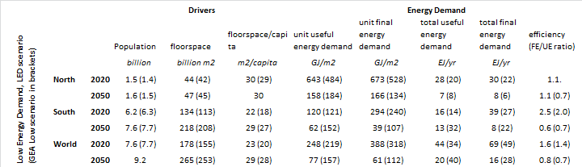



**Supplementary Information 3b (SI-3b). Final Energy Demand by End-Use Service: Consumer Goods.**

The main text and Methods section summarises how the LED scenario narrative maps onto changes in the activity levels and energy intensities relating to consumer goods, with resulting consequences for final energy demand. Here we provide additional information on:

* mapping the LED scenario narrative onto changes in the ownership and use of consumer goods;
* activity levels and energy intensity of consumer goods;
* bottom-up quantification of final energy demand for consumer goods;
* upstream effects of changing consumer goods;
* comparison of the LED scenario with other scenario literature.

**Mapping the LED scenario narrative onto changes in the ownership and use of consumer goods**

Appliances (including lighting and cooking) use more than a third of the global energy consumed in buildings16. Their part in electricity demand has been driven by the growth in several types of goods: large appliances (e.g., TVs, washing machines, refrigerators) increasing 50% since 1990; lighting, growing on average 2% annually since 2005; and networked devices and other small consumer electronics increasing 3.5% annually since 201016.

Information and communication technologies (ICTs) have dramatically progressed over the past half a century and multiplied the number of services to end-users. ICTs and consumer goods already account for 15% of electricity consumption in residential buildings17. ICTs impact final energy demand in two main categories: end-use devices, and supporting infrastructure. The growth of energy consumption by ICT and consumer electronics has been the highest of all appliances categories in the first decade of this century, accounting for around 15% of global electricity demand18. The internet, for example, has increased in accessibility from 10% to half of the world population in the last 15 years19. Meanwhile, data centres, a backbone of the Internet infrastructure, increased their energy consumption dramatically in the first decade of 2000 to reach 1.3% of global electricity use in 201020. Since then the energy demand has stabilized thanks to the efficiency improvement of servers in the past years20. Another example is mobile phones. The energy-related impact of mobile phones was estimated in 93 TWh in 2010, of which only 10% went to power the handsets21.

If energy efficiency does not improve, appliances and other equipment will double the electricity consumption in 2030, using more energy than any other energy service in buildings16.

Here we map the drivers shaping the progress of appliances and other building equipment to 2050 in the LED scenario.

*DIGITALISATION*

The capacity of ICT computation has exponentially increased since the middle of the twentieth century, doubling every 1.5 years22. This rate of improvement supports the empirical “Moore’s Law” under which the number of transistors that fit onto a chip doubles every two years. This trend has smashed the price of transistors which are 60,000 cheaper than the first sold in 197123, contributing to the widespread diffusion of these technologies. A large number of ICTs and consumer electronics are powered with batteries. The energy required to perform the same computing work from a battery decreases 100 times every decade, which is faster than Moore’s law24. This enabled the creation of disruptive technologies based on mobile computing such as laptops and smartphones which have had a marked impact on lifestyles. More recently, ICT features are appearing in quotidian objects such as thermostats and water heaters which acquire “smart” features and become connected through an 'Internet of Things' (IOT). The number of connected devices continues to raise to 100 billion in 2050 from 14 billion in 201325, enabling new services. Micro computing “chips” and sensors are ubiquitous, connecting more intelligent devices which perform end-use services better and with a lower energy use. Smart grids interact with the connected devices to optimize their operation and reduce costs. A new category of “prosumer” emerges from the conflation of producer and consumer roles. Additional features also allow the connected objects to react to their surroundings or provide new control functionality and convenience for end users. This can help diffuse the observed efficiency improvements of ICT to a wider spectrum of objects in the future, consistent with LED’s scenario narrative where Cloud-based services rapidly disseminate operating improvements (as software patches) and allow for rapid energy-performance optimisation and load management options.

*DEVICE CONVERGENCE*

Some ICT devices converge multiple services performed by ordinary objects into single devices with associated changes in consumer behaviour. As an example, smartphones substitute other technologies to perform similar services (e.g. video camera, newspapers, GPS). We estimate the energy displaced as 100 times the amount of energy used by smartphones (see Table SI-3b-1 and Figure 2 in the Main text). Smartphones also save 30 times the energy required for its own stand-by. Other objects substituting for several appliances include: smart TV (comprising access to internet and reaction in real time), kitchen appliances like thermomix (combining thermal and mixing functions), and wearable devices like smart watches (including watch, phone, heart rate monitors and so on). Changes in technology and consumer behaviour reduce the energy intensity as well as the number of devices assisting the trend of dematerialization.

***Table SI-3b-1. Saving power consumption by converging multiple services in smartphones.*** *Power consumption = 5 Watts (on), 1 Watt (stand-by)****.***

|  |  |  |
| --- | --- | --- |
| ***Technology/***  ***Power consumption (W)*** | ***On*** | ***Stand-by*** |
| *Camera* | *10* | *0.90* |
| *Hand-held calculator* | *0.001* | *<0.1* |
| *TV set* | *186.09* | *6.6* |
| *Game Console* | *67.68* | *1.01* |
| *Set-top box* | *44.87* | *43.46* |
| *DVD/VCR* | *22.37* | *5.04* |
| *White noise* | *18* | *0.5* |
| *Radio* | *17.7* | *1.12* |
| *Scanner, flatbed* | *15.6* | *2.48* |
| *Tablet/ I-Pad* | *10* | *0.75* |
| *Stereo portable* | *8.25* | *1.66* |
| *Alarm clock* | *7.6* | *0.7* |
| *(fixed) telephone* | *7.4* | *2.92* |
| *GPS* | *7.4* | *0.031* |
| *Electronic weather station* | *6* | *0.5* |
| *MP3/ I-Pod* | *5* | *0.75* |
| *PDA* | *5* | *2.24* |
| *Pager* | *4.03* | *2.24* |
| *Video camera* | *4* | *0.9* |
| *LED pocket lamp* | *1* | *0.5* |
| *Voice recorder* | *1.2* | *0.5* |
| ***TOTAL (a)*** | ***449*** | ***72*** |
| ***Smartphone (b)*** | ***5*** | ***2.24*** |
| ***Share of Smartphone in Total (b/a)*** | ***1%*** | ***3%*** |

*ENERGY EFFICIENCY*

Efficiency improves over time driven by developments in lighting, appliances, consumer electronics and information and communication technologies (ICTs). Historical trends show technological progresses in inventing, developing and diffusing higher performance technologies with lower environmental impacts. The energy efficiency of computers has doubled every 18 months, similar to the trends in computational power22,26. Lighting, electronics (consumer and office) and residential appliances are among the sectors with the highest potential for resource gains and for energy demand reduction by 2.11 EJ each in 203027. These efficiency gains largely come from the dissemination in 2050 of the current top performance models, e.g., refrigerators reducing annual consumption from around 600 kWh to 120 kWh of the today’s RF19 model from Sun Frost28. Assuming the continuation of trends in the next decades, the energy efficiency of ICTs should increase by several factors until 2050. Technology improvements assimilate fast in ICT as granular, short-lived technologies tend to replace more rapidly older models. Activity levels should also reduce further with the growth of cloud computing and virtualization which reduce the need for more computer infrastructure (software and hardware)29. In additions to improving conversion efficiencies of devices, practical actions could reduce energy demand in appliances by 67% by reducing losses in passive systems28. The practical actions summarised in Table SI-3b-2 can save 67% and 95% of current global energy use in appliances and lighting respectively (88 EJ + 12 EJ).

***Table SI-3b-2. Practical actions to reduce losses from passive systems of appliances.***

|  |  |  |  |
| --- | --- | --- | --- |
| **Appliance** | **Electricity demand** | **Savings** | **Practical actions** |
|  | EJ | % |  |
| Cooker | 8 | 80 | better insulation of containers (stove-top, ovens) |
| Refrigerator/freezer | 15 | 88 | reducing heat gains (e.g., more insulation of the shell) |
| Consumer electronic | 11 | 0 | - |
| Washing machine | 4 | 91 | horizontal axis, lowering the water temperature, recovering energy from the hot wastewater, using less hot water |
| Dishwasher | 2 | 91 | lowering the water temperature, recovering energy from the hot wastewater, using less hot water |
| Clothes dryer | 2 | 65 | heat exchanger, lowering the water temperature, recovering energy from the hot wastewater, and using less hot water |
| Other | 11 | 59 | improving mechanical driven systems |
| Total | 53 | 67 |  |

*USE VALUE FROM SERVICES*

“Usership” substitutes for ownership of devices. High load factors improve efficiency in use and reduce operating costs. Less devices reduce the demand in manufacturing while helping in the dematerialization of the economy (including more recycling) and to make more services with less environmental impacts30. Increasing sharing of equipment limits the rise of activity levels. Digital platforms and social networks enable increased exchange and sharing of smaller consumer electronics that increase load factors and helps curb ownership growth. Larger appliances (e.g., washing machines) can also be shared in multi-family residential buildings in cities.

G*RANULARITY*

Small-scale, low unit cost granular technologies (e.g., mobile phones) have lower adoption barriers and can diffuse more rapidly. Shorter lifetimes accelerates the adoption of more efficient models contributing to rise the conversion efficiencies of the appliance stock more rapidly. Smaller appliances such as consumer electronics are more rapidly replaced because of the low embodied energy and the rapid efficiency improvement. Social networks accelerate the turnover by showing the benefits of new services and organizational models (including sharing), reducing social inertia.

*NOVEL SERVICES*The rate of technological progress in consumer goods will lead to innovative and highly efficient technologies appear by 2050 which are unforeseeable today.

This narrative of future change in consumer goods can be summarised by interrelated changes in behaviour, technology and institutions:

*∆ behaviour*: convenience, sharing, recycle, scope economies

*∆ technology*: convergence, dematerialization, micro computing & sensors, batteries

*∆ institutions*: social networks/platforms, usership, cross-sectoral regulation

**Activity levels and energy intensity of consumer goods**

We develop a decomposition equation inspired by the methodology proposed in Cabeza et al.31 and Unander et al.32, which provide a standard framework to explain changes in residential energy consumption:

*kWh = $\sum_{service}{ h . \frac{n}{h} . \frac{kWh}{n}}$ = $\sum_{service}{ h . \frac{n}{h} . \frac{u . W}{n}}$*

This provides us two main terms through to which on energy demand:

Activity: changes in the number of consumer goods per household: $h . \frac{n}{h}$

Intensity: changes in the energy consumption per appliance or other equipment: $\frac{kWh}{n}$

Activity can be further decomposed into two main terms: 'Demography' changes the number of households ($h$); and 'Ownership' changes the number of devices ($n$) particularly in terms of the average number of goods per household ($\frac{n}{h}$).

Intensity can be further decomposed into two main terms: 'Usage' changes the average hours of use per device ($u$); and 'Efficiency' changes the average power of appliances ($W$).

In our analysis we focus on Activity and Intensity.

*Activity* refers to the quantity of energy service consumed by private users in residential households and commercial and public services, proxied by the number of appliances. Activities encompass the use of consumer goods, such as light bulbs for lighting and appliances for entertainment or cooking, without including devices for cooling or space heating which are covered in a separate chapter (i.e., thermal comfort). Activity levels increase or decrease depending on several factors such as improved and more equal access to the technology, introduction of new devices, or increases in the number of dwellings.

*Intensity* denotes the final energy necessary to deliver a unit of service measured in terms of average consumption per device during a year or kWh. This can vary by sector (residential/commercial) and by both service effectiveness and energy efficiency of devices such as light bulbs, appliances or cooking stoves. Examples include changes in consumer preferences towards devices that converge multiple services, such as listening radio or watching videos on smartphones, or the dissemination of more efficient kitchen appliances, light bulbs or other devices.

We also analyse upstream effects in supporting sectors such as industry or energy supply that manufacture the devices or allow them to operate. For example, the increasing electrification of objects, from small electric openers to large shades and blinders, rises the demand for electricity. The introduction of smarter products, which can connect with other objects and interact like plug and play, increases the activity through the creation of more demand for specific products from the industry.

Table SI-3b-3 summarises how the drivers of change in the LED scenario narrative map onto more specific changes characterising consumer goods. Tables SI-3b-4 and SI-3b-5 then summarise how the LED scenario impacts the factors which determine energy demand for consumer goods in the Global North and the Global South.

It is important to emphasise that the LED scenario narrative aims for improvement in the levels of material comfort in the Global South. The ownership of consumer goods such as televisions rise with incomes but saturates around $8 - 10,000 annual income per person ($PPP)33. Activity can reduce in the Global North as a result of saturating number of consumer goods and increasing levels of sharing.

***Table SI-3-3. Changing Consumer Goods Consistent with the LED Scenario Narrative.*** *Green arrows (up or down) denote changes that contribute to reduce energy demand; Red arrows refers to changes that increase energy demand. Smaller arrows show the sub-categories that drive change in the main decomposition factors, Activity and Intensity.*

|  |  |  |  |  |  |
| --- | --- | --- | --- | --- | --- |
| **Change in consumer goods based on the LED scenario narrative** | **Impact on Energy Demand** | | | | |
| **Activity** | *- Ownership* | **Intensity** | *- Efficiency* | *- Usage* |
| Efficiency improvement over time follows historical rates driven by lighting and ICTs |  |  | ↑ | ↑ |  |
| Increasing shared ownership improves load factors with lower number of devices | ↓ | ↓ | ↑ |  |  |
| Granular technologies are affordable, can diffuse faster, and have shorter lifetimes allowing for rapid adoption of more efficient models | ↑ |  | ↑ | ↑ | ↑ |
| Convergence of devices into multiple purpose appliances (e.g., smartphones or smart TVs) and change in consumer preferences enable the performance of more services with less resources | ↓ | ↓ | ↑ | ↑ |  |
| Trend for electrifying every appliance (including battery powered and (partially) solar powered devices) and households in developing countries | ↑ |  |  |  |  |
| Continued ICT penetration into appliances with an increase in the number of networked devices and new services (e.g., Internet of Things) that optimise the use of resources and allow the emergence of prosumers (conflation of the role of producers and consumers) | ↑ |  | ↑ | ↑ |  |
| Innovative and more efficient technologies appear until 2050 which are unforeseeable today | ↑ | ↑ | ↑ | ↑ |  |

***Table SI-3b-4. Impact of LED Scenario on Consumer Goods in the Global North***

|  |  |  |  |
| --- | --- | --- | --- |
|  | ACTIVITY | INTENSITY | UPSTREAM |
| Lighting | stabilized: more efficient lighting requires less lights | reduced: dissemination of light-emitting diodes (LEDs), higher use of daylight in buildings, and adoption of lighting control systems in commercial buildings, reduces intensity by 75%a | more LEDs and generally SSLs (manufacturing) |
| Appliances (incl. ICTs) | reduced: demand saturation and sharing; cloud computing and virtualization optimize the use of software and hardware | reduced: 60%b energy savings in average through the adoption of best available technologies (BAT) and better standards (including stand-by power reductionc), building automation systems and web-connected appliancesd, and practical actions in passive systems | more intelligent devices (manufacturing); electrification (energy supply) |
| Cooking | increased: more use of improved electric appliances (e.g. stoves, ovens, microwaves) | reduced: 60-70%e of efficiency improvement through the implementation of BAT and practical actions in passive systems | electrification (energy supply) |
| Productive | increased: more use of electricity for agriculture and forestry activities | increased: machines are larger and more powerful (e.g. chainsaw) | electrification (energy supply) |

Notes: **a** - The potential for increasing energy efficiency in lighting is between 40 to 80%34. Replacing conventional light bulbs with LEDs can save electricity use by 75%16,35. In addition, using current technology to change lighting control systems in buildings can reduce energy demand by 50% in new buildings and 29% in a retrofit, particularly in commercial buildings27. Cullen et al.28 estimates the potential for energy savings in lighting at 95% through the implementation of practical actions in passive systems (i.e., not related to the conversion device) such as task lighting, reducing over-design and improving the luminaire in lighting. **b** - The technical potential to reduce energy use is in average 50-80% in several sectors36 37 Cold appliances could reduce the energy use in 45% in the European Union and even more in other regions if they catch up with the EU efficiency levels17. “Wet” appliances (washing machines, dishwashers, dryers) and kitchen appliances could save 40-60% with the implementation of best available technologies17. Already certified appliances improves efficiency by 35% in average comparing to standard appliances27. **c** - ICT and networked devices could reduce the energy demand in 65% through the implementation of best available technologies and standards25 . For example, a large part of their electricity demand (up to 80% in some devices) goes to stand-by power, of which 40-80% can be avoided with better designs (and standards) and more appropriate uses25. Mobile phones provide already connectivity with nearly 0 (zero) stand-by consumption21,25. **d** - Replacing manual with automated building management controls that regulate and controls energy services such as lighting, ICT or appliances, can reduce the energy consumption in 10 to 20%38. Implementing more efficient building automation systems (BAS) can save 40% of energy demand in commercial buildings (IEA, 2013). Recent trends in automation and web-connected objects like in the Internet of Things and Smart-grids could accelerate the adoption of BAS in a wider range of building sizes, ownership (commercial and residential) and regions (OECD and developing countries) 38. **e** - There is a 80% potential energy savings in cooking through the implementation of practical measures28.

***Table SI-3b-5. Impact of LED Scenario on Consumer Goods in the Global South***

|  |  |  |  |
| --- | --- | --- | --- |
|  | ACTIVITY | INTENSITY | UPSTREAM |
| Lighting | increased: 'quality of life' & more equal access to quality end-use technologies | reduced: dissemination of LEDs, and adoption of lighting control systems in commercial buildings, reduces intensity by 75% allowing smarter (‘ICT’) features and more efficient management of resources | more LEDs and generally SSLs (manufacturing), electrification (energy supply) |
| Appliances (incl. ICT) | increased: rising income and ‘quality of life’ & more equal access to quality end-use technologies | reduced: 10-20% of efficiency improvement by upgrading to developed countries’ standards, and further 40-60% through implementing BAT and standards (including to minimize stand-by power) and practical actions in passive systems | more appliances (manufacturing); electrification (energy supply) |
| Cooking | increased: more equal access to end-use technologies | reduced: 40% of efficiency gains through the adoption of BAT and practical actions in passive systems | more electric stoves and microwaves (manufacturing); electrification (energy supply) |
| Productive | increased: more use of electricity for agriculture and forestry activities | increased: machines are larger and more powerful (e.g. chainsaw) | electrification (energy supply) |

**Bottom-up quantification of final energy demand for consumer goods**

We estimate the overall effect of these changes to activity and intensity in both the Global North and South in 2050 using the GEA Efficiency scenario as a reference point. The GEA Efficiency scenario is the reference point against which the LED scenario is compared (see Methods and SI-3c for details of GEA Efficiency). This scenario narrative comprises detailed bottom-up analysis of several end-use including appliances and consumer goods, mapping changes in the types of goods, number of appliances, efficiencies and activity on a regionally disaggregated basis39. Box 3b-GEA compares the main features of the GEA Efficiency scenario narrative against our LED scenario.

We estimate the impact of the LED scenario on energy demand from consumer goods by changing the assumptions on activity and intensity for both residential and commercial sectors in the GEA Efficiency scenario, as explained in Tables SI-3b-4 and SI-3b-5.

Table SI-3b-6 presents the results of the LED scenario for both the Global North and the Global South in 2050. The expected number of households in 2050 is 609 million and 1717 million respectively in the two regions. Global specific electricity demand from consumer goods in 2050 is 11,477 TWh (or 41 EJ), of which 7,834 TWh is in the Global South and 3,643 TWh in the Global North. Lighting (residential and commercial) represents almost a third of the final electricity consumption in the Global North and is also the main category in the Global South. The second highest source of demand is from refrigerators in the Global North, and from TVs in the Global South. 'Other appliances' are also important, including: 'wet appliances' other than washing machines (e.g., dishwashers, clothes dryers); mechanical energy systems (e.g., water pumps, ventilation systems, electric generators); other small consumer electronics and ICT (e.g., video, DVD, CD), kitchen (e.g., kettles, blender); and a diversity of other devices and innovations in 2050 that are as yet unknown.

Table SI-3b-7 compares the LED scenario with GEA Efficiency. The upper panel shows results for the Global North and the lower panel for the Global South.

Overall energy demand is 20% and 22% lower in the Global North and Global South respectively in the LED scenario compared to GEA Efficiency. Activity reduces in the LED scenario particularly in the Global North where it is cut by 14% as a result of saturation of demand and the role of the sharing economy. Intensity decreases dramatically globally and reaches almost a third in lighting and appliances in developing countries thanks to the dissemination of LED light bulbs and highly efficient appliances. Even though the progresses made by developing countries, the number of devices owned per capita as well as the energy demand per capita remain roughly half the numbers in OECD, but these numbers are large enough to provide decent living standards (see SI-2).

|  |
| --- |
| ***BOX 3b-GEA. Main features of the GEA Efficiency scenario of future consumer goods.***  The GEA Efficiency scenario and the LED scenario converge on the vision that energy demand from appliances and consumer goods is likely to increase in the coming decades associated with quality of life improvements. Both scenarios also anticipate that appliances and plug-in loads may dominate the energy demand from buildings in 2050 if the energy performance of buildings keeps improving.  The GEA Efficiency scenario focuses on improving conversion efficiencies to manage the growth of electricity consumption for appliances in 2050. The GEA Efficiency scenario compares energy savings against a scenario of frozen efficiencies. The reduction of standby power (to near zero or 0.1 W) is the highest source of energy savings in relative terms with 65% of electricity demand. Savings for other appliances are 50% on average, particularly in the two appliances responsible for the highest electricity consumption (refrigerators and TVs). The GEA Efficiency scenario assumes continued growth in activity levels particularly in the Global South where incomes rise sharply.  Compared with the GEA Efficiency scenario, the LED scenario is more ambitious with respect to efficiency improvements of appliances thanks to the penetration of ICT in appliances and widespread dissemination of high performance standards. The LED scenario takes the high end of the range for potential improvement from the literature which is 60% on average in 2050 from the adoption of best available technologies and the convergence of standards in the Global South with the Global North16,17,25. Hence, reductions in energy intensity are 30% more important than in the GEA Efficiency scenario. In addition, the LED scenario takes into account changes in consumer behaviour that reduce the number of appliances. Compared to GEA Efficiency activity levels reduce by 14% and 2% in the Global North and South respectively. In the Global North, activity falls due to demand saturation of appliances. In both the Global South and North activity growth is further constrained by the use of ICT-driven converging devices (e.g. smartphones, smart TVs) and a more important part of sharing in the performance of energy services (e.g., shared washing machines in buildings, ICT equipment in shared office spaces). Very high efficiency and changes in activity in lighting, appliances and coking offsets 3,147 TWh annually (11 EJ/a) by 2050 in comparison with the GEA Efficiency scenario. |

|  |
| --- |
| ***Table SI-3b-6. LED Scenario for Specific Electricity Demand from Consumer Goods in the Global North and Global South in 2050.*** |

|  |  |  |  |  |
| --- | --- | --- | --- | --- |
|  |  | **Global North** | **Global South** | **World** |
| **SECTOR** | **TYPE** | TWh | TWh | TWh |
| **Residential** | **Lighting** | 84 | 396 | 480 |
|  | **Appliances:** |  |  |  |
|  | *Refrigerator* | 121 | 396 | 517 |
|  | *Fan* | 14 | 132 | 147 |
|  | *Washing machine* | 50 | 128 | 178 |
|  | *TV* | 66 | 649 | 715 |
|  | *Standby* | 6 | 14 | 20 |
|  | **of which ICTs:** |  |  |  |
|  | *PCs* | 24 | 263 | 287 |
|  | *Router/Modem* | 17 | 190 | 207 |
|  | *Mobile Phones* | 3 | 14 | 16 |
|  | ***Other appliances*** | 850 | 3035 | 3885 |
|  | **Cooking** | 92 | 121 | 213 |
|  | *Total Residential* | 1327 | 5338 | 6664 |
| **Commercial** | **Lighting** | 252 | 598 | 850 |
|  | **Appliances & misc** | 1865 | 1228 | 3094 |
|  | **Productive (agriculture/fisheries)** | 200 | 670 | 870 |
|  | *Total Commercial* | 2317 | 2496 | 4813 |
|  | *Total* | 3643 | 7834 | 11477  (41 EJ) |

***Table SI-3b-7. Impact of LED Scenario on Consumer Goods (compared to GEA Efficiency).***

|  |  |  |  |  |  |  |  |  |  |  |
| --- | --- | --- | --- | --- | --- | --- | --- | --- | --- | --- |
| **LED SCENARIO relative to GEA Efficiency | Developed region | 2050** | | | |  |  |  |  |  |  |  |
|  |  | **ACTIVITY** (millions of units) | | | **INTENSITY** (kWh per unit) | | | **ENERGY DEMAND** (TWh) | | |
|  | **PER GOOD** | GEA Efficiency | LED Scenario | Δ in LED Scenario | GEA Efficiency | LED Scenario | Δ in LED Scenario | GEA Efficiency | LED Scenario | Δ in LED Scenario |
|  | **lighting** | 30 894 | 24 171 | -22% | 36 | 26 | -29% | 627 | 335 | -46% |
|  | **appliances (incl. ICT)** | 42 960 | 39 053 | -9% | 169 | 155 | -9% | 3 643 | 3 016 | -17% |
|  | **cooking** | 2 273 | 2 273 | 0% | 40 | 40 | 0% | 92 | 92 | 0% |
|  | **productive** | 1 600 | 1 600 | 0% | 125 | 125 | 0% | 200 | 200 | 0% |
|  |  |  |  |  |  |  |  |  |  |  |
|  |  |  |  |  |  |  |  |  |  |  |
|  | **total** | **77 727** | **67 097** | **-14%** |  |  |  | **4 562** | **3 643** | **-20%** |
|  | ***total per capita*** | 49 | 42 | *units per capita* | 112 | 104 | *weighted avg* | 2 851 | 2 277 | *kWh per capita* |
|  |  |  |  |  |  |  |  |  |  |  |
| **LED SCENARIO relative to GEA Efficiency | Developing region | 2050** | | | |  |  |  |  |  |  |  |
|  |  | **ACTIVITY** (millions of units) | | | **INTENSITY** (kWh per unit) | | | **ENERGY DEMAND** (TWh) | | |
|  | **PER GOOD** | GEA Efficiency | LED Scenario | Δ in LED Scenario | GEA Efficiency | LED Scenario | Δ in LED Scenario | GEA Efficiency | LED Scenario | Δ in LED Scenario |
|  | **lighting** | 80 110 | 80 110 | 0% | 36 | 26 | -29% | 1 392 | 994 | -29% |
|  | **appliances (incl. ICT)** | 99 151 | 94 945 | -4% | 159 | 115 | -28% | 7 880 | 6 049 | -23% |
|  | **cooking** | 2 999 | 2 999 | 0% | 40 | 40 | 0% | 121 | 121 | 0% |
|  | **productive** | 7 600 | 7 600 | 0% | 88 | 88 | 0% | 670 | 670 | 0% |
|  |  |  |  |  |  |  |  |  |  |  |
|  |  |  |  |  |  |  |  |  |  |  |
|  | **total** | **189 861** | **185 654** | **-2%** |  |  |  | **10 063** | **7 834** | **-22%** |
|  | ***total per capita*** | 25 | 24 | *units per capita* | 103 | 74 | *weighted avg* | 1 324 | 1 031 | *kWh per capita* |

* Number of appliances using standby are not counted in order to avoid double counting.

**Upstream effects of changing consumer goods**

We also estimate the upstream implications of the LED scenario. Table SI-3b-8 shows the changes in activity (number of appliances, ownership by household) and intensity (energy efficiency in Wh per device, usage in hours per year per device) in 2020 and 2050 between LED scenario and GEA Efficiency (the value of LED scenario in 2020 is equal to GEA Efficiency). The upper table is for the Global North; the lower table is for the Global South.

Activity levels (measured by the number of devices) are higher than in 2020 in both scenarios given the increase in demand for consumer goods and the introduction of new innovations. This creates new demands for industry and supply chains to provide an increasing number of electrical devices. The number of appliances is lower in 2050 in the LED scenario comparing to GEA Efficiency by sharing the use of a higher number of goods as well as by the ICT-driven convergence of services onto smartphones and smart TVs. Hence ownership is also lower in LED scenario related to GEA Efficiency in both per household and per capita. The decrease in the Global North compensates for the low reduction in activity levels in developing countries.

Usage (weighted average per unit annual operating time) reduces in both scenarios (slightly more in LED scenario) as a result of the reduction in the electricity use and in share in the number of appliances of large devices that run over the entire year (e.g., refrigerator, freezers, routers/modems).

Energy efficiency improves (reduction of average Wh) in the Global North through the implementation of smart technologies, shared goods, and ICT-driven convergence of devices. In the Global South, efficiency improves in the LED scenario in relation to GEA Efficiency but the increase in large appliance ownership more than offsets the efficiency gains.

***Table SI-3b-8. Number of appliances, energy efficiency and usage in 2050.***

|  |  |  |  |  |  |
| --- | --- | --- | --- | --- | --- |
| **Stock and Usage of Appliances | Developed** | | |  |  |  |
|  |  |  | **GEAeff 2020** | **GEAeff 2050** | **LED 2050** |
| **ACTIVITY** | No of appliances | million of units | 37 582 | 77 727 | 67 097 |
|  | Households (HH) | millions | 533 | 728 | 728 |
|  | Appliances per HH | units/HH | 71 | 107 | 92 |
|  | Appliances per capita | units | 27 | 49 | 42 |
| **INTENSITY** | Weighted avg | kWh/unit | 126 | 112 | 104 |
|  | Energy efficiency | W/hr | 74 | 112 | 68 |
|  | Average hours of use | hrs-year/device | 1 697 | 1531 | 1 529 |
|  |  |  |  |  |  |
| **Stock and Usage of Appliances | Developing** | | |  |  |  |
|  |  |  | **GEAeff 2020** | **GEAeff 2050** | **LED 2050** |
| **ACTIVITY** | No of appliances | million of units | 67 452 | 189 861 | 185 654 |
|  | Households (HH) | millions | 1 400 | 2 999 | 2 999 |
|  | Appliances per HH | units (devices/HH) | 48 | 63 | 62 |
|  | Appliances per capita | unit | 11 | 25 | 24 |
| **INTENSITY** | Weighted avg | kWh/device | 75 | 103 | 74 |
|  | Energy efficiency | W/hr | 33 | 55 | 50 |
|  | Average hours of use | hrs-year/device | 2 274 | 1 863 | 1 503 |

**Comparison of consumer goods in the LED scenario with other scenario literature**

The LED scenario provides the lowest estimate for energy demand in consumer goods in 2050 when compared to other low-energy demand scenarios in the literature. Figure SI-3b-1 compares the specific electricity demand per capita (kWh) in 2020 and 2050 between LED, GEA Efficiency, the “Beyond 2ºC scenario” from IEA Energy Technology Perspectives 201716, and the “[R]evolution” scenario from Greenpeace Energy Revolution17. In 2020 the LED Scenario is equal to GEA Efficiency. The top figure is for the Global North; the lower figure is for the Global South. Both figures use the same y-axis scale for comparability.

The LED scenario anticipates a decrease in specific electricity demand in the Global North from 3,490 kWh per capita in 2020 to 2,277 kWh per capita in 2050. This is the lowest energy demand expected among the scenarios. It also anticipates one of the lowest energy demands in the Global South in 2050 of 1,031 kWh per capita.

|  |
| --- |
| Note (Cooking): some appliances related to cooking (e.g. microwaves, electric ovens, stoves) can be included in "appliances (incl. ICT)" in GEA, what explains the differences to the numbers in IEA`s ETP. |

***Figure SI-3b-1. Comparison of LED Scenario on Consumer Goods Per Capita with Scenario Literature.***

**Supplementary Information 3c (SI-3c). Final Energy Demand by End-Use Service: Mobility**

The main text and Methods section summarises how the LED scenario narrative maps onto changes in the activity levels and energy intensities of mobility, with resulting consequences for final energy demand. Here we provide additional information on:

* mapping the LED scenario narrative onto changing patterns of mobility;
* activity levels and energy intensity of mobility;
* bottom-up quantification of final energy demand for mobility;
* upstream effects of changing mobility;
* comparison of mobility in the LED scenario with other scenario literature.

**Mapping the LED scenario narrative onto changing patterns of mobility**

Here we map the drivers and emergent features of our scenario narrative onto patterns and forms of mobility in 2050. We distinguish four combinations of drivers and describe how they reshape mobility as it is today (also see Box SI-3c-Mobility).

*Quality of Life [QOL] & Urbanisation [URB]*.  
Healthy lifestyles are pursued in clean local environments in a rapidly urbanising world. Overall activity (p-km) levels rise sharply in the Global South as rising incomes open up greater opportunities for work, leisure and social activities requiring mobility. A strong emphasis on reducing air pollution and congestion in cities leads to switching away from private cars towards public and shared modes. Shared vehicle fleets and flexible transit systems dramatically increase asset utilisation and reduce road usage. Walking and cycling also rise in modal share as considerably fewer vehicles free up existing road infrastructure for repurposing.

*Novel & Better Energy Services [SER], Use Value, Services not Goods [USE] & Peer-to-Peer Business Models [P2P]*.  
Alternatives to car ownership offer ease of use and convenience as well as affordability, particularly in rapidly-growing cities in the Global South. New forms of mobility are characterised by an increasing focus on use, service value, flexibility, and variety of choice. Car-sharing, ride-sharing, bike-sharing in various forms (round-trip, designated parking, floating, peer-to-peer) rise as alternatives to car ownership, removing the inconvenience of maintaining and operating vehicles. Ever-cheaper sensors, chips, and wireless systems also enable widespread deployment of autonomous vehicles. Congestion and trip times are dramatically reduced, and journey times in autonomous vehicles are freed up for productive uses.

*Exponential Info-Based Learning [ICT], Digitalisation of Daily Life [DIG] & Multiple Energy End-User Roles [USR]*.  
Ever-more affordable and accessible mobile devices are increasingly integrated into the daily planning and provision of daily transportation needs. Electric vehicles (“iPads-on-wheels”) further integrate digital technology and increasingly inter-link transportation and electricity systems. Mobility-as-a-service (‘MaaS’) offers a single easy-to-use digital gateway linking multiple forms of mobility for specific journeys on a pay-per-use basis. Distributed real-time data collection and analytics supports continual performance improvements and responsiveness to end-user demands. Demand slows for long-distance mobility (including aviation) as exponential improvements in virtual-reality technologies allow seamless interaction at a distance.

*Granular Technologies [GRA] & Decentralised Service Provision [DEC]*.  
Users seeking more active roles adopt granular, household-scale refuelling infrastructure for electric vehicles, and in the longer-term, distributed H2 electrolysis. Expansion and adaptation of centralised road and rail infrastructure occurs piecewise. Enabled by digitalisation, infrastructure becomes smarter, more efficiently used, and more responsive to end-user needs. Public transport modes including on high-frequency, high-capacity routes emphasise flexibility and use of existing infrastructure (e.g., rapid transit buses) rather than new fixed route infrastructure with high sunk costs (e.g., trams, trains). However rail remains the mode of choice for long-distance inter-urban mobility. Freight activity slows as distributed and additive manufacturing reduces supply chain distances and standardisation erodes local differentiation in manufacturing capabilities.

This narrative of future mobility can be summarised by interrelated changes in behaviour, technology and institutions:

*∆ behaviour*: convenience, use value, sharing, high capacity

*∆ technology*: integrated gateways, autonomous & electric vehicles

*∆ institutions*: platforms, fleets, aggregators, collectives, communities

|  |
| --- |
| ***Box SI-3c-Mobility. A Day in the Life of 2050 … Getting Around.***  My daily routine is varied: my work takes me all over the city and sometimes further afield. I also work at home on days when I need to pick the kids up from school. There’s no single best way of getting around. On most days I use the city’s ‘mobility-as-a-service’ app to combine a walk to the flexi-bus stop which then takes me across town, with an on-demand bike rental for the final leg of the journey. I pay a monthly fee and can use the service as much as I want. The app’s learnt my preferences and usually suggests the right thing. If the weather’s good, I choose combinations with more walking or cycling; if it’s raining, I’ll do the final leg in a shared taxi. Sometimes these are self-driving which I still find weird, but I appreciate the extra time to prepare for my work appointment and drink a coffee. Way fewer people drive now, and I hardly know anyone with a car. The streets and parking lots in our neighbourhood are being converted into parks, bike routes, and even allotments. It’s much easier and fresher to walk or bike the kids to school. |

**Activity levels and energy intensity of mobility**

Following Unander et al.32 and Fulton et al.40, mobility-related energy demand can be decomposed into five factors:

$$MJ= \sum_{mode}{ \sum_{fuel}{ p.km . \frac{v}{p} . \frac{MJ}{v.km}}}$$

This gives five terms through which to act on energy demand:

Mode: changes in modal share: $\sum_{mode}{ }$

Vehicle: changes in vehicle technology & fuel: $\sum_{fuel}{ }$

Activity: changes in passenger.km levels: $p.km$

Capacity: changes in load factors: $\frac{v}{p}$ (expressed as the inverse)

Efficiency: changes in energy efficiency of vehicles or modes: $\frac{MJ}{v.km}$

In our analysis, we express *Activity* per mode and per vehicle, and we combine capacity and efficiency into single Intensity term: $\frac{MJ}{p.km}$.

*Activity* describes the quantity of energy service consumed by passengers or private users (measured in passenger-kilometres, p-km), and by freight (measured in tonne-kilometres, t-km). Activity varies between different transport modes (e.g., car, motorbike, bus, train, plane). Activity levels can rise or fall overall, but levels can also shift between different modes (mode switching).

*Intensity* describes the final energy required to deliver a unit of energy service (measured in MJ/p-km or MJ/t-km). This varies by mode. Intensity is affected by both the fuel efficiency of vehicles, buses, trains and planes, but also by service efficiency. As an example, increases in load or capacity factor (people per vehicle or goods per truck) leads to more service being delivered for the same final energy consumed. Improvements in vehicle efficiency, switching to electric powertrains, increasing capacity factors, and modal shifts from private to public transport, can all improve energy intensity.

We also analyse upstream effects of downstream changes. *Upstream* describes how changes in activity and intensity affect supply chains from manufacturing, industry and the energy supply. For example, rising activity in private vehicle modes creates more demand for materials in manufactured cars. Increased market shares for electric vehicles creates more demand for electricity.

Table SI-3c-1 summarises how the drivers of change in the LED scenario narrative map onto more specific changes characterising mobility. Tables SI-3c-2 and SI-3c-3 then summarise how the LED scenario impacts each of these three factors which determine energy demand for passenger mobility in the Global North and the Global South (see SI-4c for similar tables describing freight mobility).

It is important to note that the LED scenario allows for a substantial increase in activity levels for passenger mobility in the Global South across all modes. In the Global North, annual activity levels have risen steadily with rising incomes to then level off around $25-35,000 per capita GDP (2000$ PPP). Activity levels have saturated between 10,000 p-km per capita (Japan) to 25,000 p-km per capita (USA) (Figure 9.5 in the Global Energy Assessment, GEA41; and in Millard-Ball & Schipper42). Current annual activity levels on average in the Global South are around 5,000 p-km per capita.

***Table SI-3c-1. Changing Mobility Consistent with the LED Scenario Narrative***

|  |  |  |
| --- | --- | --- |
| Scenario Narrative Drivers | Changing Mobility | Decomposition Factor Affected |
| QOL, URB | higher demand for mobility across all modes in the Global South as incomes rise driving improved quality of life | Activity |
| QOL, URB | lower demand for motorised modes within cities to save time, inconvenience (congestion, parking), and exposure to pollution | Activity |
| GRA, DIG | widespread adoption of low unit cost vehicles including bicycles, e-bikes & smart cars | Mode, Vehicle |
| USE, P2P | shared car fleets increase capacity factors and reduce total fleet size with dramatic reductions in congestion & journey times | Mode, Capacity |
| QOL, USE | shared car fleets provide test beds for new clean vehicle technologies (EV, H2FCV) accelerating market penetration | Vehicle |
| SER, USE | producer & fleet-manager incentives for strong efficiency and performance improvements in shared vehicle fleets | Vehicle, Efficiency |
| URB, SER, ICT, DIG | introduction of autonomous vehicle fleets providing on-demand use-based service including both private and shared mobility | Vehicle, Capacity, Efficiency |
| QOL, URB, SER, ICT | rapid market penetration of zero-emission EVs to improve air quality in an urbanising world | Vehicle, Efficiency |
| QOL, DEC | switching from motorised modes to active modes within cities as decongested road infrastructure is repurposed  | Activity, Mode |
| URB, SER, USE, DIG | mobility-as-a-service integrating public & shared modes to match journey requirements on a pay-per-use basis | Activity, Mode, Capacity |
| URB, DEC, USE | flexible & user-responsive public transport modes including flexible route buses & shared taxis | Mode, Capacity |
| QOL | electrification of remaining rail infrastructure to improve air quality | Vehicle |
| ICT, DIG | lower demand for long-distance mobility as virtual reality enables seamless interactivity at a distance | Activity |
| SER, USE | sharing economies and dematerialisation reduce volume of single-owned consumer goods reducing freight demand | Activity |
| DEC, GRA, DIG | use of distributed, additive manufacturing localises supply chains and reduces freight distances | Activity |
| DEC, GRA | distributed H2 electrolysis & storage creates longer-term opportunity for new vehicle technologies in freight | Vehicle |

***Table SI-3c-2. Impact of LED Scenario on Passenger Mobility in the Global North (increase/decrease denoted relative to GEA Efficiency reference scenario - see below).***

|  |  |  |  |
| --- | --- | --- | --- |
| PER MODE | ACTIVITY | INTENSITY | UPSTREAM |
| LDV | increase: rising demand partially offset by sharing | reduced: less congestion, high load factors & on-road usage so rapid EV introduction into fleets with factor 3 improvements in vehicle (powertrain) efficiency (mainly urban) | fewer cars as load factors increase in shared vehicle fleets (manufacturing); electrification (energy supply) |
| 2W-3W | increase: e-bike penetration substituting for short intra-urban LDV journeys | reduced: less congestion, granularity so rapid e-bike (mainly urban) | more e-bikes (manufacturing); electrification (energy supply) |
| rail | marginal increase: continued use of public transport for high-capacity high-frequency routes (in line with GEA Efficiency modal shares) | reduced: all remaining rail infrastructure is electrified | electrification (energy supply) |
| bus | strong increase: use of public transport for high-capacity high-frequency routes (in line with GEA Efficiency modal shares) | reduced: less congestion, high load factors & on-road usage so rapid EV introduction into fleets with factor 3 improvements in vehicle (powertrain) efficiency (mainly urban) | electrification (energy supply) |
| air | marginal increase: rising demand partially offset by telepresence ICTs as substitutes for some commercial travel | small reduction | only marginal change |

***Table SI-3c-3. Impact of LED Scenario on Passenger Mobility in the Global South (increase/decrease denoted relative to GEA Efficiency reference scenario - see below).***

|  |  |  |  |
| --- | --- | --- | --- |
| PER MODE | ACTIVITY | INTENSITY | UPSTREAM |
| LDV | increase: 'quality of life' through increased mobility & more equal access to end-use technologies (cars) | reduced: same reasons as for Global North, but to greater extent as higher load factors due to spatial constraints in rapidly-developing cities so more rapid uptake of shared modes (e.g., flexi-route taxis) + more rapid electrification as EVs penetrate into expanding stocks more rapidly | more cars (manufacturing); electrification (energy supply) |
| 2W-3W | strong increase: 'quality of life' through increased mobility & more equal access to granular end-use technologies (e-bikes) | reduced: same reasons as for Global North, but more rapid electrification as new e-bike sales penetrate into expanding stocks more rapidly | more e-bikes (manufacturing); electrification (energy supply) |
| rail | strong increase: significant expansion in high-capacity high-frequency routes particularly for inter-urban mobility between mid-to-large size cities | reduced: same reasons as for Global North, all remaining and new rail infrastructure is electrified | more rail infrastructure (industry); electrification (energy supply) |
| bus | strong increase: significant expansion in high-capacity high-frequency routes particularly for intra-urban mobility including flexi-route buses (shared mobility) | reduced: same reasons as for Global North, less congestion, high load factors, higher service efficiencies with shared fleets, & on-road usage so rapid EV introduction into fleets with factor 3 improvements in vehicle (powertrain) efficiency (mainly urban) | more buses (manufacturing); electrification (energy supply) |
| air | marginal increase: rising demand partially offset by telepresence ICTs as substitutes for some commercial travel | assumed consistent with energy intensity in Global North | none |

**Bottom-up quantification of final energy demand for mobility**

We estimate the overall effect of these changes to activity (per mode) and intensity in both the Global North and South in 2050 using the GEA Efficiency scenario as a reference point.

The GEA Efficiency scenario of global energy-system transformation describes a future in which deep, pervasive, and highly ambitious policy-driven efforts to improve energy conversion efficiencies are rapidly and cumulatively built up throughout the economy43. This scenario narrative is mapped onto the transportation sector in a detailed bottom-up analysis of modes, vehicles, fuels, efficiencies, and activity levels on a regionally disaggregated basis44. The main features of the GEA Efficiency scenario are summarized in Box SI-3c-Features_Mobility.

GEA Efficiency serves as a useful reference scenario for five reasons: (1) its underlying scenario narrative is strongly technological in focus, so is a complementary base upon which our end-user focused narrative can build; (2) within the mitigation scenario literature it already achieves relatively slow rates of global energy demand growth; (3) time-series data at regional and sectoral scales are publicly available in online databases; (4) quantitative projections are substantiated by detailed bottom-up chapters per sector; (5) quantitative projections are calculated using the global integrated assessment model, MESSAGE, which we also use here to quantify our LED scenario, allowing clear comparative interpretations and consistent assumptions.

GEA Efficiency provides reference data for activity levels (billion p-km) and energy intensity (MJ/p-km) for both 2020 and 2050 (with activity x intensity giving final energy demand).

GEA Efficiency data for 2050 were adjusted according to assumptions derived from the LED scenario narrative (see Tables SI-3c-2 and SI-3c-3 above).

GEA Efficiency data for 2020 were used as base year data (as these capture improvements in vehicle efficiency consistent with the LED scenario storyline) unless GEA Efficiency deviated significantly from near-term expectations (GEA having been published in 2012). In such cases, 2020 base year data was adjusted to fit observations and near-term projections. In particular, GEA Efficiency envisaged very low growth in activity levels for passenger transport in the Global South to 2020. Total activity across all modes in 2020 was projected to be 16,000 billion p-km (excluding international aviation) which is a factor 2 lower than recent IEA and ITF projections in the range of 33,000 to 37,000 billion p-km across a range of scenarios16,45.

Consequently, activity levels in the Global South for the LED scenario were set equal to the ITF base scenario45, which reports activity levels for road, bus, rail and domestic aviation. (Final energy demand from International aviation is accounted for in the LED scenario in a separate international bunker fuels category). Road p-km from the ITF scenario data were split into light duty vehicles (LDVs) and two-to-three wheelers (2W-3W) using their respective shares in 2020 in the GEA-Efficiency scenario.

Final energy demand in the Global South for the LED scenario were similarly scaled up to ensure consistency with the increased activity levels (keeping energy intensity consistent with GEA Efficiency).

|  |
| --- |
| ***BOX SI-3c-Features_Mobility. Main features of the GEA Efficiency scenario of future mobility44.***  In GEA Efficiency, activity levels across all transport modes increase from 2020 to 2050 by 3% and 71% in the Global North and the Global South respectively. In the Global North, activity falls for LDVs but rises for rail and aviation. In the Global South, activity rises strongly across all modes except buses. Energy intensity falls by 28% and 26% on average across all modes in developed and the Global South respectively. Reductions in energy intensity are particularly strong in LDVs and aviation, linked to engine efficiency improvements and the use of alternative fuels.  As a result of these changes in activity levels and energy intensity, global final energy demand for transportation falls by 10% from 2020 to 2050 as improvements in energy efficiency offset ever-increasing mobility. Energy demand falls by 26% in the Global North, but rises by 27% in the Global South as rising incomes create and enable greater demands for mobility including private car ownership and use. On a per capita basis, the Global South remain at far lower levels than the Global North. By 2050, annual activity levels are still 76% lower in the Global South (3,892 vs. 15,925 p-km per capita) and energy demand is 86% lower (3.4 GJ vs. 24.0 GJ per capita).  Further details on future passenger mobility in GEA Efficiency include:  - *rising overall activity levels particularly in the Global South* as income growth releases latent demand, but annual per capita activity across all modes in the Global South (3,892 p-km) is still a long way from converging on developed country levels (15,925 p-km)  - *increasing car ownership in the Global South* with annual sales of LDVs roughly doubling from 2005 to 2050, but growth constrained by a range of factors including infrastructure limitations, congestion, policy measures, affordability for sizeable low-income consumer groups, and still falling short of the saturation levels observable currently in the Global North: with growth concentrated in the Global South  - *extremely high technical efficiency improvements* across all modes of passenger transportation, particularly LDVs (as a result of market-driven innovation, ratcheting up of efficiency standards, and other policy measures including fuel taxes); fuel economy in new LDVs improves from around 7 L/100km in 2020 to around 3 L/100km in 2050 which taking fleet turnover into account results in stock-average fuel economy improving from around 9.5 L/100km in 2020 to 6 L/100km in 2050 (Figure 9.37)  - *slow shift to alternative fuel vehicles* with EVs and H2FCVs accounting for about 30% of new vehicle sales in 2050, although hybrid electric (gasoline, diesel) are more common than ICE only by 2050  - *very strong modal shifts* away from private car usage and towards public transportation particularly trains (as a result of urban planning, mobility demand management, infrastructure investments in both public and active modes, and other policy measures e.g., to manage congestion and air quality) but against a backdrop of rapidly rising private car stocks in the Global South  - *rapid activity growth in aviation* from 6,722 billion p-km in 2020 to 14,340 billion p-km in 2050 |

Taking GEA Efficiency as a reference point (with the upward revision to activity levels and final energy demand in 2020 in the Global South noted above), we estimate the effect of the LED scenario on mobility-related energy demand in 2050 by varying the assumed levels of activity and intensity consistent with Tables SI-3c-2 and SI-3c-3. Here we focus on passenger mobility; results for freight transport are set out in detail in SI-4c.

Our results are summarised in Table SI-3c-4, with the upper panel showing results for the Global North and the lower panel for the Global South. Overall energy demand for passenger mobility in the LED Scenario in 2050 relative to GEA Efficiency is 40% and 50% lower in the Global North and South respectively. The main causes are rapid electrification of all modes and switching from private to shared, public or active modes which more than offset rising activity levels particularly in the Global South. Global final energy demand for passenger mobility in 2050 is 27 EJ.

***Table SI-3c-4. Impact of LED Scenario on Passenger Mobility in 2050 (compared to GEA Efficiency).***



**Upstream effects of changing mobility**

We also estimate upstream impacts on manufacturing, focusing on LDVs. Shared modes, higher load factors, constraints on car ownership and parking in dense urban areas, combine to yield significant reductions in the size of the global vehicle stock (Table SI-3c-5). The impacts of these changes in the global vehicle stock are picked up in the quantification of material and energy resources required for manufacturing processes in the LED scenarios (see SI-4b on Industry).

***Table SI-3c-5. Light Duty Vehicle Stock in 2050. ***

**Comparison of mobility in the LED scenario with other scenario literature**

Figure SI-3c-1 compares activity levels (billion p-km) in 2020 and 2050 between LED, GEA Efficiency44, three scenarios from IEA`s Energy Technology Perspectives 201716, and one base scenarios from OECD-ITF Transport Outlook 201745. The LED Scenario is included for 2050; in 2020 the LED Scenario is equal to the GEA Efficiency scenario for the Global North, and the ITF base scenario for the Global South (see above for rationale). The top figure is for the Global North; the lower figure is for the Global South. Both figures use the same y-axis scale for comparability.



Note: sources are from GEA44, IEA16 and ITF45.

***Figure SI-3c-1. Mobility per capita by mode in the LED scenario compared to GEA, ETP and ITF.***

Figure SI-3c-2 compares activity levels (billion p-km) in 2020 and 2050 between LED, GEA Efficiency, and select SSP scenarios (SSP1, 2 & 5 with both RCP 2.6 and Ref variants, generated by the IMAGE and REMIND models which report total activity levels but do not disaggregate by mode). The LED Scenario is included for 2050; in 2020 the LED Scenario is equal to the GEA Efficiency scenario for the Global North, and the ITF base scenario for the Global South (see above for rationale).



Note: Scenarios can be found in IIASA`s SSP Database. Available at: <https://tntcat.iiasa.ac.at/SspDb/dsd?Action=htmlpage&page=about>.

***Figure SI-3c-2. Mobility per capita in the LED scenario compared to GEA and the SSPs.***

**Supplementary Information 3d (SI-3d). Final Energy Demand by End-Use Service: Food**

The foundation of a good quality of life is good health. Adequate and appropriate nutrition, in turn enables and sustains good health. In the Global South, 795 million people are undernourished by inadequate calorie intake46. In contrast, excess calories from unhealthy foods have increased the risk of chronic diseases from obesity in industrialized countries and increasingly among the affluent in developing economies. With food demand globally expected to increase by 70 to 100 percent by 205047, current dietary trends will lead to a significant increase in health risks.

Improving food security globally therefore requires not just more production, but changes in diets towards more nutritious calories. Dietary improvements target the reduction of chronic disease risk and providing essential nutrients for human growth and development. For instance, more than 2 billion people are at risk of one or more micronutrient deficiencies such as calcium, iodine, iron, selenium, zinc, and vitamin A48. Dietary shifts that can bridge these gaps are numerous and context-dependent, because the nutritional content of diets depends on biology, food production processes, preparation and consumption.

One general category of dietary shift that has significant climate mitigation and health potential is reduced meat consumption, particularly red meat from ruminants (beef, lamb)49. Red meat consumption has been shown to increase the risk of cardiovascular disease50. Meat production under current trends is expected to double by 2050. In contrast, McMichael et al.49 recommend that globally we should aim for a contraction and convergence of meat consumption to 90 g per capita per day, with not more than 50 g coming from red meat. This is in contrast to the United States and Latin America, where the average person consumes close to 330 g of meat per day, and in Western Europe about 230 g per day (FAOSTAT[4]). From a health perspective, at these levels of consumption, meat alone would provide a person’s daily protein requirement, even though meat constitutes only up to 20 percent of daily calorific intake.

Livestock production (including meat, dairy and eggs) contributes 12-18 percent of global greenhouse gas emissions51,52. The contribution to GHGs is predominantly from non-CO2 gases, including methane emissions from ruminant animals and nitrous oxides from fertilizers, and from land use change expansion. The energy and consequent CO2 emissions from agriculture depend on how animal feed is produced, but globally contributes only 9 percent of total CO2 emissions.

The mitigation potential of dietary changes towards lower meat consumption has been well-explored53 and documented as uncertain but significant by the IPCC54. Perspectives on the extent to which mitigation potential depends on dietary changes hinge on researchers’ expectation of the potential to sustainably intensify agricultural production. For instance, Havlik et al.51 rely almost exclusively on ambitious intensification of livestock production. Bajželj et al.55 demonstrate mitigation potential from several healthy diet scenarios that include reductions in livestock consumption in high-income countries.

The LED scenario combines production intensification and dietary shifts away from red meat. On the demand side, concerns about healthy living lead to only moderate increases in daily calorific intake. Table SI-3d-1 summarizes LEDs main trends in food consumption. By 2050, average daily calorie intake in the Global South (GS) increases to over 3,000 kcal, implying that undernourishment is eradicated. In the Global North (GN), daily intake does not exceed 3,500 kcal, and meat consumption stays relatively constant despite increasing economic growth, reflecting a shift from historical trends. Over the course of the century, the share of red meat reduces marginally.

**Table SI-3d-1: Food consumption in the LED scenario.**

|  |  |  |  |  |  |  |
| --- | --- | --- | --- | --- | --- | --- |
|  | **2020** | | **2050** | | **2100** | |
|  | **GN** | **GS** | **GN** | **GS** | **GN** | **GS** |
| **Total kCal per day per capita** | 3298 | 2768 | 3366 | 3082 | 3483 | 3400 |
| **Total meat (g) per day** | 335 | 167 | 349 | 227 | 367 | 315 |
| **Ruminant meat (g) per day** | 89 | 43 | 83 | 41 | 75 | 46 |

Note: based on 1400 kCal/kg of meat.

**Supplementary Information 4a (SI-4a). Energy Used in Intermediate and Upstream Sectors: Commercial and Public Buildings**

**Upstream Implications: Commercial and Public Buildings**

Table SI-4a-1 shows the composition of energy demand in commercial (e.g. retail) and public (e.g. education and health) buildings that provide economic and social services to the population. We first correct for base year differences (statistics and short-term forecasts to 2020 in LED versus the projected values to 2020 from a 2005 base year in GEA Efficiency) revising upward the original GEA Efficiency number for floorspace (from 58 to 62 billion m2) and final energy demand (from 22 to 31 EJ) for the base year 2020. For projected floorspace we largely follow the GEA Efficiency Scenario with small differences arising for the correction of 2020 base year values.

In terms of projected specific energy demand we follow the LED scenario storyline that emphasizes thermal comfort as well as increasing consumer independence which translates into improved low-energy building designs as well as novel end-use energy service provisions with economies of scope (heat pumps, fuel cells) offering further efficiency gains (lower final energy per unit of useful energy) and greater consumer control (peer-to-peer energy exchanges). As for residential buildings we also differentiate between building retrofits (that dominate commercial/public floorspace in the Global North) and new construction (that dominate in the Global South) and a corresponding achievable efficiency gradient as well as end-use service provision efficiency.

In the Global North specific energy demand in commercial and public buildings is projected to improve to some 130-140 MJ/m2 (useful and final energy respectively). The difference is small, as LED assumes that the efficiency impacts of heat pump or fuel cell systems will remain more modest in building retrofits (and thus is more conservative than the GEA Efficiency Scenario resulting in a 25% higher final energy demand). In the Global South specific useful energy demand are projected to improve to some 70 MJ/m2 (about half of the values of building retrofits in the Global North) that combined with the additional efficiency effects of novel end-use technologies such as heat pumps (with a comparable effect as in GEA Efficiency) translates into a final energy demand of 44 MJ/m2 (almost three times lower than in GEA Efficiency).

Aggregate final energy demand in LED is 8 EJ by 2050 (5 EJ in the Global North versus 3 EJ in the Global South), corresponding to a 50% reduction in final energy demand compared to the GEA Efficiency Scenario (12 EJ globally by 2050).

***Table SI-4a-1. Decomposition of drivers of thermal energy demand in commercial and public buildings. LED scenario and GEA Efficiency (in parenthesis).***





**Supplementary Information 4b (SI-4b). Energy Used in Intermediate and Upstream Sectors: Industry.**

**Summary**  
For the quantification of the LED scenario we draw on the following principal sources: The GEA Efficiency Scenario41, the 2-Degree Scenario (2DS) of IEA’s Energy Technology Perspectives (ETP) 2017 16, the (limited literature) on material efficiency, in particular Allwood et al.56 and Allwood and Cullen et al.57, and the traditional industrial (process) energy efficiency literature58-60. Due to data limitations in the original GEA Efficiency scenario (that was formulated via aggregated energy intensity per unit industrial value added without physical material flow analysis) we use the ETP 2DS Scenario as a reference projection of industrial activity data in terms of tonnage of major industrial commodities and materials produced, and then construct the LED scenario based on assumptions with respect to materials (entering the activity variable) and energy efficiency with aggregate scenario characteristics provided in the summary Table 1 in the main text.

Whereas LED’s assumption on energy intensity of material manufacturing are representative of the recent literature exploring efficiency improvement potentials in industry (in particular the ETP 2DS scenario16), the scenario departs from traditional approaches by explicitly considering options for reducing materials use using an approach similar to IEA WEO 201561.

In our baseline scenario (ETP 2DS[5]), the commodities considered — steel, aluminium, cement, paper, petrochemicals, and feedstocks (non-energy uses of energy for fertiliser and plastics production) — add up to some 10 Gt by 2050 (compared to less than 8 Gt in 2020). Through dematerialisation, we estimate that this materials demand could be reduced by close to 4 Gt resulting in material demand in LED of a rounded 6 Gt by 2050.

The LED scenario's industry energy demand in 2050 is 107 EJ, substantially lower compared to the 207 EJ in GEA Efficiency and 179 EJ in ETP 2DS (and the 273 and 172 EJ in the ETP Reference and “Beyond 2°C” scenarios respectively) and comparable to the 133EJ in the Greenpeace [R]evolution scenario17. IEA’s WEO 201561 “material efficiency scenario” calculated for 5 major commodities (aluminium, paper, plastics, cement and steel) an energy demand of 67 EJ (slightly below the 2013 level) for 2040. Adding 47 EJ61 for other materials not covered explicitly, yields a total energy demand of 111 EJ for 2040, the projection horizon of IEA, WEO 2015, which is also quite comparable to LED in 2050 (107 EJ).

**Material Goods (Industry)**

The LED scenario narrative affects the production of material goods (industry sector) in two major ways. First, changing demands affect the quantity, type, and quality of materials and goods manufactured by industry. The emphasis on Quality of Life, Novel Energy Services, Information Innovation (exponential info-based learning) increase consumer expectations and thus demands in term of product quality, ease of use, and extended producer responsibility globally. The aspirational trend for greater material well-being in large population segments of the Global South, results in a Middle Class standard of living for all by 2050, driving significant growth in the demands for materials and goods in the Global South. The trends described in the LED scenario narrative also affect the way industrial production and manufacturing are organised: Towards higher degrees of customisation, product co-design integrating customer specifications, quality assurance, and greater integration of all aspects of product lifecycles, including end-of life disposal (remanufacturing, repurposing, recycling) under the trends towards higher Quality of Life, multiple End-user Roles, and pervasive digitalisation often referred to in concepts such as Industry 4.0. These changes affect industrial energy demand via two principal routes: activity levels (demand for materials and goods, moderated by increases in material efficiency and by dematerialisation) and specific energy needs per unit activity (improvements of energy efficiency due to process innovations, better control, and increasing fractions of recycled materials). The corresponding assumptions of LED are documented below.

As in the other activities and sectors we begin with a scenario baseline. The original GEA Scenarios described industrial energy use via aggregate intensities, i.e. final energy use per unit of industrial activity, represented by an aggregate monetary indicator ($ industrial value added) that is not suited for a bottom up assessment of industrial activities, either by accounting for major materials produced or by industry sub-sector. We have therefore adopted the scenarios of IEA’s Energy Technology Perspectives 201716 for our baseline as the most recent scenario study available containing industrial activity detail as well as being comparable to GEA Efficiency in terms of an intermediary population and economic growth outlook, an identical long-term climate target of limiting global warming to less than 2 degrees (IEA`s ETP 2DS), and comparable industrial energy demand (GEA Efficiency: 207 EJ by 2050, IEA`s ETP “two degree scenario” 2DS: 179 EJ, with a range of between 273 and 172 EJ in the ETP Reference and “Beyond 2°C” B2DS[6] scenarios respectively). We then perform a bottom up assessment by seven material categories reported in IEA`s ETP16 using a decomposition approach separating out the effects of materials efficiency improvements (affecting our activity variable) from the effects of energy efficiency improvements (affecting the specific energy per unit of activity), drawing on scenario comparisons (in particular across the three IEA ETP scenarios) as well as the work of Allwood and Cullen et al.57. In this decomposition, we examine the potential for improving materials efficiency by further breaking our activity variable down into two factors: a “dematerialisation” factor representing absolute material demand reduction from increased asset utilisation (i.e sharing economy), a characteristic feature of LED; and a “material efficiency” term, which includes (mostly manufacturing-side) strategies such as longer product lifetimes, altered product designs, or remanufacturing/reuse of existing components. These two decomposition factors are formulated via a multiplier (≤1) acting on the activity variable (tonnes of a spneecific material). For steel and aluminium, we draw heavily on a detailed model presented in Allwood and Cullen et al.57 that examined the potentials for six different material efficiency options (less material by design, yield loss reduction, scrap diversion, reuse of components, product lifetime extensions, and use intensification[7]) for some 25 different product types (e.g. for steel, road vehicles are disaggregated into body structure, drivetrains, and suspension, or for buildings a disaggregation into structural sections, reinforcement steel and steel sheets is performed). This compositional analysis is reported in Table SI-4b-1 below.

***Table SI-4b-1. Decomposition analysis of final energy demand in industry by different commodity/product types. Values for the year 2050. Units: Mt= Million (metric) tons.***

**

The assumptions underlying the energy demand for different materials are itemised below. As mentioned above, the starting point of our analysis is in each case the IEA ETP 2DS scenario reported material output as activity variable.

*Steel:* We assume a dematerialisation multiplier of 0.9, i.e. an absolute demand reduction for steel to represent the effects of increased asset utilisation (sharing economy) in LED. Increasing car sharing in LED is projected to lead to a reduction in the vehicle stock from 1.6 billion (GEA Efficiency) to some 700 million (LED) by 2050 (while increasing transportation output) translating in a reduction of steel demand by 140 Mt (or 6.4% of the projected global steel output of 2.2 Gt by 2050 in IEA ETP 2DS). The combined effects of the sharing economy of global steel demand are assessed conservatively to offer at least a reduction of 10% in projected steel demand in 2050 in LED. Improving materials efficiency through lifetime extensions, light-weighting, and use intensification is assessed by Allwood and Cullen et al.57 to yield a maximum potential of 73% reduction in the demand for virgin steel manufacturing from iron ore (excluding recycling, reuse and remanufacturing), a value we have retained for LED. (Assuming that only 50% of this potential can be realised would increase energy use for steel by 6 EJ beyond the 7.9 EJ adopted for LED, i.e. an increase of 2% of LED’s total energy demand). Contrasting this optimistic scenario assumption, we adopt a somewhat more conservative assumption for energy intensity at 14 GJ/t (derived from Allwood and Cullen et al.57, which is 23% higher [equivalent to 1.4 EJ energy demand] than the 11.4 GJ/t assumed in IEA`s ETP 2DS). The results for LED translate into a global steel output of 533 Mt by 2050 and a final energy demand of 7.5 EJ.

*Aluminium:* We have adopted the following assumptions for aluminium, an energy intensive material which is however highly attractive due to its properties (light weight, non-corrosive). For the dematerialisation factor we adopt the material efficiency improvement potential as estimated by IEA ETP16, in particular the difference between the ETP 2DS and B2DS scenarios, where aluminium demand is reduced by some 31%16. For the materials efficiency factor we follow the Allwood-Cullen model that suggests a demand reduction potential of up to 55%, particularly through product and material lifetime extensions for which aluminium is particularly suited. Combined, material efficiency improvements could yield a reduction in the demand for virgin aluminium from 252 Mt (ETP 2DS by 2050) to 78 Mt in LED. (Again assuming that only 50% of this potential can be realised would increase energy use for aluminium by 3.5 EJ beyond the 3.3 EJ adopted for LED, i.e an increase of 1% of LEDs total energy demand). Following our assumptions for the steel sector, which are optimistic for changes in design and patterns of materials use but more conservative (in relative terms) on process energy efficiency, we adopt a specific energy use per tonne of aluminium of 42.7 GJ/t, similar to current intensity values as electrolytic processes are already highly energy efficient. This, however, is conservative compared to the values projected by IEA ETP 2DS at 22 GJ/t, a difference corresponding to 1.6 EJ energy demand, or the energy equivalent of realising only 75% of material efficiency potential estimated by the Allwood-Cullen model. Combined, virgin aluminium accounts for an output of 78 Mt in LED and a final energy demand of 3.3 EJ by 2050 in LED, compared to 252 Mt and 5.6 EJ in IEA ETP 2DS (with a range of 4.6 to 6.7 EJ across the IEA ETP B2DS and Reference scenarios).

*Cement:* As the dominant use of this material is for long-lived infrastructures and buildings, most of which are either public or shared (multi-family) capital assets, we do not assume any impacts of “dematerialisation” from the sharing economy characteristic of LED. For the materials efficiency factor we assess a potential of a 20% reduction in cement production due to demand reduction arising from an assumed extension of the lifetime of buildings of some 25% following the LED narrative of retrofits and asset re-use rather than demolition and new construction. The impact estimate adopts the values from Allwood and Cullen’s 2012 impact matrix for buildings. For energy intensity we adopt a value of 1.7 GJ/t (23% lower than ETP 2DS) following the efficiency improvement potential estimate of GEA Chapter 8 (p. 535)58. Cement production in LED totals 4 Gt by 2050 resulting in close to 7 EJ energy demand.

*Paper:* We assume a 50% demand reduction in paper (“dematerialisation”) resulting from ubiquitous digitalisation, ITC convergence and the increasing substitution of virtual for physical communication (travel, letters), characterising the LED scenario storyline. Conversely, the potential for material efficiency improvements (such as thinner paper towels) is assessed to be marginal only (materials efficiency multiplier of 1). For energy intensity of paper manufacturing (9.4 GJ/t) we adopt the values from the IEA ETP B2DS scenario that aims at a slightly less stringent climate target as LED.

*Petrochemicals:* This material category includes a great diversity of speciality and general purpose chemicals used in industry as well as manufactured for final consumption. Detailed information by different product types is not available from IEA`s ETP 201716, which only reports aggregates. We assume that half of petrochemicals manufactured end up directly as final consumption, and that Quality of Life (health conscious consumers) in LED reduce their consumption by half in 2050 (“dematerialisation” multiplier of 0.75). Energy reductions from improvements in material efficiency for petrochemicals products (i.e plastics and fertilisers) are considered separately in the *Feedstock* section, and the materials efficiency multiplier is set to 1 here. For aggregate energy intensity we depart from the IEA ETP scenarios which are invariably conservative (in the Reference scenario even projecting higher energy intensities by 2050 than at present) and assume that energy intensities could be improved to half current values, i.e. 15 GJ/t which is close to the OECD energy intensity in 2050 (18 GJ/t) for the 2DS and B2DS IEA ETP scenarios. Together, petrochemicals in 2050 account for 753 Mt in LED and for some 11 EJ of energy inputs.

*Other:* This category comprises all remaining materials not assessed separately by IEA ETP16 and thus our LED scenario as well and also includes energy use in manufacturing. Tonnage-based activity data are not available for this category. We assume that compared to the ETP B2DS scenario assumptions efficiency improves further by 36% (the improvement from the ETP 2DS to the B2S scenarios respectively), yielding a final energy use of some 47 EJ by 2050 in LED (compared to a range of 58 to 63 EJ in the two ETP scenarios).

*Feedstocks:* This product category comprises so-called “non-energy uses” of energy, i.e. where energy carriers (basically hydrocarbons) serve as raw material for the manufacturing of fertiliser, plastics, etc. This product category includes “High Value Chemicals” as reported by IEA ETP, ammonia (for fertiliser production) and other materials, not further specified in IEA`s ETP 201716. For all those categories we assume zero potential for improvements in material efficiency (as most are “consumptive” material categories). For “dematerialisation” we take a conservative approach and assume zero impacts for fertilisers (in order to maintain high levels of food production required to assure high levels of well-being and Quality of Life of the population, especially in the Global South). For plastics and other feedstock materials (e.g. lubricants, asphalt) we assume potentials for materials conservation (dematerialization multipliers) of 50% for plastics and 25% for the “other” category (dematerialisation multipliers of 0.5 and 0.75 respectively), resulting in an aggregate dematerialisation multiplier for feedstocks of 0.68 (32% dematerialisation). These assumptions reflect our interpretation of LED’s Quality of Life emphasis and corresponding reductions of wastes of a “throwaway society”. Same levels of service provision (e.g. packaging) would be provided in LED as in comparable scenarios, but with more re-useable/refillable containers. Thus, by 2050 LED returns to a comparable form of retail organisation as was prevalent before the introduction of once-through throwaway packaging 100 years earlier. The energy use for plastics and ammonia (fertilisers) can be determined simply by using their lower heating value (from GEA Chapter 858, Table 8.5) of 20.7 GJ/t for ammonia and some 46.5 GJ/t for plastics (based on LHV of ethylene and propylene from table 8.5 in Banerjee et al., 2012). For the “other category” we simply adopt the IEA ETP D2S value of 12.6 EJ energy demand, lowered by our dematerialization factor (0.75), yielding a LED total energy demand for this product category of 9.6 EJ by 2050. Combined feedstocks add up to a still significant 736 million tonnes and an energy input of 27.5 EJ by 2050 in LED (compared to 1 Gt and 43.5 EJ in IEA ETP 2DS).

Table IND-SI-2 summarizes the industry sector in terms of values and differences to the IEA ETP 2DS scenario that served as a baseline for our calculations for both the Global North and the Global South, equivalent to the scenario decomposition in other LED sectors/demand categories and summarized in Table 1 of the main text. Globally, activity levels in LED are, with 6.4 Gt by 2050, 36% lower than in the ETP 2DS scenario and energy use is, with 107 EJ, lower by some 40% compared to ETP 2DS (and by 47% compared to the GEA Efficiency Scenario for which no comparable activity data are available).

***Table IND-SI-2. Decomposition of LED material goods (industry) activity levels and energy use 2020 and 2050, World and for the Global North and the Global South in comparison to IEA’s ETP 2DS scenario and (for energy) also the GEA Efficiency Scenario.***



**Supplementary Information 4c (SI-4c). Energy Used in Intermediate and Upstream Sectors: Freight Transportation.**

The main text and Methods section summarises how the LED scenario narrative maps onto changes in the activity levels and energy intensities of mobility, affecting both passenger and freight transportation. SI-3c provides further details on passenger mobility as an end-use service.

How the drivers of change in the LED scenario affects patterns of freight transportation for the movement of material goods is covered in SI-3c in relation to mobility in general.

Here we provide further information on surface freight transportation (road and rail):

* activity levels and energy intensity of freight transportation;
* bottom-up quantification of final energy demand for freight transportation.

International shipping and aviation for freight are not covered here as they are accounted for separately as international bunker fuels in our energy demand estimates.

**Activity levels and energy intensity of freight transportation**

As set out in SI-3c, the impacts of the LED scenario narrative on energy demand can be decomposed into three factors: *Activity*, *Intensity* and *Upstream*.

Table SI-4c-1 summarises how the LED scenario impacts each of these three factors which determine energy demand for freight transportation. Changes are broadly similar in the Global North and the Global South.

***Table SI-4c-1. Impacts of the LED Scenario on Freight Transportation.***

|  |  |  |  |
| --- | --- | --- | --- |
| PER MODE | ACTIVITY | INTENSITY | UPSTREAM |
| truck | increase in line with expanding energy-service levels, tempered by some dematerialisation as (1) convergence of consumer goods into multi-purpose products with ICT integration (2) sharing economies increasing asset utilisation rates and decreasing single purpose ownership | reduced: rapid EV introduction into truck fleets with factor 3 improvements in vehicle (powertrain) efficiency | fewer trucks (manufacturing); electrification (energy supply) |
| rail | increase for similar reasons (particularly in Global South) but more constrained by limited new lumpy infrastructure investments (particularly in the Global North) | reduced: all remaining rail infrastructure is electrified | electrification (energy supply) |

**Bottom-up quantification of final energy demand for freight transportation**

As set out in SI-3c, we estimate the overall effect of these changes to activity (per mode) and intensity in both the Global North and South in 2050 using the GEA Efficiency scenario as a reference point (see Box SI-4c-FREIGHT).

|  |
| --- |
| ***BOX SI-4c-FREIGHT. Main features of the GEA Efficiency scenario of freight transportation41***  Further details on future freight mobility in GEA Efficiency include:  - *rising overall activity levels in both developed and the Global South* as incomes and consumption rise, and supply chains become more globally integrated: on a per capita basis, activity in the Global North doubles from 8,200 t-km in 2005 to 16,000 t-km per capita by 2050, and activity in the Global South almost triples from 1,060 t-km per capita in 2005 to 2,774 t-km per capita by 2050  - *continued dominance of international shipping* with activity levels of 88,000 billion t-km in 2020 doubling to 168,000 billion t-km by 2050  - *strong modal shifts* away from trucks and towards rail  - *improved overall efficiency of freight transportation* by a factor of 2 (1.3 MJ/t-km to 0.7 MJ/t-km from 2005 to 2050) |

Our results are summarised in Table SI-4c-2t, with the upper panel showing results for the Global North and the lower panel for the Global South. Overall energy demand for freight transportation in the LED scenario relative to GEA Efficiency is 18% and 1% lower in the Global North and the Global South respectively. The main causes are rapid electrification of rail and some road-based freight, and falling activity levels due to dematerialisation, localisation of production, and increased utilisation rates of consumer goods and assets.

***Table SI-4c-2. Impact of LED Scenario on Freight Transportation (compared to GEA Efficiency).***



**Supplementary Information 5 (SI-5). Summary of Energy Demand in the LED Scenario.**

In this Section we summarize and provide additional detail on the LED scenario’s energy demand. We begin by presenting detail on the 2020 base year of LED. And then proceed to provide additional information on LED’s energy demand and underlying drivers beyond the material presented in the main text.

**2020 Base Year**  
As discussed in the main text, we have adopted 2020 as base year for LED for reasons of both salience as well as methodology. Readers should be able to assess the LED scenario not in comparison to a historical base year, but to a year as close as possible to the time of publication of this work. The methodological reason for choosing 2020 as base year is in the intertemporal, forward looking nature of the IAM framework used to assess the upstream implications of LED demands that could produce a modelling artefact of counter-factual rapid short-term (pre-2020) transitions in case an earlier base year (e.g. 2010) would have been chosen. Evidently, our 2020 base year values are affected by uncertainty, but represent our best effort and knowledge integrating most recent scenario studies, sectorial studies, as well as short-term trend extrapolation of available activity and energy statistics. Most recent statistical information available at the time of the writing of this article refer to the year 2014/2015.

Table SI-5-1 gives an overview of the LED scenario 2020 base year data. For information we have also added alternative data sources (scenario studies or statistics) to inform readers about the degree of uncertainty surrounding our base year data.

***Table SI-5-1. 2020 Base year data for LED and comparison to selected other sources.***

|  |  |  |  |  |  |  |  |  |  |  |
| --- | --- | --- | --- | --- | --- | --- | --- | --- | --- | --- |
|  | | | activitya | | final energy demand | | | | | |
| LED | comparable data/scenario | LED | LED per sector | GEA Efficiency | IEA data in PFUDB b | ETP , B2DScx | |
| 2020 | 2015d | 2020 | 2020 | 2020 | 2014 | 2014 | 2025 |
| **buildings** | thermal comfort | North | 44 x 109m2 e | 47-48 x 109m2 e,f | 30 EJ | 61 | 52 | 61 | 60 | 49 |
| public & commercial | 24 x 109m2 e | 13 EJ |
| consumer goods | 38 x 109 units | 38 x 109 units g | 18 EJ |
| thermal comfort | South | 134 x 109m2 e | 160-163 x 109m2 e,f | 39 EJ | 75 | 59 | 73 | 71 | 78 |
| public & commercial | 39 x 109m2 e | 17 EJ |
| consumer goods | 67 x 109 units | 67 x 109 units g | 18 EJ |
| **industry** | | North | 1.7 Gt h | 1.5 Gt h,i | 60 EJ | 60 | 61 | 54 | 61 | 57 |
| South | 6.2 Gt h | 5.5 Gt h,i | 105 | 105 | 92 | 96 | 103 | 113 |
| **transport** | passenger | North | 20 x 1012p.km j | 18-22 x 1012p.km j,x | 39 | 54 | 52 | 53 | 56 | 44 |
| freightl | 15 x 1012t.km k | 12-19 x 1012t.km k,x | 15 |
| passenger | South | 33 x 1012p.km j | 17-40 x 1012p.km j,x | 28 | 47 | 43 | 42 | 41 | 53 |
| freightl | 29 x 1012t.kmk | 21-37 x 1012t.km k,x | 19 |
| international bunkers | | | - | | *8* | *8* | *n.a.* | *15* | *10m* | *14m* |
| **Total (world)** | | | | | **410** | **410** | **358** | **395** | **402** | **409** |

Notes:   
a - Activity level units vary per sector.   
b – Primary, Final and Useful Energy Database15, available online at: <http://www.iiasa.ac.at/web/home/research/researchPrograms/TransitionstoNewTechnologies/PFUDB.en.html>,   
c – IEA ETP16 presents data disaggregated to OECD, non-OECD and selected countries. To increase comparability with LED, North is approximated as the sum of OECD and Russia, minus Mexico, while South as the sum of non-OECD and Mexico, minus Russia.   
d – Data are for 2015, unless otherwise specified in the footnote.   
e- billion m2 of floorspace.   
f – Data source: Gueneralp et al.11 S25 scenario based on 2010 as a base year and Urge-Vorsatz et al.12 “deep efficiency” scenario based on 2005 as a base year, decomposed using GEA ratios.   
g – Source: GEA Efficiency scenario41, online at: <http://www.iiasa.ac.at/web/home/research/researchPrograms/Energy/Global-Energy-Assessment-Database.en.html>,   
h - gigatonnes of materials,   
i - data for year 2014 from IEA ETP 201716,   
j - trillion passenger-kilometers,   
k -trillion tonne-kilometres,   
l - freight transport data (activity and energy demand) exclude shipping, which is included in bunkers.   
m – Energy demand data for shipping reported in ETP is considered as bunker fuels and treated separately.

**Per Capita LED Scenario, 2050, compared to 2020**  
Table 1 in the main text summarises how the LED scenario impacts activity levels and final energy demand in 2050. Table SI-5-2 provides the same data on a per capita basis.

***Table SI-5-2. Impact of LED Scenario on Final Energy Demand Per Capita in 2050, and change compared to 2020.***

|  |  |  |  |  |  |  |  |
| --- | --- | --- | --- | --- | --- | --- | --- |
|  |  | region | % change in per capita activity levels (2020-2050) | % change in per capita energy demand (2020-2050) | activity levels  per capita in 2050 | energy demand per capita in 2050 | total global energy demand  per capita  in 2050 |
| end-use services | thermal comfort | North | -1% | -75% | 29.3 m2/cap a | 4.9 GJ/cap | 1.8 GJ/cap |
| South | 33% | -83% | 28.6 m2/cap a | 1.1 GJ/cap |
| consumer goods | North | 56% | -35% | 41.9 units/cap | 8.2 GJ/cap | 4.5 GJ/cap |
| South | 125% | 25% | 24.4 units/cap | 3.7 GJ/cap |
| mobility | North | 21% | -62% | 15.8 × 103 p.km/cap b | 9.9 GJ/cap | 3.0 GJ/cap |
| South | 81% | -67% | 9.7 × 103  p.km/cap b | 1.5 GJ/cap |
| contingency reserve | | | | | | 0.9 GJ/cap |
| upstream | public & commercial buildings | North | 40% | -66% | 22.0 m2/cap a | 3.0 GJ/cap | 0.9 GJ/cap |
| South | 44% | -86% | 9.0 m2/cap a | 0.4 GJ/cap |
| industry | North | -46% | -60% | 0.6 t/cap c | 16.0 GJ/cap | 11.7 GJ/cap |
| South | -28% | -37% | 0.7 t/cap c | 10.7 GJ/cap |
| freight transport | North | 96% | -32% | 19.5 × 103  t.km/cap d | 6.8 GJ/cap | 3.0 GJ/cap |
| South | 43% | -28% | 6.7 × 103  t.km/cap d | 2.2 GJ/cap |
| international aviation and shipping (bunker fuels) | | | | | | 1.1 GJ/cap |
| **TOTAL** | | **North\*** |  | **-56%** |  | **49 GJ/cap** | **27 GJ/cap** |
| **South\*** |  | **-45%** |  | **20 GJ/cap** |

* Contingency reserve of 8 EJ is allocated equally to Global North and South respectively. Bunker fuels are estimated only at the global level, consistent with current energy balances and emission accounting frameworks. Activity level units vary per end-use service and upstream sector: a m2 of floorspace per capita; b passenger-kilometres per capita; c tonnes of materials per capita; d tonne-kilometres per capita.

**LED compared to GEA Efficiency Scenario**  
In the Supporting Information for LED end use and upstream demand sectors (SI-3 and SI-4) we have described the methodology and assumptions underlying LEDs energy demand in 2050. As discussed there, a major component in developing LED was to benchmark it in comparison to the GEA Efficiency scenario. Therefore we complement Table 1 in the main text, also with a table comparing the LED and GEA Efficiency scenarios (Table SI-5-3).

***Table SI-5-3. Impact of LED Scenario on Final Energy Demand in 2050 in comparison to GEA Efficiency scenario.***

|  |  |  |  |  |  |  |  |  |  |  |
| --- | --- | --- | --- | --- | --- | --- | --- | --- | --- | --- |
|  | **energy service** | **global energy demand** | **activity levels** | | **%∆ from GEA Efficiency** | | **energy demand** | | **%∆ from GEA Efficiency** | |
| North | South | North | South | North | South | North | South |
| end-use services | thermal comfort | 16 EJ | 47 109m2 b | 218 109m2 b | +4% | +5% | 8 EJ | 8 EJ | +30% | -62% |
| consumer goods | 41 EJ | 67 109 units | 186 109 units | -14% | -2% | 13 EJ | 28 EJ | -20% | -22% |
| mobility | 27 EJ | 25 tr p.km a | 73 tr p.km a | +40% | +184% | 16 EJ | 12 EJ | -41% | -49% |
| contingency reserve | 8 EJ | n.a. | n.a. | n.a. | n.a. | 4 EJ | 4 EJ | n.a. | n.a. |
| upstream | public & comm.  buildings | 8 EJ | 35 109m2 b | 68 109m2 b | +4% | +5% | 5 EJ | 3 EJ | +3% | -62% |
| industry | 107 EJ | 1.0 Gton | 5.4 Gton | -44% c | -35% c | 26 EJ | 82 EJ | -52% d | -45% d |
| freight transport | 27 EJ | 31 tr  ton-km | 51 tr ton-km | +32% | +139% | 11 EJ | 17 EJ | -18% | -1% |
| Int. bunker fuelse | 10 EJ | n.a. | n.a. | n.a. | n.a. | n.a. | n.a. | n.a. | n.a. |
| **Total** | | **245 EJf** | n.a. | n.a. | n.a. | n.a. | **82 EJ** | **153 EJ** | **-25%** | **-46%** |

n.a. not applicable

a trillion passenger-kilometers  
b billion m2 of floorspace  
c difference to ETP 2DS scenario16 due to lack of data in GEA

d difference in energy use between LED and ETP 2DS is –38% and -41% respectively.  
e Considered at the global level only in energy statistics and emission accounting (and in GEA Efficiency).  
f GEA-Efficiency global final energy use: 396 EJ. LED: -38%

**LED aggregated into 3 Sectors and Compared to other Studies**

Final energy demand is conventionally reported in three end-use sectors: buildings, transport, and industry. These aggregations are common to many other studies including national and global energy statistics10, energy projections16, and mitigation pathway analysis62.

To ensure comparability between the LED scenario and these other studies we aggregate our end-use services and upstream sectors into:

* buildings (other studies) = thermal comfort + consumer goods + contingency reserve (LED scenario)
* transport (other studies) = mobility + freight transport + international aviation and shipping (LED scenario)
* industry (other studies) = industry (LED scenario).

Table SI-5-4 the aggregated 3-sector LED demands which enables a direct comparison with other scenarios that share comparable characteristics with LED (i.e. have an efficiency focus and meet also stringent climate targets).

***Table SI-5-4. LED scenario aggregated to 3 sectors and compared to alternative scenarios by 2050.***

|  |  |  |  |  |  |  |
| --- | --- | --- | --- | --- | --- | --- |
|  | region | LED | | comparable scenarios | | |
|  | GEA Efficiency | Greenpeace A[R]evolutiona17 | ETP B2DSb16 |
|  | 2020 | 2050 | 2050 | | |
| buildingsc | North | 61 EJ | 26 EJ | 27 EJ | 124 EJ | 40 EJ |
|  | South | 75 EJ | 40 EJ | 73 EJ | 79 EJ |
| industry | North | 60 EJ | 26 EJ | 27 EJ | 133 EJ | 48 EJ |
|  | South | 105 EJ | 82 EJ | 153 EJ | 125 EJ |
| transportd | North | 54 EJ | 27 EJ | 55 EJ | 57 EJ | 25 EJ |
|  | South | 47 EJ | 28 EJ | 61 EJ | 48 EJ |
| *contingency reserve* |  | *-* | *8* EJ | *-* | *-* | *-* |
| *international bunkers* |  | *8* EJ | *10* EJ | *n.a.* | *n.a.* | 12 EJ |
| **total global** | | **410 EJ** | **245 EJ** | **396 EJ** | **314 EJ** | **377 EJ** |

Notes:  
a - Only sectoral data available.   
b – IEA`s ETP 201716 presents data disaggregated to OECD, non-OECD and selected countries. To increase comparability with LEDs Global North region, the IEA data are reaggregated where Global North is approximated as the sum of IEA OECD and Russia, minus Mexico, while the LED Global South region is approximated as the sum of IEA non-OECD and Mexico, minus Russia.  
c - This category includes buildings and agriculture, forestry and fisheries.   
d - Energy demand data for shipping reported in ETP is considered as bunker fuels and treated separately

**LED Scenario described with Macro-Level Indicators.**

Lastly Tables SI-5-5a and SI-5-5b also characterize the LED scenario in terms of macro-level indicators and also provides corresponding values for scenarios with comparable climate outcomes. The exposition follows the widely used decomposition technique of the IPAT identity and includes the primary variables population, GDP, as well as final energy as well as the two derived variables GDP/capita and energy intensity (final energy per GDP) for 2020 and 2050 and for the global and two-regional level. As discussed above, the macro-drivers population and GDP were adopted from the SSP2 Reference scenario (REF) and represent a “middle of the road” development pathway and were not subject to the detailed scenario quantifications reported here that focus on energy service levels and final energy demand.

**Table SI-5-5. LED Scenario characterized by Macro-level indicators and compared to selected scenarios with comparable climate change outcomes.  
Table SI-5-5a:** population (million) GDP (billion 2010 $PPP, all scenarios harmonized to comparable unit) and final energy (EJ) in 2050 and average annual growth rate in %/year 2020-2050.  
**Table SI-5-5b:** GDP per capita and final energy per GDP, LED and comparable scenarios in 2050 and average annual growth rate in %/year 2020-2050.

|  |  |  |  |
| --- | --- | --- | --- |
|  |  |  |  |
|  |  |  |  |

In terms of the macro-level drivers population and GPP, the LED scenario portrays similar trends as in the comparable scenarios from the literature. Where the LED scenario differs markedly is in its characteristic of a low demand scenario projecting an absolute decline in final energy use to 2050 globally, a trend replicated by other scenarios only for the Global North. LEDs 2050 energy intensities and improvement rates (above 4%/annum) are ambitious by historical standards (e.g. final energy intensity improvement rates since the 1970s typically were below 2%/year[8], PFUDB, 2018) but are not too dissimilar from other scenarios aiming at comparable stringent climate targets (e.g. ETP B2DS or SSP-1.9). Given LEDs radically different end use and consumption patterns and associated structural economic shifts, traditional measures of macro-economic energy productivity and intensity as well as price-driven demand responses are unlikely to be comparable to historical experience, suggesting an important area of further research to develop macro-economic representations of new forms of economic organization and market transactions (emphasizing quality of life and based on sharing and circular economy concepts).

**Summary of LED Scenario at Regional Level.**

In Figure 3 of the main text, we summarized the drivers of LED demand changes 2020 to 2050 in a (multiplicative) decompositional analysis. Figure SI-5-2 and SI-5-3 provide the corresponding detail for the Global North and South respectively.

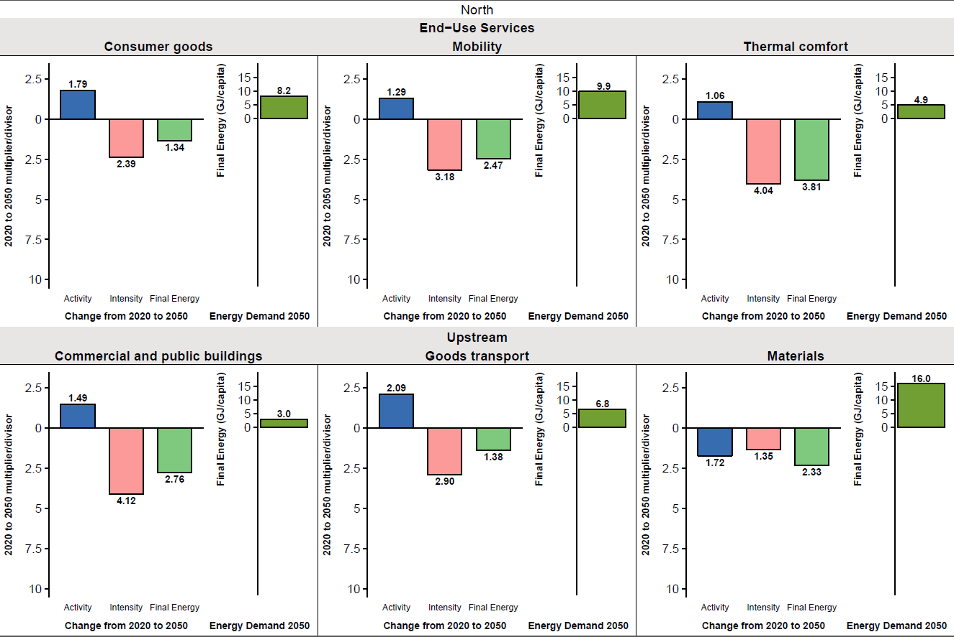

***Figure SI-5-2. Decomposition analysis of determinants of LED energy demand for end-use services and upstream sectors, Global North.*** *Changes 2020-2050 in activity, energy intensity, final energy demand (variable multiplier, left axis) and resulting per capita final energy demand (GJ/capita, right scale axis). Note that decomposition is represented by variable multipliers with direction of change also shown. The multipliers are not additive. For global results see Figure 3 in the main text.*

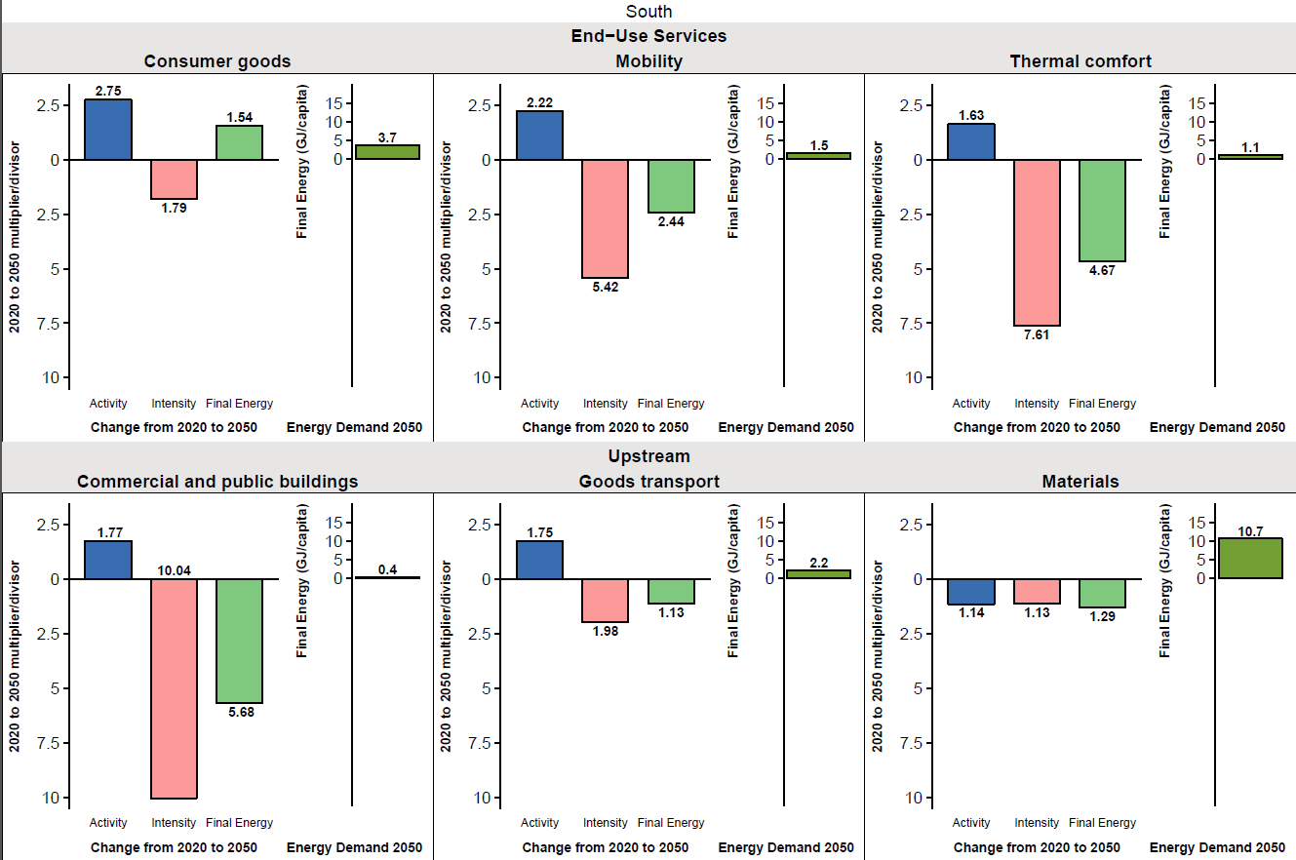

***Figure SI-5-3. Decomposition analysis of determinants of LED energy demand for end-use services and upstream sectors, Global South.*** *Changes 2020-2050 in activity, energy intensity, final energy demand (variable multiplier, left axis) and resulting per capita final energy demand (GJ/capita, right scale axis). Note that decomposition is represented by variable multipliers with direction of change also shown. The multipliers are not additive. For global results see Figure 3 in the main text.*

**Supporting Information 6 (SI-6). Supply-Side Transformations.**

The main text summarises how the LED scenario narrative maps onto changes in the energy supply, and how the MESSAGE-GLOBIOM modelling framework interprets these changes to generate quantitative transformation pathways. Here we provide:

* additional notes on the LED scenario narrative as it translates to supply-side transformations as input for the MESSAGE modelling framework;
* additional results on the transformation of primary, secondary and final energy, energy sector conversion efficiency and carbon management technology deployment in the literature (zero in LED).
* discussion of investment costs in energy end-use technologies;
* regional disaggregation of results shown in the main text;
* additional results and discussion on food production and land use change from the GLOBIOM model

**Additional notes on the LED scenario narrative related to Supply Side Transformations**

**Inputs to MESSAGE**

For the upstream energy supply implications of LED we have used the IIASA MESSAGE model (see Methods section). Here we summarize the main input parametrizations of MESSAGE that drive the supply-side transformations in LED.

**Base parametrization: SSP2**As discussed in the Methods section, we have maintained the MESSAGE SSP2 parametrizations unless specified otherwise. The reason for this lies in the fact that we wanted the LED scenario maintain its energy demand and efficiency focus and not draw attention away by making more extreme supply-side scenario assumptions. SSP2’s “Middle of the Road” characteristics thus serve as a most useful reference. As outlined in the Method section, overall scenario drivers such as population and economic growth, resource availability and potentials were kept at their respective SSP2 ranges and are available online: <https://tntcat.iiasa.ac.at/SspDb/>.

**LED parametrizations:**LEDs supply side transformations are driven are driven by three groups of interdependent variables: (low) energy demand (see main text and SI-2 TO SI-5), a stringent climate constraint aimed at meeting the 1.5 °C target (that translates into cumulative emissions below 390 Gt CO2 over 2020-2100), as well as the technology options available in LED.

Foremost, LEDs supply-side transformation is strongly shaped by the LED normative assumption that negative emissions technologies and CCS (Carbon Capture and Storage) technologies would not be available (due e.g. to innovation failure, unacceptable investment risks, public opposition, or a combination thereof). Combined with a stringent climate constraint, this drives fossil fuels and technologies out of the market. For the post-fossil technologies we have not made comparable stringent assumptions, basically allowing in principle a wide, and diverse post-fossil technology portfolio (renewables but also nuclear). But the model is guided in its technology choice by the overall LED scenario narrative.

The LED scenario emphasises energy-supply technologies that offer two distinct different features compared to traditional fossil fuel technologies: granularity and economies of scope.

Granular (small unit-scale) technologies are scalable across a variety of application scales (from household all the way up to utility-scale levels), are modular and serial and hence can benefit from significant learning and manufacturing scale economies that lead to drastic cost reductions and widening of application potentials. PV cells but also wind turbines are classical examples of such granular technologies, as are fuel cells or hydrogen electrolysers.

Economies of scope technologies such as like batteries and fuel cells are those that find multiple applications, providing “bundled” energy services, e.g. when integrated in cars, in stationary residential applications, or in distributed urban district-scale systems. Economies of scope provide via multiple-outputs economic benefits and also offer significant potentials for technology spillover effects across sectors and applications. Conversely, conventional single-purpose technologies lose consumer appeal and are at a technological and economic disadvantage in LED. As examples, gas boilers and owned vehicles see their relative cost advantage offset by end-user preferences for heat pumps and mobility-as-a-service which offer flexibility, multiple functionality, and convenience.

Despite a clear overall trend towards granularity and decentralisation, large-scale forms of energy supply continue to play important roles particularly in serving large urban centres in the Global South. This includes nuclear, emphasising standardised replicable designs as well as modularity, and biorefineries for substituting petrochemical feedstocks and some liquid transportation fuels (e.g., aviation).

The technology portfolio choice in MESSAGE is informed by modifying particular granular and economies-of-scope technologies for the LED scenario (Table SI-6-1) whose stationary cost trends in the original SSP2 scenario was judged non-compliant with the LED scenario storyline. All other technologies not listed in Table SI-6-1 have been retained at their original (quite conservative) SSP2 values (e.g. for the year 2050: wind 500 $/kW, nuclear 2600 $/kW, biomass power plants 1200 $/kW, etc.), an assumption in line with keeping LEDs emphasis on efficiency and demand, and granular, decentralized supply options and new organizational IT and digital economy models of combining supply and demand, e.g. in grid-to-vehicles but also vehicles-to-grids options or other distributed storage options (e.g. hydrogen based).

***Table SI-6-1. LED-scenario specific cost assumptions for granular technologies for MESSAGE supply-side transformation analysis (specific investment costs in US$2010 per kW installed).***



|  |
| --- |
| Notes: PV: short-term: based on Haegel et al.63 high deployment scenario; medium- and long-term: assuming 20% learning rate applied to IEA`s ETP 201716 B2D scenario deployment rate |
| batteries: short-term: EPA TAG 201664 (for 100%EV scenario), medium- and long-term: assuming cost reductions of 3.5%/year (manufacturing scale economies and design improvements) |
| fuel cells: short-term, extrapolation of Japanese residential program cost assuming 15% learning rate and global market growth to 10 million units by 2030 using Wei et al.65 costing model |
| electrolysis: short-term: SSP2 scenario, medium- and long-term: assuming a cost decline of 1.6 %/year (manufacturing scale economies) |
| solar direct: short-term costs from IEA-ETSAP & IRENA66, medium-term costs based on IEA-ETSAP & IRENA66 best performing to average cost ratio |

**Additional results on the transformation of primary, secondary and final energy**

**End-use Transformations driving Supply Transformation**  
The fundamental transformations in energy end-use and its supporting infrastructures in the LED scenario lead to a structural shift towards “hydricity”67, a combination of electricity and hydrogen that serve as the main energy carriers to bridge changing energy demand to available energy resources. The supply-side energy system in the LED scenario is characterized by a combination of flexible, variable renewables like solar and wind, and hydrogen. Their expansion is driven by the granularity and scalability of these technology options, and resulting rapid cost declines and spillover effects. Combined with an emphasis in the LED scenario narrative on environmental quality across all scales from local air pollution to global climate change, the energy-supply system is most prominently characterized by a shift away from fossil-energy carriers (Figure SI-6-1, panel a). However, all final energy carriers are generated in very different ways from today (Figure SI-6-1, panel b-d).

By mid-century, no more electricity is produced from fossil energy; the contribution of coal disappears by 2040 (Figure SI-6-1, panel b). In favouring granular technologies, decentralized energy provision and digitalization, the LED scenario allows the share of electricity produced from renewable sources to more than triple between 2020 and 2050. By 2050, roughly 85% of electricity production is supplied by hydro, wind and solar, with the remainder being covered by nuclear. The high power density and base-load characteristic of nuclear plants makes them a valuable asset supplying energy to large concentrations of energy demand in urban centres. But the technology is at a crossroads: in the near-term lifetime extensions of existing reactors and completion of already commissioned projects can maintain this traditional technology option even in the LED scenario's rapidly modernizing energy-supply system. But over the longer-term the nuclear option is only reconcilable with the LED scenario narrative under assumptions of highly standardized, reduced-complexity modular reactor designs. Should these not materialize, nuclear might turn out to be a transitional technology, ultimately replaced by renewable electricity.

Due to the low demand characteristics of the LED scenarios, the expansion rates of renewable supply options in fact is more gradual and organic, compared to the recent past which has seen a strong policy-induced demand-pull. PV and wind turbine output increased on average well above 20%/year (decadal averages over 1996 to 2006, and 2006 to 2016, ranged between 22 to 50 %/year for wind and solar PV respectively, source: BP, 2017), compared to short-term (to 2030) expansion rates of 10-16 %/year (wind and solar PV respectively) in LED that decline thereafter to 5 %/year (2030-2040), and 2-3 %/year (2040-2050). However, due to the low (and declining) demand characteristics of the LED scenario, even these comparatively modest growth rates for renewable electricity translate into a substantial and rapid transformation of energy systems. The share of solar PV and wind in primary energy (and using the conservative direct equivalence primary accounting convention which we have preferred for the LED scenario) increases from some 4% of primary energy in 2020 to almost 50 (48%) percent by 2050, ultimately to approach 60% share in primary energy (direct equivalence method) towards the end of the 21st Century.

Alongside its strong emphasis on electrification, the LED scenario also sees roles for hydrogen and liquids generation in the energy supply. In the initial stages of its deployment, hydrogen is produced from fossil energy carriers. By mid-century, hydrogen accounts for about 5% of final energy, with about three quarters produced with electricity, increasing to virtually 100% one to two decades later (Figure SI-6-1, panel c). For the production of liquid final energy carriers, biomass plays the most prominent role. Although fossil energy carriers dominate today in the liquids sector, biomass covers 25% of the global demand for liquids by mid-century, increasing to 95% by 2100 (Fig. SI-6-1, panel d).

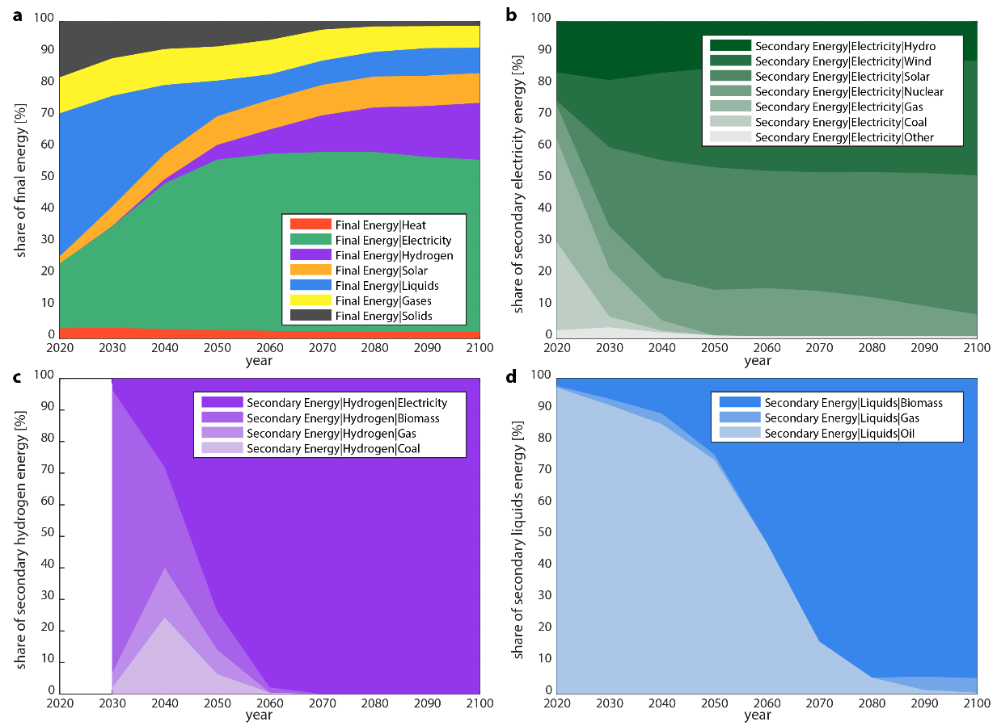

***Figure SI-6-1. Structural change in the energy supply in the LED scenario.******a****, structure of final energy over the 21st century;* ***b-d****, structural change of primary energy per secondary energy carrier for electricity (panel* ***b****), hydrogen (panel* ***c****), and liquids (panel* ***d****). Relative shares for hydrogen are reported from 2030 onward as its contribution only appears by 2030. The “Other” category in panel* ***b*** *covers oil, geothermal, and biomass.*

Shifts in the energy-system cascade from primary to secondary (carriers) to final and then useful energy also translate into shifts in the efficiency of the respective system parts. The widespread electrification of final energy is anticipated to increase the efficiency of final to useful energy conversion. At the same time, a reduction in primary to final energy efficiency is anticipated due to the conversion deepening of the supply system, i.e. energy carriers are more profoundly and pervasively converted into cleaner and more flexible forms of energy like electricity or hydrogen. Nevertheless, the primary to final energy conversion efficiency in the LED scenario is still at the high end of the range of supply-side driven stringent mitigation scenarios (Figure SI-6-2). In part this indicates that energy losses are not as pervasive as might be assumed. However it is also in part a known artefact of energy accounting methods because ambient energy that is used in heat pumps is added to the system, but is not part of the primary energy accounting balance.

The whole-system transformations of the LED scenario (from primary to useful energy) provide overall efficiency gains, since demand-side efficiency gains are far stronger than the minor efficiency losses in the supply systems.

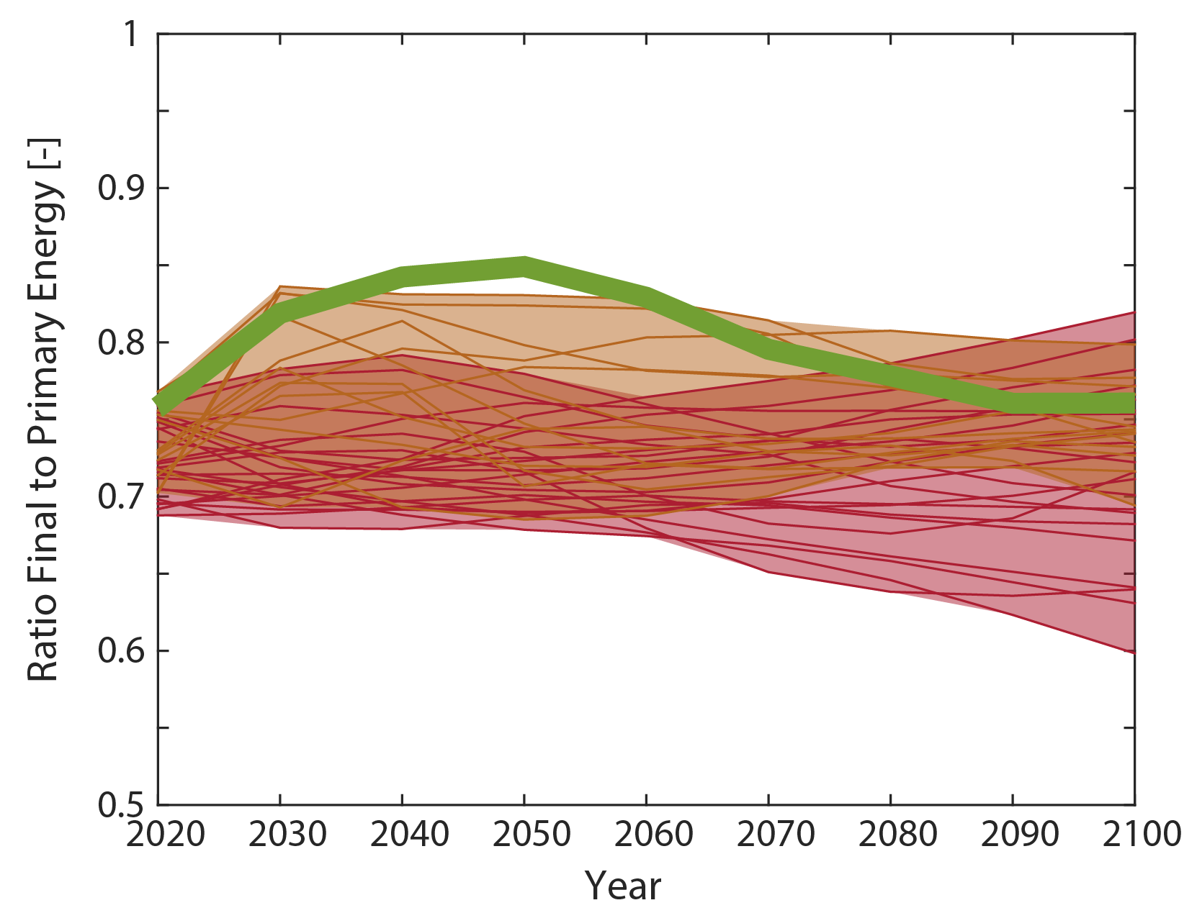

***Figure SI-6-2. Primary to final energy conversion efficiency in the LED scenario.*** *Comparison of the LED scenario (green) with SSP baselines13 (red) and SSP 1.9 W/m2 scenarios68 (orange). The dashed light-blue line shows the whole-system efficiency of the LED scenario, from primary to useful energy.*

**Carbon management in the LED scenario**

Stringent mitigation scenarios are typically characterized by large volumes of residual flows of CO2 which require management, in particular flows of captured CO2 which need to be transported and stored for carbon capture and storage (CCS) and bioenergy with CCS (BECCS) (Figure SI-6-3). The LED scenario eliminates the deployment of CCS and BECCS and reduces the volume of CO2 that is still produced in 2050 by roughly a factor 4 compared to traditional 1.5°C-consistent scenarios (Figure SI-6-3, panel a). This leads to significantly lower risks of carbon leakage and lower exposure to future innovation or deployment failure for these largely unproven technologies.

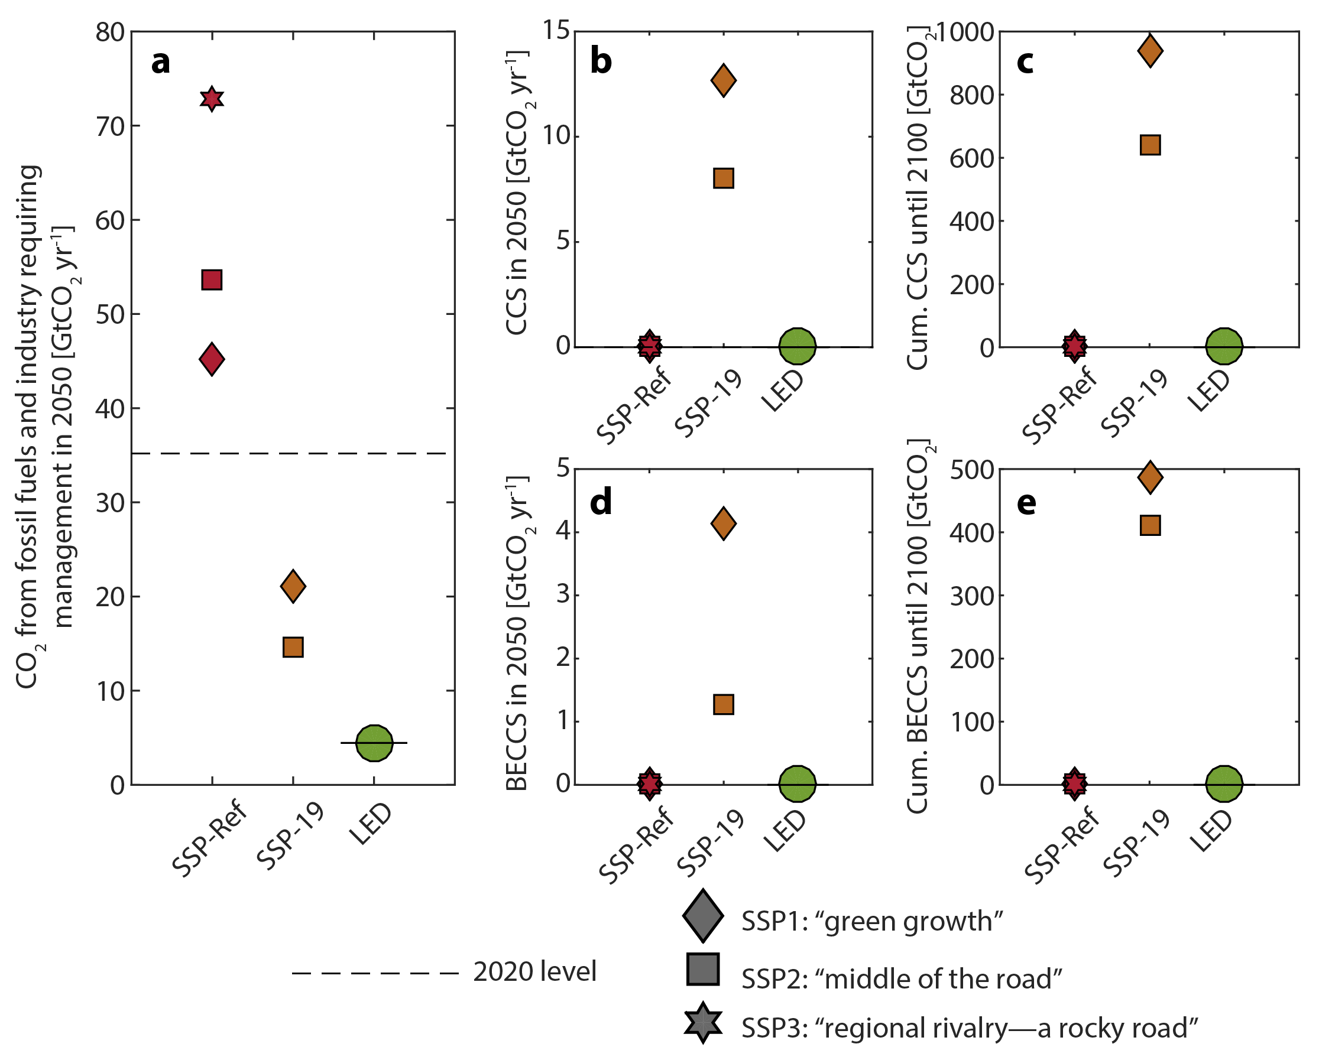

***Figure SI-6-3. Carbon management in the LED scenario.******a****, the volume of annual CO2 emissions requiring management in 2050;* ***b****, annual amount of CO2 sequestered by CCS in 2050;* ***c****, cumulative amount of CO2 sequestered by CCS from 2020 to 2100;* ***d****, annual amount of CO2 sequestered by BECCS in 2050;* ***e****, cumulative amount of CO2 sequestered by BECCS from 2020 to 2100. Note that the LED scenario deploys neither BECCS nor CCS. The LED scenario is shown in green, SSP baselines13 in red and SSP 1.9 W/m2 scenarios68 in orange. Box plots show the minimum-maximum and interquartile range, as well as the median. Small circles show single scenario results. The dashed line shows the 2020 value.*

Figure SI-6-4 complements Figure SI-6-3 in providing temporal profiles of various CO2 emission categories between LED and the SSP2-1.9 scenario.

The strong energy demand reductions in the LED scenario, allow it to reduce the total amount of CO2 produced in the economy until mid-century much more rapidly compared to more supply-side driven scenarios such as in SSP2-1.9 (Figure SI-6-4). For example, by 2050, the LED scenario manages to reduce the total amount of CO2 produced in the economy to roughly a tenth of its level in 2020 (i.e. a 90% reduction, Figure SI-6-4, panel a, thick black line). In contrast, the SSP2-1.9 scenario reduces the total amount of CO2 produced by its economy by about 60% in 2050, relative to 2020 (Figure SI-6-4, panel b). Both scenarios achieve net zero CO2 emissions shortly before 2060 (light blue lines in Figure SI-6-4). However, the SSP2-1.9 scenario relies on carbon capture and storage (CCS) to either abate some of the fossil fuel and industry CO2 emissions before being vented into the atmosphere (hatched area in Figure SI-6-4, panel b), or to offset the residual emissions through CO2 removal by negative emissions from Agriculture, Forestry, and Other Land Use (AFOLU) and bioenergy combined with CCS (BECCS). Further into the future, during the second half of the century, the global CO2 system configurations develop dramatically differently. The SSP2-1.9 scenario relies on large-scale deployment of BECCS to neutralise residual gross CO2 emissions, and to compensate for the excess in cumulative CO2 emissions emitted before the time of carbon neutrality. The LED scenario, on the contrary, allows gross CO2 emissions from fossil fuel and industry use to be close to zero in the latter half of this century. This allows the achievement of net CO2 removal without the application of BECCS or CCS.

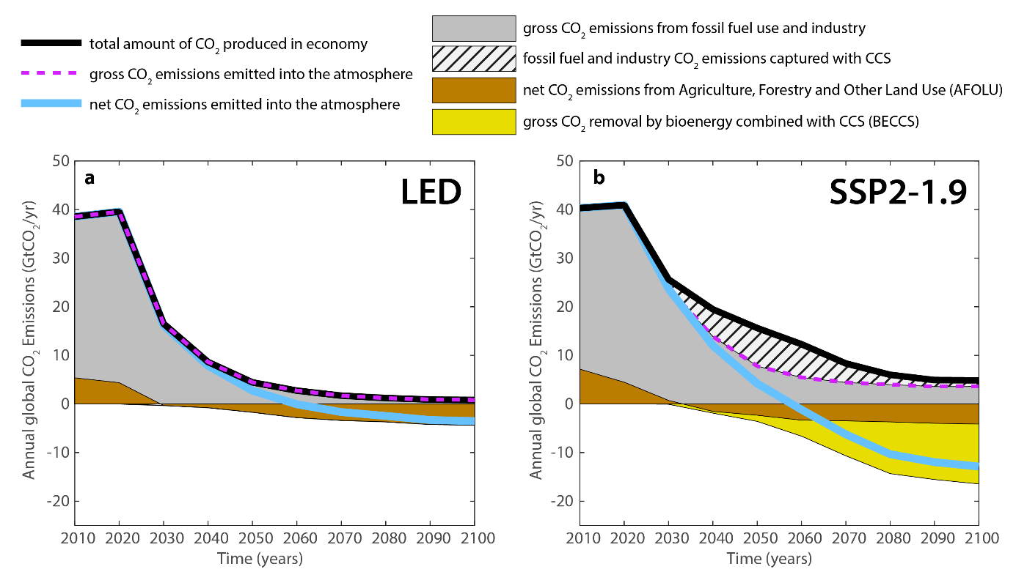

***Figure XXX | Evolution of global CO2 emission contributions over time.*** *Evolutions are shown for the LED scenario (panel* ***a****) and the MESSAGE-GLOBIOM SSP2-1.9 scenario (panel* ***b****). Note that although net global CO2 emissions reach zero roughly at the same time in both scenarios (light blue line), this point is achieved two contrasting strategies in the respective scenarios. LED achieves emissions reductions until carbon neutrality through a rapid near-term decline of the total amount of CO2 produced in the economy (thick black line), offset by a limited contribution of AFOLU removal. The SSP2-1.9 scenario, reduces the total amount of CO2 produced in the economy much less, and instead requires carbon capture and storage (CCS) to both reduce CO2 emissions from fossil fuel and industry (hatched area), and offset a large part of the emissions through BECCS.*

**Cost 1: Shadow Prices of Carbon**The fact that the MESSAGE model used for quantification of LEDs upstream supply implications is a linear programming model enables to directly quantify the cost of imposing the cumulative carbon constraint introduced for meeting the 1.5 °C target in LED, i.e. so-called carbon shadow prices (which in general equilibrium models –which MESSAGE is not-- equate to carbon taxes).

Carbon shadow prices from the MESSAGE-GLOBIOM model are 90 US$2010/tonne CO2 in 2030 rising to 160 US$/tCO2 by 2050 (and some 700 $ by 2100) in the LED scenario (all numbers rounded). This compares to a range of 60-400 US$/tCO2 (always SSP2 and SSP1 respectively, numbers rounded) by 2030, and to 1000-3700 US$/tCO2 by 2050 and (carbon shadow prices above 104 US$ by 2100) in the SSP2-1.9 and SSP1-1.9 scenarios68 that were developed with the same model as LED.In this comparison however, one must consider that differences in discount rates. For the LED scenario and consistent with the scenario narrative and storyline we have used 3%, whereas in the SSP scenario exercise a discount rate of 5% was used. Using a lower discount rate, increases carbon shadow prices in the near term (2030) but lowers them in the long-term (towards 2100), thus shifting transitions to earlier time periods. The use of an appropriate discount rate thus is an important scenario assumption beyond “technical detail”. We contend that much of the slow transitions portrayed in long-term scenario studies and mitigation analysis also arises from discount rate choices (see also Grubler & Messner69) that remain as critical as ever.

**Cost 2:Supply-side Investment costs in LED**

LEDs supply-side transformation also implies investment costs in 2050 at a level roughly similar to today's one trillion US$ per year (equivalent to a 40% decrease relative to GDP). In contrast, other 1.5°C scenarios require annual energy-supply investments two to three times above current levels (SI-6-5 panels a, b). With available data it is not possible to provide similar estimates of incremental investment costs in energy end-use (see next Section for a discussion).

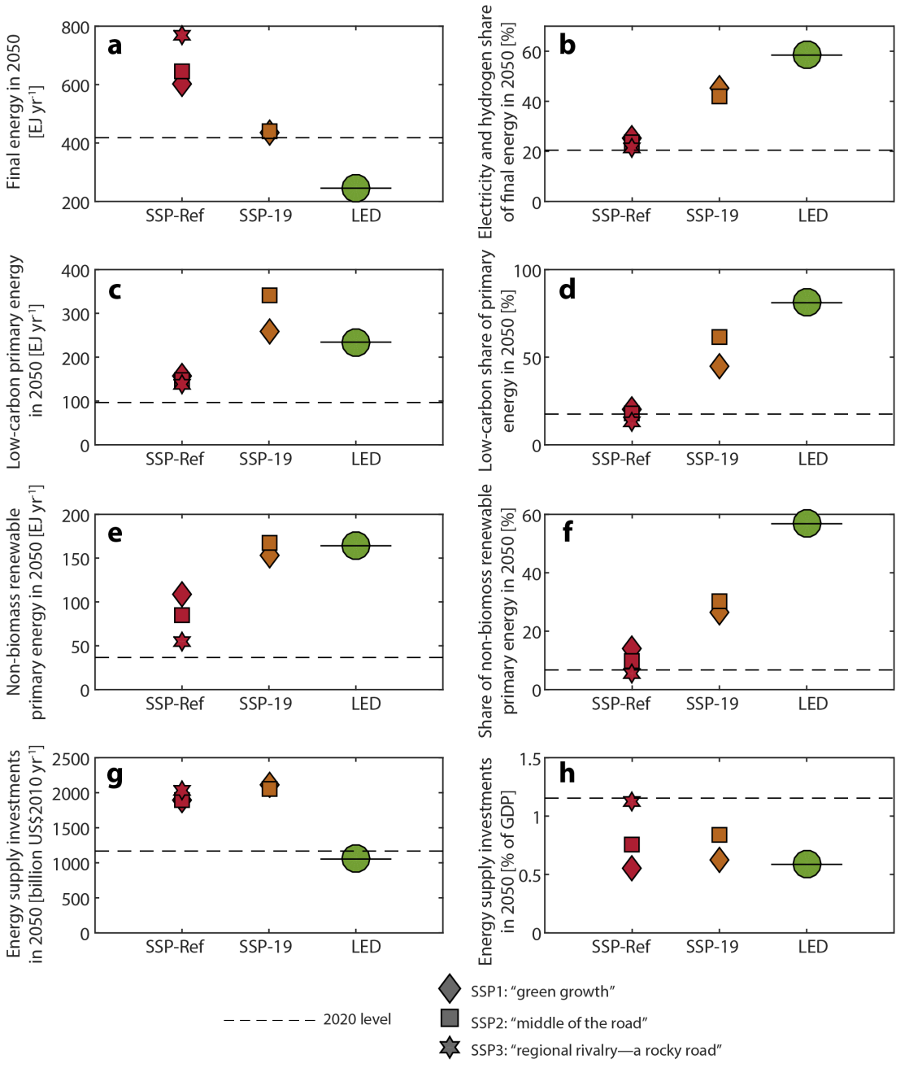

***Figure SI-6-5. Supply-side investments in LED in comparison to mitigation scenarios.  
a*** *investments in 2050 (billion US$2010);* ***b*** *2050 supply-side investments as percent of GDP.  
For definition of scenarios see Figure SI-6-3 above.*

**Discussion of investment costs in energy end-use technologies**

Above we provided quantitative estimates of energy-supply investments in the LED and other scenarios. Data limitations and methodological complexities prevent analogous estimates of end-use investments associated with the LED scenario. The difficulties of quantifying total end-use investments is discussed in detail in Wilson and Grubler70. Unlike upstream energy-conversion technologies providing a largely homogenous output (electrons, gasoline), energy end-use technologies like buildings or vehicles provide multiple functionalities beyond their narrow energy service (thermal comfort, mobility). Allocating end-use investments to different subcomponents or sub-functionalities is problematic at best, and not possible for organizational and behavioural changes associated with improvements in energy-service efficiencies (e.g., increased capacity factors of vehicles in shared or autonomous vehicle fleets).

However, the supply-side investment savings of the LED scenario compared to high demand, supply-side dominated mitigation scenarios are around 1 to 2 trillion US$/year. To put this into context, energy-end use investments were estimated in the Global Energy Assessment41 to range from 300 billion to 3 trillion US$ per year (for 2005, the latest year for which an estimate was possible based on available data)71. The wide range reflects uncertainty in where to draw the system boundary between the energy service and the other functionality of end-use devices: around energy-conversion devices (US$ 300 billion/year) or also including the passive systems which combine with these devices to provide useful services (US$ 3 trillion/year).

Depending on these system boundaries, the supply-side investment savings in the LED scenario (relative to other stringent mitigation scenarios) correspond to two-thirds to seven-fold of current demand-side investments. The extent to which these savings can potentially help finance demand side transformation in the LED scenario is an important area for further research.

**Regional disaggregation of results shown in the main text**

Energy services in the LED scenario are aggregated into three end-use sectors (transport, industry, buildings and other) to allow comparison with available historical final energy data15 (see also discussion in SI-5 above) and the scenario literature. Analogous to Figure 4 in the Main text, Figure SI-6-6 and SI-6-7 show regionalized results for the LED scenario for our two macro-regions.

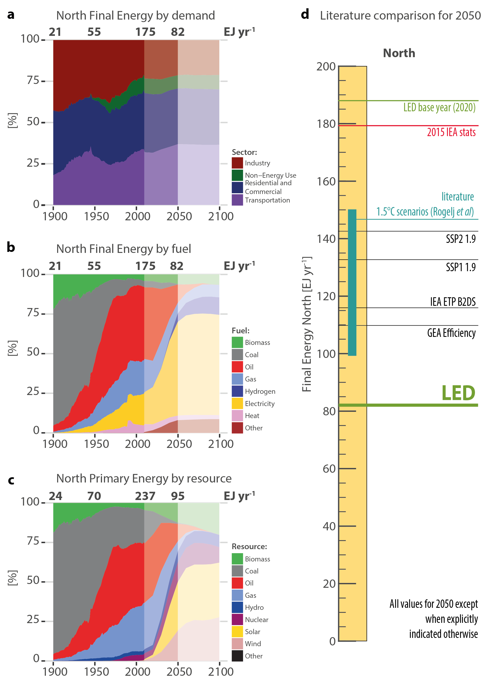

***Figure SI-6-6. LED scenario in historical context and in comparison to the literature, Global North.*** *Structural change in final energy shares by sector (****panel a****), final energy shares by fuel (****panel b****), and primary energy shares (****panel c****), historical data (to 2014), LED scenario to 2050 (light shade) and simplified scenario extension post 2050 (stronger shade) used for calculating climate change outcomes. For information absolute levels of historical final and primary energy are indicated for key years on top of panels a, b, and c.* ***Panel d:*** *LED 2050 final energy demand (in EJ) compared to 2015 statistics, LED 2020 base year, and comparable scenarios with stringent climate mitigation for the year 2050. For explanation of scenarios see Figure 4 in Main text.*

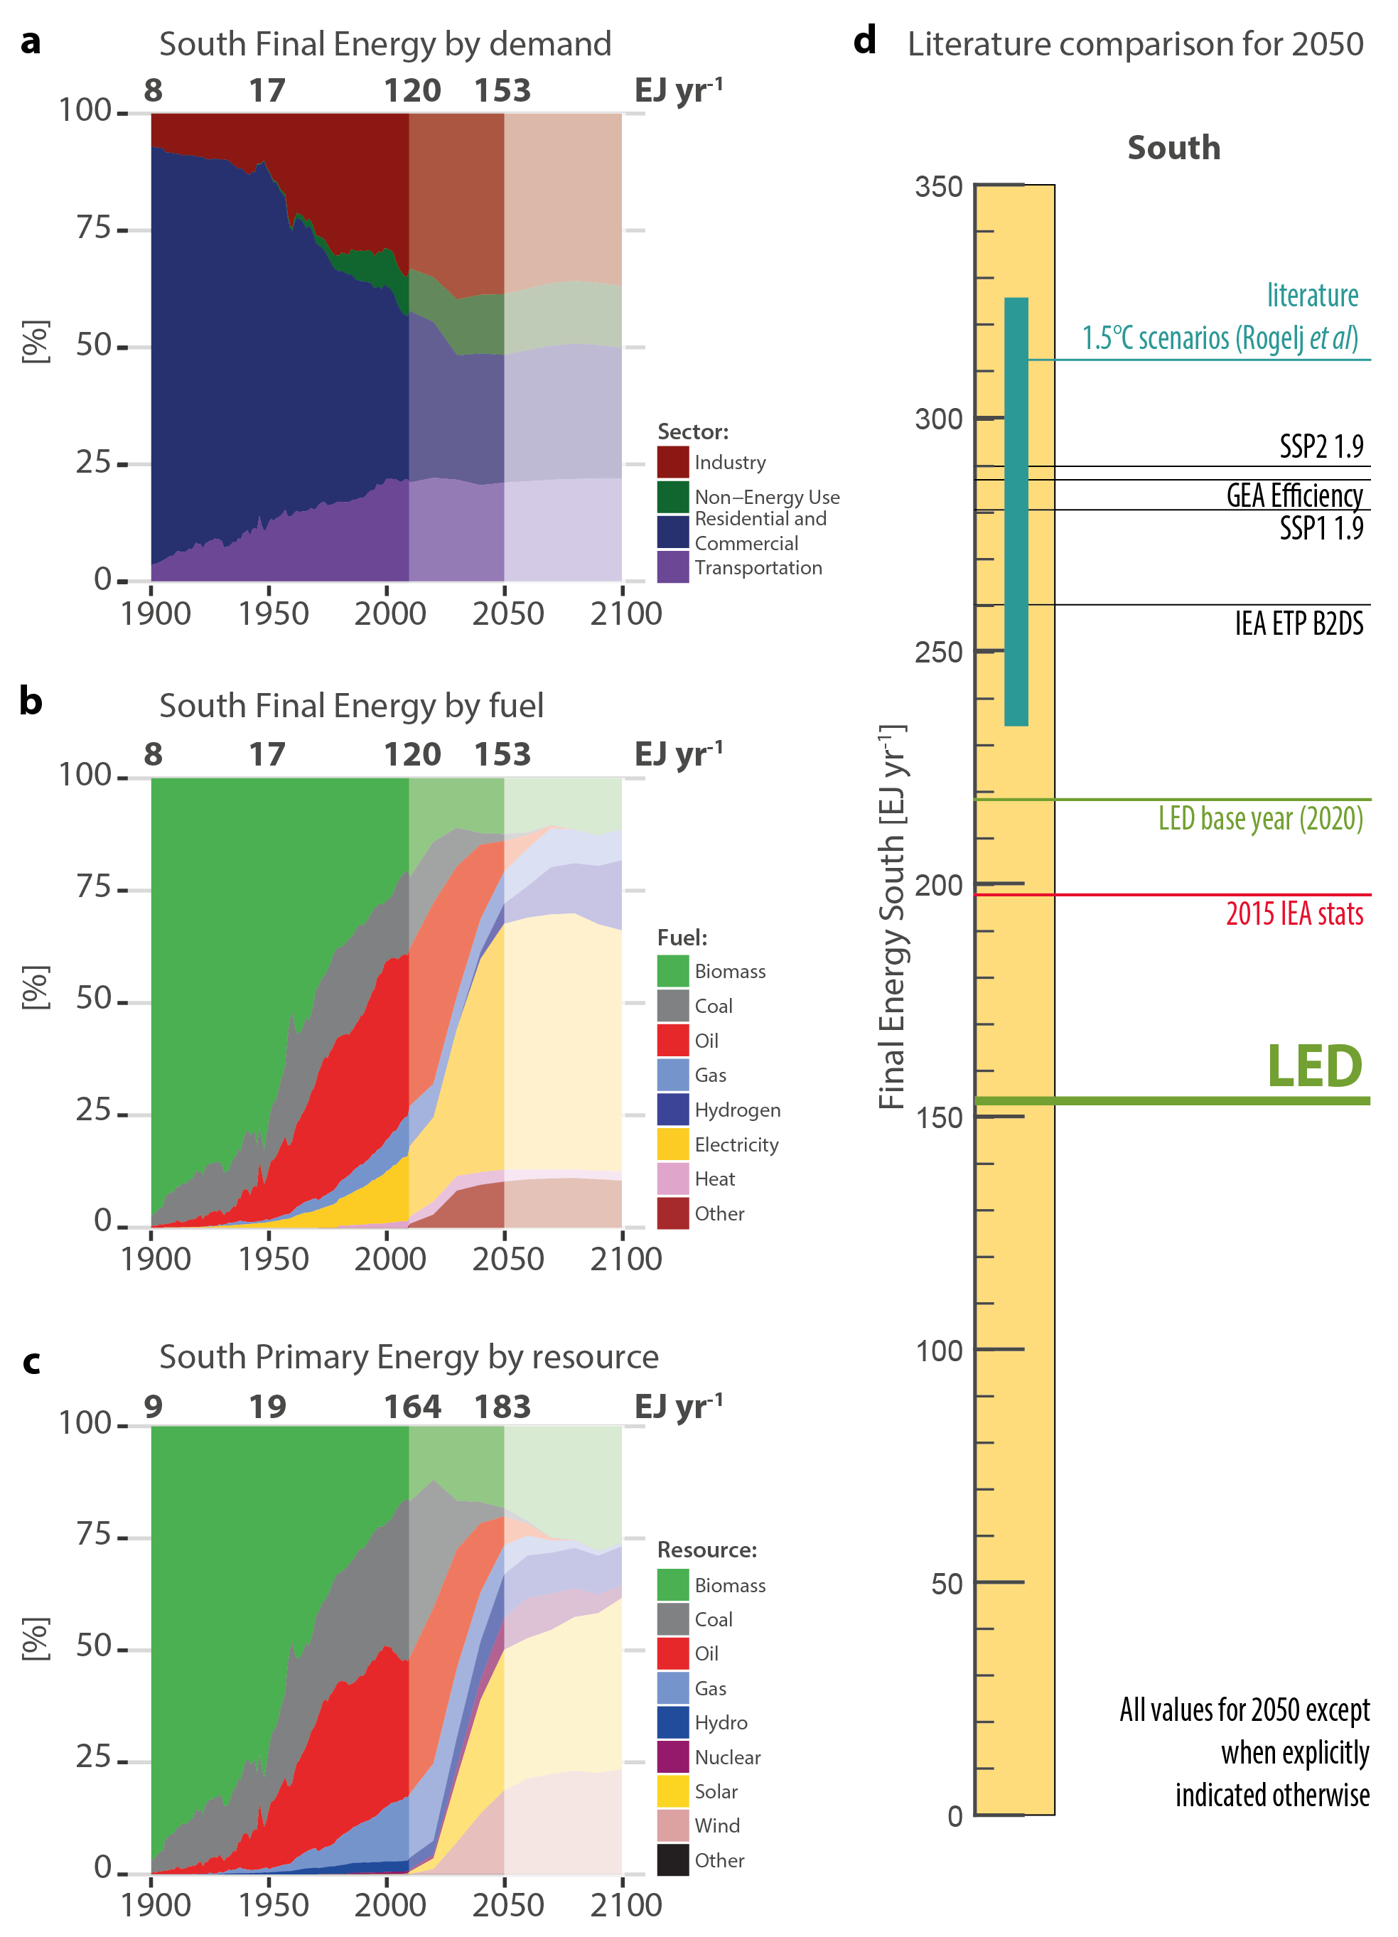

***Figure SI-6-7. LED scenario in historical context and in comparison to the literature, Global South.*** *Structural change in final energy shares by sector (****panel a****), final energy shares by fuel (****panel b****), and primary energy shares (****panel c****), historical data (to 2014), LED scenario to 2050 (light shade) and simplified scenario extension post 2050 (stronger shade) used for calculating climate change outcomes. For information absolute levels of historical final and primary energy are indicated for key years on top of panels a, b, and c.* ***Panel d:*** *LED 2050 final energy demand (in EJ) compared to 2015 statistics, LED 2020 base year, and comparable scenarios with stringent climate mitigation for the year 2050. For explanation of scenarios see Figure 4 in Main text.*

Figure SI-6-8 below also reports regional results for our consistency check of LEDs structural change in final energy structure compared to historical energy transitions for our two macro-regions analogous to Figure 5 in the main text. These transitions have first been described using a simple formal model of market substitution by Marchetti and Nakicenovic72 drawing on the technological change literature where product or technology substitution73 have been found to proceed along S-shaped market share curves, formalized by a set of coupled logistic equations akin to the generalized Lotka-Volterra interspecies competition equations in biology74.

Instead of traditional analyses focussing on fuel shares (e.g. coal versus electricity), we analyse the transition in final energy structure by aggregating the different final energy forms into the three major sources of energy release: oxidation of carbon into CO2, oxidation of hydrogen to H2O, and lastly energy provided by electrons (electricity, where we also include the relatively smaller amounts of direct heat in final energy, from district heating grids or on-site solar thermal) (see also main text). This aggregation serves to simplify the exposition of the historical energy end-use transitions (moving from up to 10 different final energy carriers to just three processes) and also reflects the increasing exergetic quality in historical and future transitions from pre-industrial direct combustion of biomass (H:C ratio of 1:10) all the way to “hydricity” and electricity.

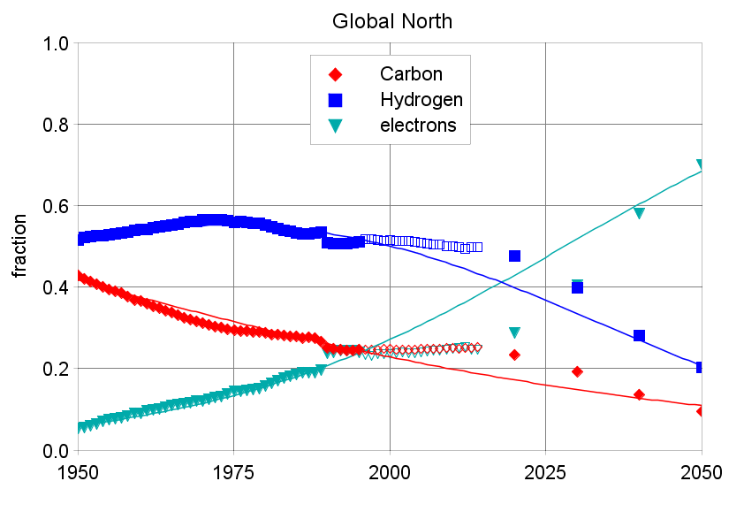

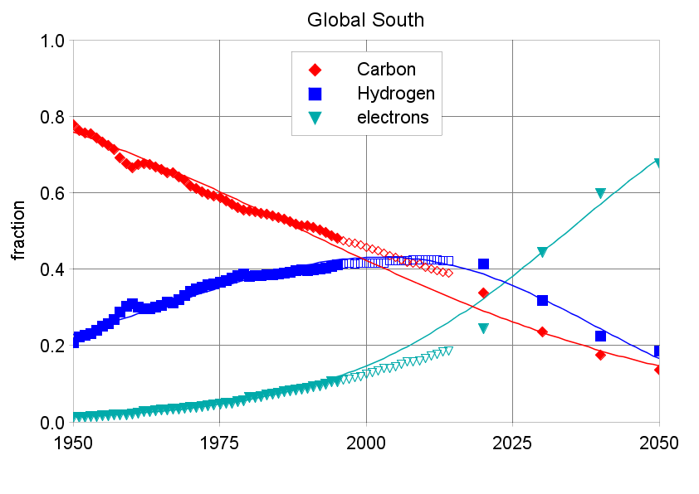

***Figure SI-6-8. Dynamics of change in final energy structure historically and in the LED scenario in the Global North (panel a) and Global South (panel b).*** *Notes: Fractional shares of final energy provided by (oxidation of) carbon (C), hydrogen (H), and electrons (e) in electricity also including direct uses of heat. Hydrocarbon fuels are allocated to the respective Carbon and hydrogen fractions of fuels are allocated based on stoichiometric hydrogen-carbon ratios (e.g. 4:1 in case of methane, CH4) applied to energy contents using lower heating values (LHV). Symbols represent historical (1950 to 2015) and LED scenario data (2020, 2030, 2040, 2050). Lines represent logistic substitution curves fitted to 1900-1995 historical data and 2020-2050 LED scenario data (shaded symbols) omitting the 1995-2015 stagnation in observable structural change (unshaded symbols).*

**Additional Results Sustainable food and biomass**

The foundation of a good quality of life is good health, which also relies on adequate and appropriate nutrition. In the Global South, 815 million people are still currently undernourished by inadequate calorie intake (FAO et al., 2017). In contrast, excess calories from unhealthy foods have increased the risk of chronic diseases from obesity in industrialized countries and increasingly among the affluent population segments in developing economies as well. Food demand is globally expected to increase by 70 to 100 percent by 2050 (Valin et al, 2014), however food security does not only rely on food supply but also on adequate food access, distribution and use.

The LED scenario combines production intensification and evolution of diets towards nutritious food with lower GHG emission footprints. On the demand side, concerns about healthy living lead to only moderate increases in daily calorific intake. On the supply side, crop and livestock production yields are expected to continue their historical trends, reflecting the current prospects on research, development and technology adoption. The impact of climate change is also significantly mitigated in the LED scenario that limits global warming below 1.5 degrees above pre-industrial levels. Deforestation rates in LED are progressively reduced through more active policies of land protection and carbon pricing. All these changes are captured through the GLOBIOM modelling framework (Havlik et al., 2011, 2014) quantification of the LED scenario.

**Healthy and low carbon impact diets**

We follow in the LED scenario diets transition that reflect economic growth and preferences of consumers for higher standard food products. Diet preference shifts for GLOBIOM are based on the standard SSP2 assumptions (Valin et al., 2013, Fricko et al. 2016). These assume a continuation of the historical trends in terms of overall dietary transitions, in line with other projections from FAO (Bruisma and Alexandratos, 2012). In particular, only moderate westernisation of diets is observed in the developing world, and consumption of animal products remain notably low in India. In all regions, consumer awareness mixed with climate policy incentives also influence the composition of diets at the product level, with less rice and red meat consumption (see Frank et al., 2017).

Table SI-3d-1 summarizes LEDs main trends in food consumption. By 2050, average daily calorie intake in the Global South (GS) increases to over 3,000 kcal, implying that food availability issues are solved. In the Global North (GN), daily intake does not exceed 3,500 kcal, and meat consumption stays relatively constant despite increasing economic growth, reflecting a change in consumption habits. Economic growth, end of undernourishment and better nutrition leads to an increase in kilocalories in the South, including for animal product calories but consumption of red meat remains low. This is due to change in consumer awareness but also to carbon taxes on the most GHG emission intensive products. A food consumption constraint is implemented in the model to ensure that these products are substituted with other food items without health impacts.

**Table SI-3d-1: Food consumption in the LED scenario.**

|  |  |  |  |  |  |  |
| --- | --- | --- | --- | --- | --- | --- |
|  | **2020** | | **2050** | | **2100** | |
|  | **GN** | **GS** | **GN** | **GS** | **GN** | **GS** |
| **Total kCal per day per capita** | 3298 | 2768 | 3366 | 3082 | 3483 | 3400 |
| **Total meat (g) per day** | 335 | 167 | 349 | 227 | 367 | 315 |
| **Ruminant meat (g) per day** | 89 | 43 | 83 | 41 | 75 | 46 |

Note: based on 1400 kcal/kg of meat.

The mitigation potential of dietary changes towards lower meat consumption has been well-explored (Creutzig et al, 2016) and documented as uncertain but significant by the IPCC (Smith et al, 2014). Perspectives on the extent to which mitigation potentials depend on dietary changes hinge on researchers’ expectation of the potential to sustainably intensify agricultural production. For instance, Havlik et al. (2014) rely almost exclusively on ambitious intensification of livestock production. Conversely, Bajželj et al. (2014) demonstrate the mitigation potentials in several healthy diet scenarios that include reductions in livestock products consumption in high-income countries.

**Yield development**

The LED scenario also relies on land and feed conversion productivity increase to reduce the dependency on natural resources in line with the “grand restoration” narrative of the LED scenario storyline. Technological change for crops is based on 18 crop specific yield response functions, pegged to GDP per capita growth and estimated for different income groups using a fixed effects model. The response to GDP per capita was differentiated over four income groups oriented at World Bank’s income classification system (<1.500, 1.500-4.000, 4.000-10.000, >10.000 USD GDP per capita). Country level yield data was provided from FAOSTAT while GDP per capita was based on World Bank data (1980-2009). Fertilizer use and costs of agricultural production increase in proportion with yields. Productivity changes through technological change in the livestock sector and transition towards more efficient livestock production systems takes place in line with historic trends.

The productivity trends associated to the LED scenario are summarized below in Table SI-3d-2.

**Table SI-3d-2: Crop yield change in the LED scenario compared to 2010 (2010 =1)**.

|  |  |  |  |  |
| --- | --- | --- | --- | --- |
|  |  | **2020** | **2050** | **2100** |
| **Crop sector** | Wheat | 1.12 | 1.55 | 1.98 |
|  | Rice | 1.14 | 1.47 | 1.76 |
|  | Coarse grains | 1.15 | 1.71 | 2.26 |
|  | Oilseeds | 1.18 | 1.64 | 2.02 |
|  | Sugar crops | 1.14 | 1.67 | 2.19 |

**Biomass supply for bioenergy**

More sustainable land resource demand patterns are not limited to agricultural products but also apply to biomass provision in general. BECCS are excluded from the LED scenarios, but land still contributes slightly to the mitigation efforts as a source of biogenic carbon to substitute fossil fuel. By the end of the century, 206 million hectares are devoted globally to bioenergy plantations. This is however much slower level than with a scenario with BECCS (Fricko et al., 2016) where the contribution of bioenergy reaches 750 Mha. The effect is notably alleviated by 2050, where plantations do not exceed 81 million ha, versus 283 Mha under a typical SSP- 1.9 scenario.

As a consequence of low bioenergy provision, and lower pressure on land from the food sector, future society needs can here be achieved without endangering natural ecosystems. As illustrated in Table SI-3d-2, both areas of natural forest and other natural land increase in the LED scenario, which in additional to carbon sequestration benefits through more vegetation regrowth also implies higher levels of biodiversity protection.

**Table SI-3d-3: Main non-agricultural land use categories in the LED scenario (Mha)**

|  |  |  |  |
| --- | --- | --- | --- |
|  | **2020** | **2050** | **2100** |
| **Cropland -energy crops** | 9 | 81 | 206 |
| **Forest managed** | 705 | 895 | 1116 |
| **Natural forest** | 3273 | 3398 | 3577 |
| **Afforestation and reforestation** | 123 | 444 | 858 |
| **Pasture** | 3462 | 2891 | 2410 |
| **Other natural land** | 3467 | 3699 | 3823 |

**Land use sector GHG emissions**

Emissions from the agricultural and land use sectors significantly decrease over the 21st century in LED (see Table SI-3d-4). CH4 emissions (mainly from rice flooding and enteric fermentation emissions) are more than halved through the lower use of rice and red meat in diets, whereas N2O emissions (mainly from fertiliser use and manure management) are decreased by a lower share, around one quarter, due to the necessity of keeping production of high yield crops and some animal proteins.

In the LED scenario, efforts to reduce deforestation and unsustainable food and material sourcing from expansion into other natural systems lead to a decrease of the land use CO2 emission sources by 83% between 2020 and 2100. Sequestration into newly grown forested land and bioenergy plantations biomass also increases the carbon sink which leads to a net sink of CO2 in the land sector of -4.3 GtCO2/year by the end century. Overall, the net contribution of the land use sector decreases from emissions of 10.2 GtCO2-eq/year down to a net sink of -0.9 GtCO2-eq/year by 2100.

**Table SI-3d-4: Agriculture and land use emissions in the LED scenario**

|  |  |  |  |  |
| --- | --- | --- | --- | --- |
|  |  | **2020** | **2050** | **2100** |
| **CH4 Emissions Agriculture and LULUCF** | (Mt CH4/yr) | 143 | 91 | 66 |
| **N2O Emissions Agriculture and LULUCF** | (kt N2O/yr) | 7631 | 6830 | 5664 |
|  |  |  |  |  |
| **CO2 Emissions Agriculture and LULUCF (Positive)** | (Mt CO2/yr) | 4995 | 877 | 896 |
| **CO2 Emissions Agriculture and LULUCF (Negative)** | (Mt CO2/yr) | -613 | -2779 | -5156 |
| **CO2 Emissions Agriculture and LULUCF (Net)** | (Mt CO2/yr) | 4382 | -1902 | -4260 |
|  |  |  |  |  |
| **Total Net GHG Emissions Agriculture and LULUCF** | (Mt CO2-eq/yr) | 10231 | 2408 | -922 |







**Supplementary Information 7 (SI-7). Implications of the LED Scenario for Sustainable Development Goals.**

The main text (Figure 7) summarises how LED scenario outcomes support SDGs on poverty, hunger, health, energy, climate and oceans, and land. Here we provide additional information for LED outcomes for SDG, first in summarizing all main SDGs, and then providing additional detail on SDG1, and SDG13 and SDG14.

* Further discussion of Figure 7 in Main text.
* SDG1: Discussion on poverty alleviation and achieving decent living standards in the LED scenario
* SDG13 (Climate) and SDG14 (Ocean)  
  Discussion of Climate impacts of LED and of atmospheric CO2 concentrations that impact ocean acidification.

**LED outcomes for SDGs: Further discussion to Figure 7 (Main text).**

The LED scenario outcomes translate into important benefits for the 17 UN Sustainable Development Goals (SDGs) especially when compared to other scenarios (see Figure 7 in Main text). We consider a range of SDGs including poverty, hunger, health, energy, production and consumption, and climate and oceans.

**SDG 1: Poverty and SDG2: Hunger**  
Both poverty and hunger are multi-dimensional, involving important distributional aspects which could not be addressed in LED. However LEDs quantitative scenario outcomes provide positive contributions to both SDGs. Quantitative estimates of minimum per capita requirements for 'decent living standards' in the Global South provide a robustness check of poverty-alleviation and hunger outcomes. The LED scenario meets or significantly exceeds minimum thresholds for all major activity variables including residential floorspace, appliances, mobility, food and material goods (see discussion below in separate Section on SDG1). Resulting energy demand in the Global South is around 150 EJ in 2050, equivalent to 21 GJ/capita. This is in line with the estimated range of energy required to ensure decent living standards of 12 - 26 GJ/capita6. However, the amount of energy services this level of final energy can provide would be significantly higher in the LED scenario as energy-service efficiencies are strongly improved (relative to the current technologies and practices on which the decent living standards are calculated). LED also assures ample 3130 kcal/day/capita food provision which is much more favourable than in comparable stringent climate mitigation scenarios (see Figure 7 panel **a** in Main text). LEDs low energy demand, coupled with structural changes in energy end-use and supply, mitigate against large-scale land-use conflict between food and bioenergy and negative emission technologies that characterize more supply-side oriented mitigation scenarios. The strong evidence of poverty and hunger alleviation in the LED scenario does not take into account potential within-country distributional inequality.

**SDG 3: Health**The major implications of the LED scenario for human health is a three-fold reduction in air pollutants, which is the major energy-related cause of mortality75.Local air pollutants from indoor combustion of traditional biomass fuels are eliminated as these are completely phased out in LED by 2030. Air pollutants like black carbon or sulphates which are co-emitted during combustion processes and lead to respiratory diseases76 are also reduced substantially with the rapid phase out of fossil fuels (see Figure 7 panels **b** and **c** in Main text).

Air quality and health impacts of LED were quantified by linking MESSAGE-GLOBIOM with the Greenhouse Gas and Air Pollution Interactions and Synergies (GAINS) model. GAINS projects emissions of air pollutants while considering air pollution policies and standards, computes the ambient concentrations of fine particles and associated premature mortality rates (Amann et al., 2011). While emissions are calculated globally, ambient concentration calculations in GAINS focus on certain geographical areas[9]. Covered GAINS regions represent a population of about 4.8 billion in 2015 or about two-thirds of the world population.

The significant energy demand decrease in the LED scenario in 2050 is associated with health co-benefits, in line with earlier studies1,2. The major implication is that emissions of key air pollutants – fine particles (PM2.5) and its precursors, e.g., black carbon (BC), sulfur dioxide (SO2), nitrogen oxides (NOx) - are reduced substantially due to the phase-out of combustion processes on the demand- and supply-side of the energy system (see Figure 7 panels b and c in Main text). Emissions of PM2.5, the major energy-related cause of mortality3, are more than halved globally between 2015 and 2050 in the LED scenario, and reduced to about one-third in case of SO2 and NOx. Indoor air pollution is practically eliminated as the combustion of traditional solid fuels is completely phased out in LED by 2030.

As shown in Figure SI-7-1, the low-demand strategy described by LED are more effective in avoiding air pollutants than a scenario attaining the same 1.5°C climate stabilization target that focuses on supply-side solutions. There, global emissions of SO2, PM2.5 and NOx in 2050 are 1.5 to 2 times higher than in LED. If the low-demand transformations of the energy system are combined with an adoption of policies to achieve a maximum feasible reduction (MFR) of emissions, air pollutants can are further reduced by 40-50%.



Figure SI-7-1. Global air pollutant emissions in 2015 and in 2050 for selected scenarios.

*Methodology for health impacts calculation*

GAINS estimates ambient concentration levels of PM2.5 from the emissions of PM2.5 and its precursor pollutants using reduced form atmospheric transfer coefficients which have been developed as a linear approximation to full atmospheric chemistry transport model simulations4,5. Concentrations are calculated at a resolution of 0.125° longitude × 0.0625° latitude (roughly 7×7km) for Europe, and at a resolution of 0.5° × 0.5° outside Europe. However, to reflect local concentration gradients in cities (“urban increments”), concentrations in cities >100,000 inhabitants are calculated explicitly beyond grid resolution, using a downscaling methodology which takes into account local variations of PM emissions from low-level sources such as road transport, cooking and heating.

Calculated concentration levels are combined with high-resolution gridded population data to calculate population exposure and associated health impacts. Premature deaths resulting from exposure to ambient PM2.5 concentrations are estimated following the methodology of the World Health Organization (WHO) for assessment of ambient air pollution for regions outside Europe6, and the methodology recommended by WHO-Europe for Europe7,8.

Premature deaths *dj* in region *j* are estimated as



With *RRi* the relative risk due to PM2.5 in grid cell *i* and *pji* the fraction of population of region *j* living in grid cell *i*. The most significant difference between the methodologies used for Europe and non-European regions are the exposure-response relationships used to derive relative risk. While WHO-Europe recommends a linear dose-response function relating ambient PM2.5 concentrations to all-cause mortality based on a large number of epidemiological evidence under European conditions, the integrated exposure-response functions (IERs) used for non-European regions (developed in the context of the Global Burden of Disease 2013 (GBD) study9), are disease and partly age-specific and have a non-linear shape, reflecting evidence from active and passive smoking suggesting that the relative risk flattens off at higher PM2.5 exposure levels10. The IERs quantify relative risk from five respiratory and cardiovascular diseases (ischemic heart disease, chronic obstructive pulmonary disease, acute lower respiratory infections, lung cancer, and stroke).

As the GBD methodology makes use of disease and age specific baseline mortality rates, our results are sensitive to demographic changes, particularly population aging. For the projection, age specific projected deaths are taken from the medium growth scenario of the UN World Population Prospects 201011. Cause and age specific deaths for the year 2010 were obtained from the estimates of the GBD 20139. In the absence of better information, we use the assumption that the relative shares of individual causes of death within total deaths of a given age group remain unchanged in the future.

*Estimates of health impacts*

Due to the strong aging foreseen in population projections by 2050, the total number of annual deaths increases in the future, and so do the projected premature deaths due to air pollution, even under stabilized or decreased ambient air pollution levels in the policy scenarios (Figure SI-7-1). In relative terms, however, reductions in air pollution imply significantly lower share of people dying because of insufficient air quality. To separate the effects of demographic changes from effects of emission changes, we construct a hypothetical case with fixed 2015 PM2.5 levels and 2050 population structure, to which the LED scenario is compared (see Figure SI-7-2).

Compared to this counterfactual case for constant 2015 emissions with 2050 population, the emission reductions by 2050 in the LED scenario lead to a reduction of premature deaths by 1.4 million cases per year, or roughly 30%. The reduction in premature mortality is disproportionally smaller than the reduction in emissions due to the non-linearity of the IERs, which show strong responses to concentration changes only at very low ambient PM levels. Further reductions of emissions by applying end-of-pipe control technologies to the MFR extent would further reduce the burden from ambient air pollution by more than 0.45 million premature deaths per year, or 40% of the total. Considering that PM2.5 concentrations from natural sources are estimated to contribute more than 500,000 cases per year, the reductions in the LED scenario combined with the MFR emission controls correspond to about 50% of the total potential for health benefits associated with reductions in anthropogenic emissions. It is also noted that the health benefits of LED are 15% larger in 2050 compared to a more supply-side climate mitigation scenario (SSP2-1.9) without the low demand characteristics of LED.



Figure SI-7-2. Premature deaths from ambient air pollution (PM2.5) in 2015 and in selected scenarios, 2050.

**SDG 7: Energy**The LED scenario meets or furthers the SDG 7 goal of universal access to clean energy and electricity and also meets the goal for the expansion of renewable energies and above all energy efficiency. Traditional biomass as household fuel is phased out completely (see Figure 7 panel **d** in Main text). Given its rapid electrification and a doubling of electricity use in the Global South between 2020 and 2050, electricity access for all can be easily provided from an energy systems perspective, but distributional and infrastructural aspects could not be examined. Insufficient data are available for assessing LED with respect to the SDG 7 goal of “affordable energy”. However, various outcomes of the LED scenario are consistent with an interpretation of affordability, including significant cost reductions in standardised, granular technologies and dramatic improvements in end-use efficiencies.

**SDG 12: Responsible Consumption and Production**

SDG 12 best describes the overall conceptual framing and the transformation pathways of the LED scenario as it emphasises the critical interdependence of demand and supply. The LED scenario shows clearly how transformative improvements in energy end-use services make more feasible corresponding transformations in the energy supply. The LED scenario also includes an analogous approach for materials use and production, coupling demand-side dematerialisation with more efficient industrial production.

**SDG 13: Climate and SDG14: Ocean**

The LED scenario keeps the increase in global mean temperature to below 1.5°C throughout the 21st century (see Figure 7 panel **e** in the Main text and also separate discussion on SDG13 below) with a greater than 60% probability of staying below 1.5°C by 2100. Rapid end-use transformation and widespread deployment of granular supply technologies in the LED scenario result in rapid emission reductions to 2050, and a net negative balance between residual emissions and natural sinks thereafter. These rapid near-term emissions reductions of CO2 lead by mid-century to atmospheric CO2 concentrations that return roughly to present levels (see Figure 7 panel **f** in Main text). This contributes to minimizing the impacts of ocean acidification, a target part of SDG 14 on ocean conservation. This is in stark contrast to other stringent mitigation scenarios which generally show an initial overshoot of the 1.5°C warming threshold, counterbalanced later-on via a massive reliance on highly uncertain large-scale negative emission technologies which face both biophysical and economic limitations (as demonstrated by Rogelj et al.77 and Smith et al.78).

**SDG 15 LAND:**

Lastly LED also yields positive outcomes for SDG15: Land. A drastically downscaled energy demand relieves supply side pressures on bioenergy supply and allows meeting the stringent 1.5 °C target without (land intensive) negative emission technologies (like BECCS). As a result land-use conflict between energy and carbon management on one hand, and food provision and biodiversity conservation are minimized in LED with bioenergy production in LED being significantly below comparable mitigation scenarios (see Figure 7, panel **g** in Main text) allowing for expansion of forest areas (Figure 7 panel **h** in Main text) that –if properly managed- combine ecosystem services of carbon uptake with biodiversity preservation.

**SDG1: Poverty alleviation and achieving decent living standards in the LED scenario**

The LED scenario satisfies all of the minimum required activity levels associated with decent living standards (see SI-2, and Table SI-7-1 and Figure SI-7-1). By 2050, households in the Global South have an average floorspace of 29 m2 per capita, compared to a minimum threshold of 10 m2. The pervasive diffusion of granular end-use technologies in the LED scenario lead to all households having at least one refrigerator, washing machine, and space conditioning and water heating equipment. Annual travel demand in the Global South is 9,700 km per capita, well above the minimum threshold of 7,000 km. Rapid electrification of the vehicle fleet and phase out of fossil fuels and traditional biomass reduces health risks from air pollution.

The other elements of a DLS, such as education and health, are not explicitly addressed in the LED scenario, but their associated energy requirements fall within the general category of industrial energy demand.

In summary, the activity levels assumed for residential buildings in the LED scenario are sufficient to comfortably provide a DLS and more to all. The remaining question is whether the energy requirements supporting these activities are reasonable in the LED scenario.

***Table SI-7-1. Comparison of LED scenario outcomes with minimum acceptable activity levels enabling decent living standards (DLS)***

|  |  |  |
| --- | --- | --- |
|  | **Decent living standards per capita** | **LED scenario outcomes per capita in the Global South by 2050** |
| Thermal comfort | 10 m2 floorspace | 29 m2 floorspace |
| Consumer goods | fridge, TV, phone | 24 devices per household |
| Mobility (p-km) | 7,000 passenger-km per year | 7,600 passenger-km per year |
| Food | 2,500 calories per day | 3,100 calories per day |

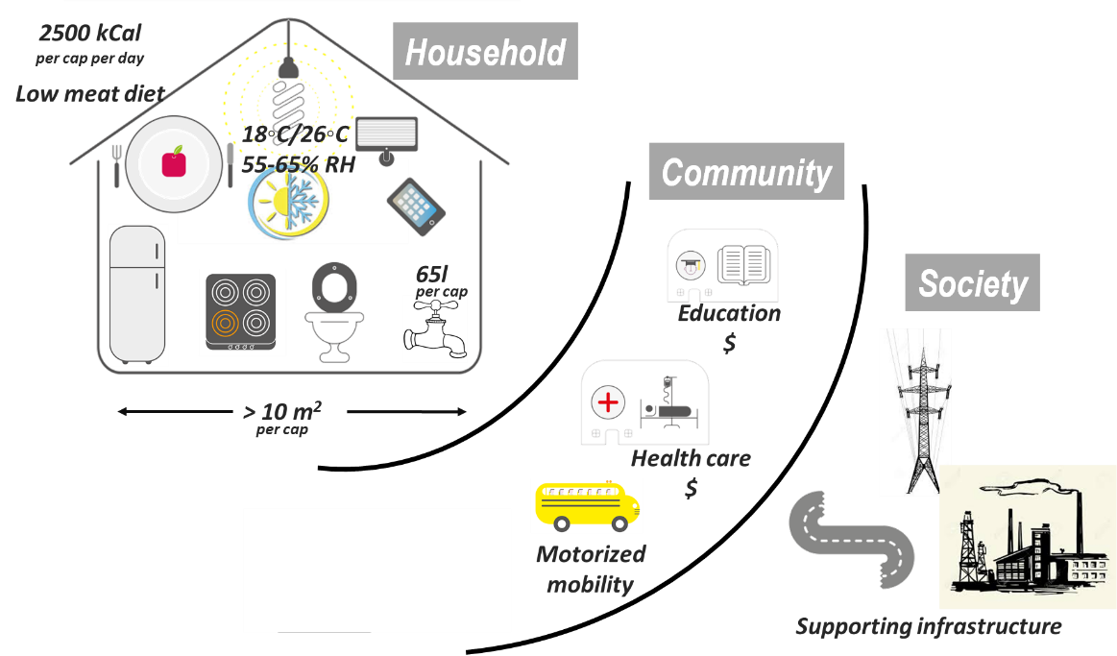

***Figure SI-7-1. Decent living standard requirements.*** *Values are suggestive. See Rao & Min6 for details. Temperature and relative humidity (RH) are winter and summer comfort standards respectively.*

Does energy demand in the LED scenario ensure people can afford a decent life, in accordance with the decent living standards (DLS) set out previously (see SI-2)? In the LED scenario, building end-use demand is derived bottom-up from end-use services, and combined with projections of technological advancements in end-use appliances to give energy demand. Energy demand for appliances (television, refrigerator, cook stoves and cell phones) are by definition accounted for in the LED scenario. What remains are residential thermal comfort requirements, and the indirect (industrial) energy needs associated with: constructing and operating the ‘back-end’ infrastructure to support DLS, including residential buildings, utilities (water, sanitation, electricity), and food production systems; manufacturing the appliances, vehicles and transportation systems; and delivering DLS services outside the home, such as education and health.

*Basic comfort energy needs*

The energy required to keep homes within the comfort range of ~18 degrees C in winter and ~26 degrees in summer depends on prevailing weather conditions. Estimating these energy requirements would require a global bottom-up, spatially explicit calculation of heating and cooling energy for this particular comfort standard. This is beyond the scope of this study. However, in recent work, Mastrucci & Rao79 conduct precisely this analysis to calculate cooling and heating energy requirements for India9. India spans five climatic zones, including hot-dry and warm-humid, the latter of which is the most energy-intensive due to the need for frequent air conditioning to reduce humidity to comfortable levels. To a rough approximation, these results bound the average space conditioning needs in the Global South. In that study, the authors estimate that cooling requires annual useful energy of about 30 MJ/m2 in the warm-humid zone, and as little as ~15 MJ/m2 in the cold zone. For heating a modest amount of water for bathing (30 litres/cap/day) to 40 °C every day would require an additional 0.66 GJ/cap in the cold zone and 0.4 GJ/cap in warm-humid zones[10]. These results can be interpreted as 66 MJ/m2 and 40 MJ/m2 respectively, since each person occupies 10 m2 in the DLS. Thus, in total on average approximately 100 MJ/m2 of useful energy would suffice to provide space conditioning needs in a DLS for a country like India, using current technology.

In comparison, the average thermal useful energy assumed in the LED scenario for the Global South is about 52 MJ/m2 (see SI-3a and SI-4a), but for much larger homes (~30 m2/cap) than is minimally acceptable for DLS. One can interpret the LED scenario as comprising wealthy households that occupy large but high-tech (and therefore low-energy) homes that reduce demand to below 50 MJ/m2, and lower income households that live in smaller but less insulated homes that consume 100 MJ/m2, of the kind simulated in the Mastrucci & Rao79 study using current technology and building construction methods.

For the Global North, whose space conditioning energy demand is dominated by heating, benchmarks from current standards for new buildings, such as the Energy Performance Building Directives (EPBD, 2010/31/EU) of the European Union, serve as useful comparisons. Best practices today that represent only the stock turnover can serve as a standard for the entire building stock in 2050 in an LED world.

The minimum performance requirements of the EPBD range between 238 MJ/m2 to 389 MJ/m2 final energy for heating and cooling. With best practice technologies, this translates to a useful energy of 216 MJ/m2 to 350 MJ/m2. In comparison, the LED scenario assumes useful energy levels of ~172 MJ/m2 (see SI-3a and SI-4a). However, total floorspace area (homes plus public and commercial buildings) in the Global North are assumed to be much larger than today (53 m2/cap vs ~41 m2/cap today). The total energy this represents would be sufficient to serve homes of the kind that are built today (both in terms of size and energy standards), or homes larger than today that have higher standards of insulation and equipment efficiency. Thus, the expectation is that the norm for buildings in 2050 in the LED scenario would be at worst that of new buildings today.

*Industrial Energy demand*

How much energy is required to build the infrastructure to support and deliver DLS to all in the Global South, and does the LED scenario allow for that growth? In a recent study, Mastrucci & Rao79 estimate this embodied energy for India and Brazil using lifecycle and input-output analysis, where appropriate, for each DLS component. India can be considered an average country in the Global South, while Brazil is among the richest countries, which therefore serves as a proxy for the most industrialized, and therefore energy-intensive pats of the Global South. The energy intensities of construction and energy conversion represent today’s technologies, and therefore are likely to be higher than the energy needs to deliver the same services in 2050. Similarly, the transport system is assumed to have similar modal patterns as today, and therefore also overestimate energy needs in 2050.

On this basis Mastrucci & Rao79 estimate that in India and Brazil respectively 12 GJ/cap and 26 GJ/capita of final energy would be required to provide DLS. This figure includes the appliance and space conditioning energy requirements discussed above. This translates to a total of 78 - 161 EJ for the population of the Global South in 2050, based on current industrial technologies. In comparison, the LED scenario estimates final energy use of about 150 EJ in the Global South. This is comparable to the extreme end of the requirement, which allows for the possibility that all countries in the Global South catch up to the leaders in terms of average living standards. Furthermore, since the LED scenario represents a more advanced, energy-efficient global economy, the services this amount of energy would deliver on average would allow for a comfortable amount of head room above basic DLS even in the most advanced economies in the Global South. As discussed earlier, this headroom is also reflected in the average size of dwellings, travel demand, and appliance ownership assumed in the LED scenario. This is realistic, since one can expect that future society would have a distribution of income that afford at least a subset of inhabitants more than the basic DLS.

**SDG13: Climate and SDG14: Oceans**

The low energy demand achieved in the LED scenario, allows emissions to be reduced rapidly. This leads to peak global mean temperature increase to be kept to 1.5°C relative to pre-industrial levels (here approximated by expressing warming relative to the 1850-1900 period). We use a reduced complexity carbon cycle and climate model MAGICC (see Method) in a probabilistic setup80,81 to assess the climatic outcomes of the LED scenario in more detail. This setup is consistent with the one used for the scenario assessment of the Working Group 3 Contribution to the Fifth Assessment Report of the Intergovernmental Panel on Climate Change. We find that peak warming is indeed kept to 1.5°C relative to preindustrial levels in the LED scenario, with a gradual temperature decline thereafter. By 2100, global mean temperature increase is estimated at 1.4°C. This is equivalent with limiting maximum warming to below 1.5°C with a probability of about 45% (rounded to the nearest 5%) and to below 2°C with a probability of about 90%. By 2100, these probabilities increase further to 60% and 90%, for 1.5°C and 2°C, respectively.

The assessment which MAGICC also allows to estimate the atmospheric CO2 concentrations implied by the LED scenario. The LED scenario halts the increase in atmospheric CO2 resulting in first a stabilization and then a decline in concentrations. Changes in atmospheric CO2 are the dominant cause of observed changes in the chemistry of surface waters82,83. By strongly limiting the increase of atmospheric CO2 (see Figure 7 panel f in Main text) the LED scenario contributes to the achievement of some of the targets of SDG14 on limiting the impacts of ocean acidification.

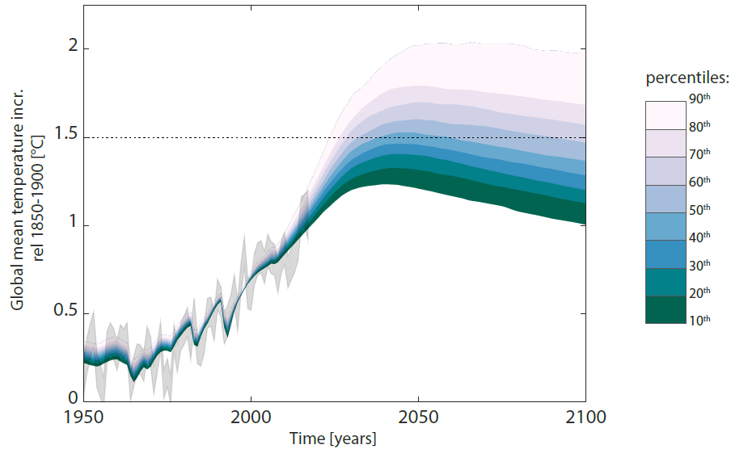

***Figure Climate. Probabilistic temperature assessment of the LED scenario.*** *Values are expressed as global mean temperature increase relative to preindustrial levels, here approximated by the 1850-1900 period. Grey shaded features are observed historical temperatures from HadCRUT484.*

**References SI**

1 Rogers, E. M. *Diffusion of Innovations*. 5th edn, 453 (Free Press, 2003).

2 von Stechow, C. *et al.* Integrating Global Climate Change Mitigation Goals with Other Sustainability Objectives: A Synthesis. *Annu Rev Env Resour* **40**, 363-394 (2015).

3 Ürge-Vorsatz, D., Herrero, S. T., Dubash, N. K. & Lecocq, F. Measuring the co-benefits of climate change mitigation. *Annu Rev Env Resour* **39**, 549-582 (2014).

4 Stiglitz, J. E., Sen, A. & Fitoussi, J.-P. Report of the Commission on the Measurement of Economic Performance and Social Progress. Report No.: N°2009-33 (OFCE, 2009).

5 Alkire, S. & Santos, M. E. Measuring acute poverty in the developing world: Robustness and scope of the multidimensional poverty index. *World Dev* **59**, 251-274 (2014).

6 Rao, N. D. & Min, J. Decent Living Standards: Material Prerequisites for Human Wellbeing. *Soc Indic Res* doi: 10.1007/s11205-017-1650-0 (2017).

7 Doyal, L. & Gough, I. *A Theory of Human Need*. 381 (Macmillan Education Ltd., 1991).

8 Schafer, A. Regularities in travel demand: an international perspective. *Journal of Transportation and Statistics* **3**, 1-31 (2000).

9 Fricko, O. *et al.* The marker quantification of the Shared Socioeconomic Pathway 2: A middle-of-the-road scenario for the 21st century. *Global Environ Change* **42**, 251-267 (2017).

10 International Energy Agency (IEA). IEA World Energy Statistics and Balances. <http://dx.doi.org/10.1787/data-00510-en> (2017).

11 Güneralp, B. *et al.* Global scenarios of urban density and its impacts on building energy use through 2050. *Proc Natl Acad Sci* **114**, 8945-8950 (2017).

12 Ürge-Vorsatz, D. *et al.* Best Practice Policies for Low Energy and Carbon Buildings. A Scenario Analysis. ISBN:979-10-91655-00-2. (Center for Climate Change and Sustainable Energy Policy, Central European University (3CSEP-CEU), 2012).

13 Riahi, K. *et al.* The shared socioeconomic pathways and their energy, land use, and greenhouse gas emissions implications: an overview. *Global Environ Change* **42**, 153-168 (2017).

14 Seto, K. C. *et al.* Human Settlements, Infrastructure, and Spatial Planning in *Climate Change 2014: Mitigation of Climate Change, Working Group III Contribution to the Fifth Assessment Report of the Intergovernmental Panel on Climate Change* (eds Edenhofer, O. *et al.*) Ch. 12, pg. 923-1000 (Cambridge University Press, 2014).

15 De Stercke, S. Dynamics of energy systems: A useful perspective. IIASA Interim Report IR-14-013 (International Institute for Applied Systems Analysis (IIASA), 2014).

16 International Energy Agency (IEA). Energy Technology Perspectives 2017 - Catalysing Energy Technology Transformations. ISBN:978-9264270503. (OECD/IEA, 2017).

17 Teske, S. *et al.* Global Energy [R]evolution - a Sustainable World Energy Outlook 2015. 100% Renewable Energy for All. (Greenpeace International, Global Wind Energy Council, Solar Power Europe, 2015).

18 International Energy Agency (IEA). Gadgets and Gigawatts. ISBN:978-92-64-05953-5. (OECD/IEA, 2009).

19 International Telecommunication Union (ITU). ICT Facts and Figures 2017. (United Nations. ITU Statistics, 2017).

20 Koomey, J. G., Belady, C., Patterson, M., Santos, A. & Lange, K.-D. Implications of recent trends in performance, costs, and energy use for servers in *The Green Computing Book: Tackling Energy Efficiency at Large Scale* (ed Feng, W.-c.) Ch. 9., pg. 297-321 (CRC Press, 2014).

21 Bento, N. Calling for change? Innovation, diffusion, and the energy impacts of global mobile telephony. *Energy Res Soc Sci* **21**, 84-100 (2016).

22 Koomey, J., Berard, S., Sanchez, M. & Wong, H. Implications of historical trends in the electrical efficiency of computing. *IEEE Ann Hist Comp* **33**, 46-54 (2011).

23 The Economist (2015). The Economist explains: The end of Moore's law. Apr 19th. Retrieved from: http://www.economist.com/node/21648858 (last access 24/10/2017).

24 Koomey, J. & Naffziger, S. in *IEEE Spectrum.* Special Report: 50 Years of Moore’s Law Retrieved from: https://spectrum.ieee.org/computing/hardware/moores-law-might-be-slowing-down-but-not-energy-efficiency (online journal, 2015).

25 International Energy Agency (IEA). More Data, Less Energy: Making Network Standby More Efficient in Billions of Connected Devices. (OECD/IEA, 2014).

26 Koomey, J. G. A primer on the energy efficiency of computing *AIP Conference Proceedings* **1652***,* 82-89 (2015).

27 McKinsey Global Institute *et al.* Resource Revolution: Meeting the world's energy, materials, food, and water needs. 209 (McKinsey & Company, 2011).

28 Cullen, J. M., Allwood, J. M. & Borgstein, E. H. Reducing energy demand: what are the practical limits? *Environ Sci Technol* **45**, 1711-1718 (2011).

29 World Business Council for Sustainable Development (WBCSD). Vision 2050: The New Agenda for Business. ISBN:978-3-940388-56-8. (World Business Council for Sustainable Development, 2010).

30 Stahel, W. R. A vision of the world in 2030 and a back casting in order to guide actions today. Societal Wealth Should Be Measured In Stock, Not Flow. Report No.: 3. (The Product-Life Institute, 2013).

31 Cabeza, L. F., Ürge-Vorsatz, D., McNeil, M. A., Barreneche, C. & Serrano, S. Investigating greenhouse challenge from growing trends of electricity consumption through home appliances in buildings. *Renew Sust Energ Rev* **36**, 188-193 (2014).

32 Unander, F., Karbuz, S., Schipper, L., Khrushch, M. & Ting, M. Manufacturing energy use in OECD countries: decomposition of long-term trends. *Energ Policy* **27**, 769-778 (1999).

33 Rao, N. D. & Ummel, K. White goods for white people? Drivers of electric appliance growth in emerging economies. *Energy Res Soc Sci* **27**, 106-116 (2017).

34 International Energy Agency (IEA). Light’s Labour’s Lost: Policies for Energy-Efficient Lighting. (OECD/IEA, 2006).

35 Yamada, M. & Strober, K. Adoption of light-emitting diodes in common lighting applications. Prepared by Navigant, (United States Department of Energy (DOE), 2015).

36 von Weizsäcker, E. U. *et al.* Decoupling 2: technologies, opportunities and policy options. ISBN:978-92-807-3383-9. (ed. International Resource Panel, Working Group on Decoupling). 161 (United Nations Environment Programme (UNEP), 2014).

37 von Weizsäcker, E. U., Hargroves, C., Smith, M. H., Desha, C. & Stasinopoulos, P. *Factor Five: Transforming the Global Economy Through 80% Improvements in Resource Productivity*. 432 (Routledge, 2009).

38 Hawkens, P. & et al. *Drawdown - The Most Comprehensive Plan Ever Proposed to Reverse Global Warming*. (Penguin Books, 2017).

39 Ürge-Vorsatz, D. *et al.* Energy End-Use: Buildings in *Global Energy Assessment - Toward a Sustainable Future* Ch. 10, pg. 649-760 (Cambridge University Press and the International Institute for Applied Systems Analysis (IIASA), 2012).

40 Fulton, L., Cazzola, P. & Cuenot, F. IEA Mobility Model (MoMo) and its use in the ETP 2008. *Energ Policy* **37**, 3758-3768 (2009).

41 GEA. *Global Energy Assessment - Toward a Sustainable Future*. 1865 (Cambridge University Press and the International Institute for Applied Systems Analysis (IIASA), 2012).

42 Millard‐Ball, A. & Schipper, L. Are we reaching peak travel? Trends in passenger transport in eight industrialized countries. *Transport Rev* **31**, 357-378 (2011).

43 Riahi, K. *et al.* Energy Pathways for Sustainable Development in *Global Energy Assessment - Toward a Sustainable Future* Ch. 17, pg. 1203-1306 (Cambridge University Press and the International Institute for Applied Systems Analysis (IIASA), 2012).

44 Kahn Ribeiro, S. *et al.* Energy End-Use: Transport in *Global Energy Assessment - Toward a Sustainable Future* Ch. 9, pg. 575-648 (Cambridge University Press, and the International Institute for Applied Systems Analysis (IIASA), 2012).

45 International Transport Forum (ITF). ITF Transport Outlook 2017. ISBN:9789282108000. (OECD/ITF, 2017).

46 Food and Agriculture Organisation of the United Nations (FAO), International Fund for Agricultural Development (IFAD) & World Food Programme (WFP). The State of Food Insecurity in the World 2015. Meeting the 2015 international hunger targets: taking stock of uneven progress. ISBN:978-92-5-108785-5. (FAO, 2015).

47 Valin, H. *et al.* The future of food demand: understanding differences in global economic models. *Agr Econ* **45**, 51-67 (2014).

48 Kumssa, D. B. *et al.* Dietary calcium and zinc deficiency risks are decreasing but remain prevalent. *Sci Rep-UK* **5**, 10974 (2015).

49 McMichael, A. J., Powles, J. W., Butler, C. D. & Uauy, R. Food, livestock production, energy, climate change, and health. *Lancet* **370**, 1253-1263 (2007).

50 Mozaffarian, D. Dietary and policy priorities for cardiovascular disease, diabetes, and obesity: a comprehensive review. *Circulation* **133**, 187-225 (2016).

51 Havlík, P. *et al.* Climate change mitigation through livestock system transitions. *Proc Natl Acad Sci* **111**, 3709-3714 (2014).

52 Stehfest, E. *et al.* Climate benefits of changing diet. *Climatic Change* **95**, 83-102 (2009).

53 Creutzig, F. *et al.* Beyond technology: demand-side solutions for climate change mitigation. *Annu Rev Env Resour* **41**, 173-198 (2016).

54 Smith, P. *et al.* Agriculture, forestry and other land use (AFOLU) in *Climate Change 2014: Mitigation of Climate Change Contribution of Working Group III to the Fifth Assessment Report of the Intergovernmental Panel on Climate Change* (eds Edenhofer, O. *et al.*) Ch. 11, pg. 811-922 (Cambridge University Press, 2014).

55 Bajželj, B. *et al.* Importance of food-demand management for climate mitigation. *Nat Clim Change* **4**, 924-929 (2014).

56 Allwood, J. M., Ashby, M. F., Gutowski, T. G. & Worrell, E. Material efficiency: A white paper. *Resour Conserv Recy* **55**, 362-381 (2011).

57 Allwood, J., Cullen, J. & et al. *Sustainable Materials - with Both Eyes Open: Future Buildings, Vehicles, Products and Equipment - Made Efficiently and Made with Less New Material*. 356 (UIT Cambridge Ltd., 2012).

58 Banerjee, R. *et al.* Energy End Use: Industry in *Global Energy Assessment - Toward a Sustainable Future* Ch. 8, pg. 513-574 (Cambridge University Press, and the International Institute for Applied Systems Analysis (IIASA), 2012).

59 Reinaud, J., Goldberg, A., Rozite, V. & et al. Energy Management Programmes for Industry - Gaining through saving. (IEA/OECD and Institute for Industrial Productivity, 2012).

60 Fischedick, M. *et al.* Industry in *Climate Change 2014: Mitigation of Climate Change, Working Group III Contribution to the Fifth Assessment Report of the Intergovernmental Panel on Climate Change* (eds Edenhofer, O. *et al.*) Ch. 10, pg. 739-810 (Cambridge University Press, 2014).

61 International Energy Agency (IEA). World Energy Outlook 2015. ISBN:978-92-64-24366-8. (OECD/IEA, 2015).

62 Clarke, L. *et al.* Assessing Transformation Pathways in *Climate Change 2014: Mitigation of Climate Change, Working Group III Contribution to the Fifth Assessment Report of the Intergovernmental Panel on Climate Change* (eds Edenhofer, O. *et al.*) Ch. 6, pg. 413-510 (Cambridge University Press, 2014).

63 Haegel, N. M. *et al.* Terawatt-scale photovoltaics: Trajectories and challenges. *Science* **356**, 141-143 (2017).

64 Office of Transportation and Air Quality of United States Environmental Protection Agency (EPA), National Highway Traffic Safety Administration of U.S. Department of Transportation & California Air Resources Board. Draft Technical Assessment Report of the 2022-2025 Light-Duty GHG Standards. Report No.: EPA-420-D-16-900, Sections 5.2.4 and 5.3.4.3.7 (EPA, 2016).

65 Wei, M., Smith, S. J. & Sohn, M. D. Analysis of Fuel Cell Markets in Japan and the US: Experience Curve Development and Cost Reduction Disaggregation. (Lawrence Berkeley National Laboratory (LBNL), 2016).

66 International Energy Agency, Energy Technology Systems Analysis Programme (IEA-ETSAP),, & International Renewable Energy Agency (IRENA). Solar Heat for Industrial Processes. Report No.: Technology Brief E21 (IRENA Publications, 2015).

67 Gençer, E., Mallapragada, D. S., Maréchal, F., Tawarmalani, M. & Agrawal, R. Round-the-clock power supply and a sustainable economy via synergistic integration of solar thermal power and hydrogen processes. *Proc Natl Acad Sci* **112**, 15821-15826 (2015).

68 Rogelj, J. *et al.* Transition pathways towards limiting climate change below 1.5°C. *Nat Clim Change* (in review).

69 Grübler, A. & Messner, S. Technological change and the timing of mitigation measures. *Energ Econ* **20**, 495-512 (1998).

70 Wilson, C. & Grubler, A. A Comparative Analysis of Annual Market Investments in Energy Supply and End-Use Technologies in *Energy Technology Innovation - Learning from Historical Successes and Failures* (eds Grubler, A. & Wilson, C.) Ch. 23, pg. 332-346 (Cambridge University Press 2013).

71 Grubler, A. *et al.* Policies for the Energy Technology Innovation System (ETIS) in *Global Energy Assessment - Toward a Sustainable Future* Ch. 24, pg. 1665-1744 (Cambridge University Press, and the International Institute for Applied Systems Analysis (IIASA), 2012).

72 Marchetti, C. & Nakicenovic, N. The Dynamics of Energy Systems and the Logistic Substitution Model. IIASA Report No.: RR-79-13, (International Institute for Applied Systems Analysis (IIASA), 1979).

73 Fisher, J. C. & Pry, R. H. A simple substitution model of technological change. *Technol Forecast Soc* **3**, 75-88 (1971).

74 Grübler, A. Diffusion: long-term patterns and discontinuities. *Technol Forecast Soc* **39**, 159-180 (1991).

75 Smith, K. R. *et al.* Energy and Health in *Global Energy Assessment - Toward a Sustainable Future* Ch. 4, pg. 255-324 (Cambridge University Press, and the International Institute for Applied Systems Analysis (IIASA), 2012).

76 Lim, S. S. *et al.* A comparative risk assessment of burden of disease and injury attributable to 67 risk factors and risk factor clusters in 21 regions, 1990–2010: a systematic analysis for the Global Burden of Disease Study 2010. *Lancet* **380**, 2224-2260 (2012).

77 Rogelj, J. *et al.* Energy system transformations for limiting end-of-century warming to below 1.5°C. *Nat Clim Change* **5**, 519-527 (2015).

78 Smith, P. *et al.* Biophysical and economic limits to negative CO2 emissions. *Nat Clim Change* **6**, 42-50 (2016).

79 Mastrucci, A. & Rao, N. D. Decent housing in the developing world: Reducing life-cycle energy requirements. *Energ Buildings* **152**, 629-642 (2017).

80 Meinshausen, M. *et al.* Greenhouse-gas emission targets for limiting global warming to 2 C. *Nature* **458**, 1158-1162 (2009).

81 Rogelj, J., Meinshausen, M., Sedláček, J. & Knutti, R. Implications of potentially lower climate sensitivity on climate projections and policy. *Environ Res Lett* **9**, 031003 (2014).

82 Doney, S. C., Fabry, V. J., Feely, R. A. & Kleypas, J. A. Ocean Acidification: The Other CO2 Problem. *Annu Rev Mar Sci* **1**, 169-192 (2016).

83 IPCC. *Climate Change 2013: The Physical Science Basis. Contribution of Working Group I to the Fifth Assessment Report of the Intergovernmental Panel on Climate Change*. (Cambridge University Press, 2013).

84 Morice, C. P., Kennedy, J. J., Rayner, N. A. & Jones, P. D. Quantifying uncertainties in global and regional temperature change using an ensemble of observational estimates: The HadCRUT4 data set. *J Geophys Res-Atmos* **117**, 101 (2012).

1. The concept of exergetic service efficiency applies the traditional exergy calculus (Carnot efficiency) to service provision. There realized efficiencies between useful energy input and services delivered (passenger-km transported, lumens of lighting services, etc.) are determined by comparing current technologies and service provision modes with best available practice providing identical levels and quality of energy services (comparing passenger-km transported in an average car with average (low) load factors to a fuel efficient car with 4 passengers yields a corresponding exergy efficiency of service provision and provides an energy-equivalence aggregation (in Joules) of otherwise non-commensurate energy services).  
   
2. These minimum requirements also include political, psychological and other social dimensions, but these aren’t intrinsically material requirements, so we set them aside here.
3. The two type of service categories are usually aggregated in the available scenario studies under the category residential/commercial sector or “buildings” that customarily also aggregate thermal and other energy uses (use of electricity in appliances). In order to allow comparisons with the published literature we also provide this aggregation separately here.
4. Available at: [www.fao.org/faostat](http://www.fao.org/faostat).
5. Chosen as comparable to the GEA Efficiency scenario as being characterised by comparable population and GDP growth assumptions as well as staying below a 2 °C climate target. In terms of industrial final energy demand the two scenarios differ slightly (by 18%) with 209 EJ (GEA Efficiency) versus 179 EJ (ETP 2DS) by 2050.
6. B2DS results in limiting global mean temperature change at below some 1.7 degrees Celsius16, i.e. substantially above the LED target of 1.5 degrees.
7. The “intensity of use” variable in the Allwood and Cullen et al.57model has a great degree of overlap with our “dematerialization” variable. In order to avoid double counting we have set that variable parameter to 1 in the Allwood-Cullen model for those categories (e.g. vehicles) covered in our dematerialization term, i.e. assuming no further reduction potentials beyond those reported in our “dematerialization” variable.
8. Energy intensities (final energy per GDP PPP) declined by 1.7 %/yr in the Global North and by 1.3 %/yr in the Global South (World average: 1.5 %/yr) in the period 1970 to 2014 (PFUDB, 2018). Note that these intensity improvements tend to be higher than corresponding intensities measuring primary energy inputs, where intensity improvements at the final energy level are partly compensated by increasing conversion losses between primary to final energy (e.g. via increased electrification).
9. The set regions, each represented by individual countries or provinces, include Asia, EU28, Other Europe, and G20 Other (i.e., Canada, Russian Federation, Turkey, South Africa, Brazil, Argentina, Australia, and United States of America).
10. Assuming an electric resistance no-storage heater with 80 percent efficiency.